**Table of Contents**

**CHAPTER 1: INTRODUCTION TO APACHE KAFKA 3**

Theory 3

An Overview of BigData 3

*Quick Introduction to Hadoop 3*

*Why Hadoop? 3*

*Quick Introduction to Hadoop Distributed File System 4*

*Block Placement in HDFS 5*

*HDFS Architecture 6*

Quick Introduction to Spark 8

*What is Spark? 8*

*Why Spark? 8*

*Components of Spark 10*

*Spark Data Storage 12*

Introduction to Kafka 13

*What is Kafka? 13*

*Why Kafka? 14*

Confluent Overview 17

Kafka Use Case 18

Introduction to ZooKeeper 20

*What is ZooKeeper? 20*

*ZooKeeper Data Consistency 21*

*ZooKeeper Architecture 22*

Why does Kafka need ZooKeeper? 23

**LAB EXERCISE 25**

**SUMMARY 26**

**CHAPTER 2: THE KAFKA FRAMEWORK 27**

Theory 27

Kafka Architecture 27

*Topics 28*

*Partitions 28*

*Producers 28*

*Consumers 29*

*Brokers 29*

*Replications 30*

*ZooKeeper 30*

**AIM 31**

**LAB EXERCISE 1: KAFKA INSTALLATION 32**

Task 1: Download and Install JDK 33

Task 2: Download and Install ZooKeeper 35

Task 3: Configure ZooKeeper 38

Task 4: Download and Install Kafka 42

Task 5: Configure Kafka 45

Task 6: Starting ZooKeeper and Kafka 48

**SUMMARY 51**

**REFERENCES 52**

**CHAPTER 1: INTRODUCTION TO APACHE KAFKA**

**Theory**

This chapter is intended to provide a comprehensive introduction to Apache Kafka, which is the center of focus throughout this book. We shall go through a brief overview of BigData before we begin with Kafka.

**An Overview of BigData**

**Quick Introduction to Hadoop**

Apache Hadoop is an open source distributed framework that allows storage and processing of large data (BigData) sets across cluster of commodity machines. Hadoop overcomes the traditional limitations of storing and computing of data by distributing the data over cluster of commodity machines, making it scalable and cost-effective.

The idea of Hadoop was originated when Google released a white paper about **Google File System (GFS)** - a computing model built by Google which was designed to provide efficient, reliable access to data using large clusters of commodity hardware. The model was then adopted by Doug Cutting and Mike Cafarella for their search engine called “Nutch”. Hadoop was then developed to support distribution for the Nutch search engine project by Doug Cutting and Mike Cafarella. Well, what does the name Hadoop mean? There is no significance for the name and it is not an acronym either. Hadoop is the name that Doug Cutting’s son gave to his yellow stuffed elephant. The name is very unique, easy to remember and sometimes funny. Not only does Hadoop have such name with no significance but also its sub-projects tend to have such names, which are based on names of animals, like Pig, and for the same reason. They are unique, not used anywhere else and are easy to remember.

**Why Hadoop?**

Companies today have been realizing that there is lot of information in unstructured documents spread across the network. A lot of data is available in the form of spreadsheets, text files, e-mails, logs, PDF’s and other data formats that contain valuable information which can help discover new trends, design new products, improve existing products, know customers better and what not. Data is increasing at an alarming rate beyond limits like never before and there are no signs of slowing down, at least in the near future. To deal with such data, we need a reliable and low cost tool to meaningfully process it. Therefore, we use Hadoop. Hadoop helps us process all this BigData which is present in variety of formats reliably, in a very lesser time and in a flexible and cost-effective way.

Let us see why Hadoop is so popular and what it has in store for you.

* **Scalable**: Hadoop is scalable, meaning: you can just start from a single node server and eventually increase more nodes as you need more storage and more computing power.
* **Fault-Tolerant**: Hadoop helps prevent loss of data. All the data which is stored in Hadoop Distributed File System is broken into blocks and stored with a default replication factor of 3. While processing data, if a node goes off, the process does not stop but continues, as the data still exists in other nodes.
* **Flexible**: Hadoop does not require schema. Hadoop can process unstructured, semi-structured and structured data from any kind of source or even from multiple sources.
* **Cost-effective**: Hadoop does not require expensive high end computing hardware. Hadoop works well with a cluster of commodity machines by parallel computing.

**Quick Introduction to Hadoop Distributed File System**

**Hadoop Distributed File System (HDFS)** is a File System which extends over a cluster of commodity machines rather than a single high end machine. HDFS is a distributed large scale storage component and is highly scalable. HDFS can accept node failures without losing data. HDFS is widely known for its reliability. Let us now check out why HDFS stands out of crowd when it comes to Distributed file systems.

|  |  |
| --- | --- |
| **Reliable Data Storage** | HDFS is very much reliable when it comes to data storage. Whatever the data stored in HDFS is replicated by a default replication factor of 3. That means, even if a machine fails, the data will be still available in two other machines. |
| **Cost Effective** | HDFS can be deployed on cluster of commodity hardware and can save you a lot of bucks. High end expensive hardware is not required by HDFS to function. |
| **Big Datasets** | HDFS is capable of storing Petabytes of data over a cluster of machines where a file can range from Gigabytes to Terabytes of size. HDFS is not designed to store huge number of small sized files as the file system meta data is stored in memory of NameNode. |
| **Streaming Data Access** | HDFS provides streaming access to data. HDFS is best suited for batch processing of data and not suitable for interactive processing. HDFS is not designed for applications which require low latency access to data such as OnLine Transaction Processing (OLTP). |
| **Simple Coherency Model** | HDFS is designed to *write once and read many times* access model for files. Appending the content to files is supported at the end but cannot be updated at arbitrary point, and it is also not possible to have multiple writers. Files can only be written by a single writer. |

**Block Placement in HDFS**

Hadoop is designed in such a way that the first block replica is placed on the same node as of client, and the second replica is placed on a different rack from first replica. Third replica is placed on a random node on the same rack as of the second replica. If the replication factor is more, random nodes in the cluster are selected to place the replicas. If a client running outside the cluster stores a file, random node (That isn’t busy) is picked to place the first replica. This way, if a node fails, the data is still available on other nodes of the cluster, and if a rack fails, again, the data is still intact.

**HDFS Architecture**

HDFS is a Master and Slave architecture, in which the Master node controls and assigns jobs to all its slave nodes. The following terminologies are used to describe the Master and Slave nodes.

The Master Nodes in HDFS are:

* NameNode
* Secondary NameNode

The Slave Nodes in HDFS are:

* Data Nodes

These nodes are the core serving roles in HDFS architecture. Let us now look in detail about the roles of each Node and understand them better.

|  |  |
| --- | --- |
| **NameNode** | NameNode is a HDFS daemon which controls all the Data Nodes and handles all the File System operations such as creating a directory, creating a file or reading and writing a file. The NameNode is responsible for managing the File System namespace image. It holds the image in memory, representing how the File System looks like. It also maintains the meta data for all the blocks of files in the File System and also tracks the replication value, so it knows the locations of blocks stored on Data Nodes within the cluster. But the meta data is not stored onto the disk and is every time recreated when it starts. NameNode stores all this information persistently on local disk in the form of namespace image and edit log. The NameNode is the *single point of failure* in the Hadoop cluster. If the NameNode fails, entire cluster fails. |
| **Data Nodes** | Data Nodes are the slave machines controlled by the NameNode, that actually does all the block operations. Data Nodes store and retrieve blocks when asked to do so by NameNode, and periodically inform NameNode with the lists of blocks they store by sending heartbeats. Data Nodes replicate the data physically when instructed by the NameNode on where and how to replicate. |
| **Secondary NameNode** | Secondary NameNode, as its name implies, is not exactly the Secondary NameNode. The secondary NameNode is not a high availability solution and does not automatically take over the responsibilities of NameNode on failure. Its main role is to create checkpoint and take the backup of NameNode periodically. It is like a backup solution to the NameNode. The hardware specifications of secondary NameNode should be similar to that of NameNode. In case of NameNode’s failure, the secondary NameNode can be manually configured to work as a primary NameNode. This is not a high availability solution. |

Now that we have had a quick introduction to Hadoop, let us shift our focus on the main topic of our discussion, Apache Spark.

**Quick Introduction to Spark**

**What is Spark?**

Apache Spark is an open source, fast and unified parallel large-scale data processing engine. It provides a framework for programming with distributed processing of large datasets at high speed. Spark supports the most popular programming languages such as Java, Python, Scala and R. Spark is scalable, meaning, it can run on a single desktop machine or a laptop to a cluster of thousands of machines. Spark provides a set of inbuilt libraries which can be accessed to perform data analysis over a large dataset. However, if your requirement doesn’t get satisfied with the inbuilt libraries, you can write one or explore countless external libraries from open source communities on the internet.

**Why Spark?**

Why use Spark when we have Hadoop? Well, Spark excels as a unified platform for processing huge data at very high speeds for various data processing requirements (will be discussed later in this chapter). Also, Spark is an in-memory processing framework. Spark is considered as a successor of Apache Hadoop. Let us briefly discuss the advantages of Spark over Hadoop.

With the Hadoop ecosystem, we had various frameworks for various data processing requirements. As a developer, you would use MapReduce framework to analyze your data using any of the languages such as Java, C++, Python etc, but a data warehouse engineer who is a SQL expert, has to learn any of the aforementioned programming languages. To overcome this problem, a new framework which runs on the top of Hadoop called “Hive” was introduced. This was also a problem for ETL processing, and so “Pig” was introduced. Similarly tools like “Giraph” and “Mahout” were introduced for Graphs processing and Machine Learning respectively. Moreover, Hadoop is only used for batch processing and there was no way to process data in real time. So, for this a new framework called “Storm” was integrated with Hadoop to work with streaming data. With so many frameworks, organizations had a tough time to maintain all the frameworks and track issues pertaining to them. Fortunately, all this would change with the advent of Spark. As mentioned, Spark is a unified platform which provides all these frameworks as one package with four major components.

Now, what actually does In-memory processing mean? Aren’t all the applications processed in memory only? Well, yes, all the applications are processed in-memory and written back to disk when processing is done, but Spark can process data in-memory and also retain the data within the memory or write to disk. Let us understand this with a figure by comparing Spark with MapReduce.

***1(a) Data Processing with MapReduce***





*Read Write* *Read* *Write* *Read Write Read Write*



In MapReduce, the data present in HDFS or any other *Distributed file system* is read by a MapReduce application and is processed in memory and then written back to disk after the job is complete. If the processed data is again needed for further processing, the data is again read from disk by a MapReduce application, processed in memory and then written back to disk. This process continues as per the requirement, as seen in the figure 1(a). The processes of reading and writing data from and to the disk increase the IO latency and so the overall job duration is increased. This is optimized in Spark as shown in the figure 1(b).

***1(b) Data Processing with Spark***







*Read*



*Write*

In Spark, the data is read from the disk, processed in-memory but, instead of spilling it back to disk, Spark can retain the data within the memory for further processing. So, if the processed data is again required for further processing, the data is already present in the memory and the Spark application processes the data eliminating the IO latency, and therefore the overall time to process the job is significantly reduced. With this, the processing speed when compared to MapReduce has been increased up to 100 times faster. The processed data from a Spark application can either be retained in memory or can be stored to the disk as per the requirement, as shown in the figure 1(b).

The reasons, such as a unified platform for various data processing requirements and High Speed In-Memory processing, have gained worldwide popularity throughout the industry with almost all the major organizations using Spark for their data processing requirements.

**Components of Spark**

Now that we know why Spark is being used, let us dive in more and learn what Spark is made up of. Let us look at each of the major Spark’s components individually and know them in detail. The following figure 1(c) shows the components of Spark.

***1(c) Components of Spark***









Let us look at a brief explanation regarding these components so that we can better understand the Spark components.

|  |  |
| --- | --- |
| **Spark Core** | Spark Core, as the name suggests, is the core component of Spark which has all the basic functionalities for processing large datasets. Some of its functionalities include managing memory, scheduling jobs, fault tolerance, using in-memory computation, referring datasets stored in storage systems etc. Spark Core includes a programming abstraction (API) called Resilient Distributed Datasets also known as RDDs, which is responsible for partitioning data across nodes on a cluster. With the help of these RDDs, the data can be transformed, collected and reduce things together. These RDD APIs can be referred by using any of the programming languages such as Scala, Python, Java and R as shown in the figure 1(c). |
| **Spark SQL** | The Spark SQL component provides the developer with an SQL like interface to work with huge structured data which is distributed over a cluster of nodes. Spark SQL works well with structured and semi structured data. Spark SQL can also work with data sources such as Apache Hive tables, Avro, JDBC, ORC, JSON and Parquet file formats. Spark SQL also allows developers to combine RDD APIs along with Spark SQL code in a single application. |
| **Spark Streaming** | Spark Streaming component of spark deals with processing of real time data also known as Streaming data. The streaming data can be from fleet of web servers, sensors, IOT devices or any other sources which generate data. This enables Spark to ingest data as it is generated in realtime and perform data manipulation on that data. There are three major phases of Spark Streaming. They are *Gathering*, *Processing* and *Data Storage*. Spark Streaming is also fault tolerant and scalable. We will talk a little about Spark Streaming in this book. |
| **Spark MLlib** | Spark MLlib is short for Machine Learning libraries which provides Machine Learning for huge datasets. MLlib contains various Machine Learning algorithms such as *Regression*, *Clustering*, *Classification* and *Collaborative Filtering*. MLlib also contains lower level primitives such as generic gradient descent optimization algorithm. MLlib also uses the linear algebra package called *Breeze* for numerical computing. |
| **GraphX** | GraphX deals with processing of Graphs in very efficient and distributed manner. GraphX extends the RDD APIs, which allows a developer to create a directed multigraph with properties attached to each vertex and edge. |
| **Cluster Managers** | Spark is all about processing massive amounts of datasets by distributing them over a number of nodes and scaling the cluster as required. In order to efficiently perform this task, a cluster manager is required, and Spark has its own cluster manager called *Standalone Scheduler*. Spark can also be deployed using *Hadoop YARN,* *Apache Mesos* or *Kubernetes* as a cluster manager to schedule jobs and manage the resources of the cluster. |

**Spark Data Storage**

Spark supports major file systems such as HDFS, Amazon S3, Azure Blob etc. Spark supports the local file system for storing the data as well. However, using a distributed file system such as HDFS can leverage the power of Spark by distributing the datasets throughout the cluster. Spark is also capable of dealing with various file formats such as text, ORC, parquet etc.

Hadoop and Spark are used to analyze huge amounts of data. This only solves one of the challenges faced with BigData. The other challenge is to actually collect huge amounts of data efficiently. Kafka helps us with this challenge. Let us now proceed with an introduction to Kafka and see how it deals with this challenge.

**Introduction to Kafka**

**What is Kafka?**

Kafka is an open-source, distributed, persistent and fault-tolerant message streaming platform or a central repository, which can handle high volume (trillions) of Publish-Subscribe messages every day. Publish-Subscribe messaging system is a system where data is produced (Publish) by producers and consumers consume (subscribe) the data. We shall be looking at Producers and Consumers in detail, in the next chapter.

Kafka is written in Scala and is built on top of the ZooKeeper coordination service. The integration of Spark and Kafka enables real-time streaming data analysis. Kafka was built at LinkedIn and later donated to the Apache Software Foundation, making it open-source.

Kafka is popular because of the following features:

* **Scalable**: Kafka can be scaled from a single machine to a cluster of machines spanning data centers with zero downtime. The number of machines required can be scaled as per the requirement.
* **Persistent**: The data or messages are stored and cached in disk instead of memory, making them persistent and durable. Kafka is also fault-tolerant with replications and partitions.
* **Performance:** Kafka provides great performance and stability with huge volumes of publishing and subscribing messages.
* **Distributed**: Kafka is distributed to a cluster of machines and hence processes streams with great speed and efficiency.
* **Real-Time Streaming:** Kafka is capable of processing streams of messages in real-time as they occur.

Kafka is used to build real-time streaming data pipelines for steady transfer of data between applications. The use cases include collecting logs from multiple servers, data from sensors etc.

**Why Kafka?**

Why do we need Kafka? Don’t we already have message queue or data streaming platforms? How is Kafka better than the traditional data streaming platforms? Let us answer all these questions now. To understand why we need Kafka, we should first understand how the traditional streaming platforms work.

Consider a traditional system with a message queue as shown below. The message queue could be implemented in any of the programming languages. The message queue receives messages from various numbers of processes. These messages are denoted by P1, P2…Pn. This message queue may store data in-memory or on the file system based on the implementation. If the system is memory based, the data will be lost in case of system failure. But if the system is file based, the data will be intact even if the system goes down. The data from the message queue will be consumed by various numbers of consumer processes. These processes are denoted by C1, C2…Cn.

The data is produced by the producers and the consumers consume the data via the message queue. So far so good. However, the problem arises when one of the consumers is connected to a distributed platform such as Spark application. Spark is capable of processing huge amounts of data in a distributed manner. The message queue is not distributed and is implemented in a single machine. Therefore, the traditional message queue is limited by resources of that machine such as CPU core, RAM and disk size, and becomes the bottleneck as it cannot receive huge data similar to Spark.

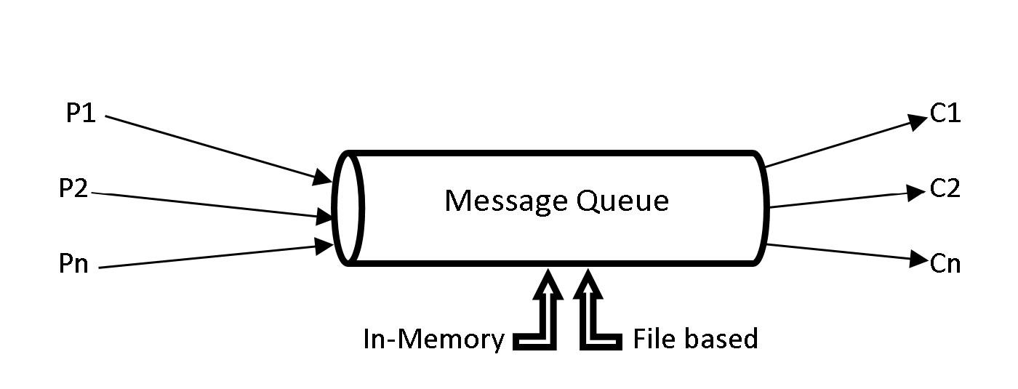

***1(d) Traditional Message Queue***

In order to cater a distributed processing application such as Spark, it is only efficient to have a message queue distributed across several machines. The limitation of machine resources such as CPU, RAM and disk was one of the reasons to develop Kafka, which is a distributed message queue.

Let us now look at another reason why Kafka had to be developed. Consider an application *app1* which generates data during its operations. This data is required by an analytics application, say *appA*. The data is simply transferred via an interface from *app1* to *appA*. Later there comes another application, say *app2* that generates data. This data is also required by the analytics application *appA* for more analytics. So, an interface has to be implemented to send the data from *app2* to *appA*. Once the interface for *app2* is implemented and tested, the interface for *app1* should also be tested in order to make sure the new implementation has not broken something with the old implementation.

Eventually more operational (*app3, app4, app5…*) and analytics (*appB, appC, appD…*) applications were developed which require data from operational to analytics applications. For example, data from *app4* might be needed by *appB* and *appD* or data from *app3* might be required by *appA* and *appC.* There might be many such possibilities for transferring data from one or more operational applications to one or more analytics applications. Every time a new operational application generates data for analytics application, a new interface has to be implemented, and all the interfaces should be tested to check if something is broken due to the new implementations. This becomes very hard to maintain when there are so many applications and interfaces. The entire system should be tested every time a new interface between applications is implemented.

All these problems lead to the development of Kafka. Instead of having different interfaces for different applications, all the operational applications send the data to Kafka. The analytics applications can then consume the data from Kafka, making it a central repository. The figure below shows a pictorial representation of how data is being produced and consumed with Kafka as a central repository.

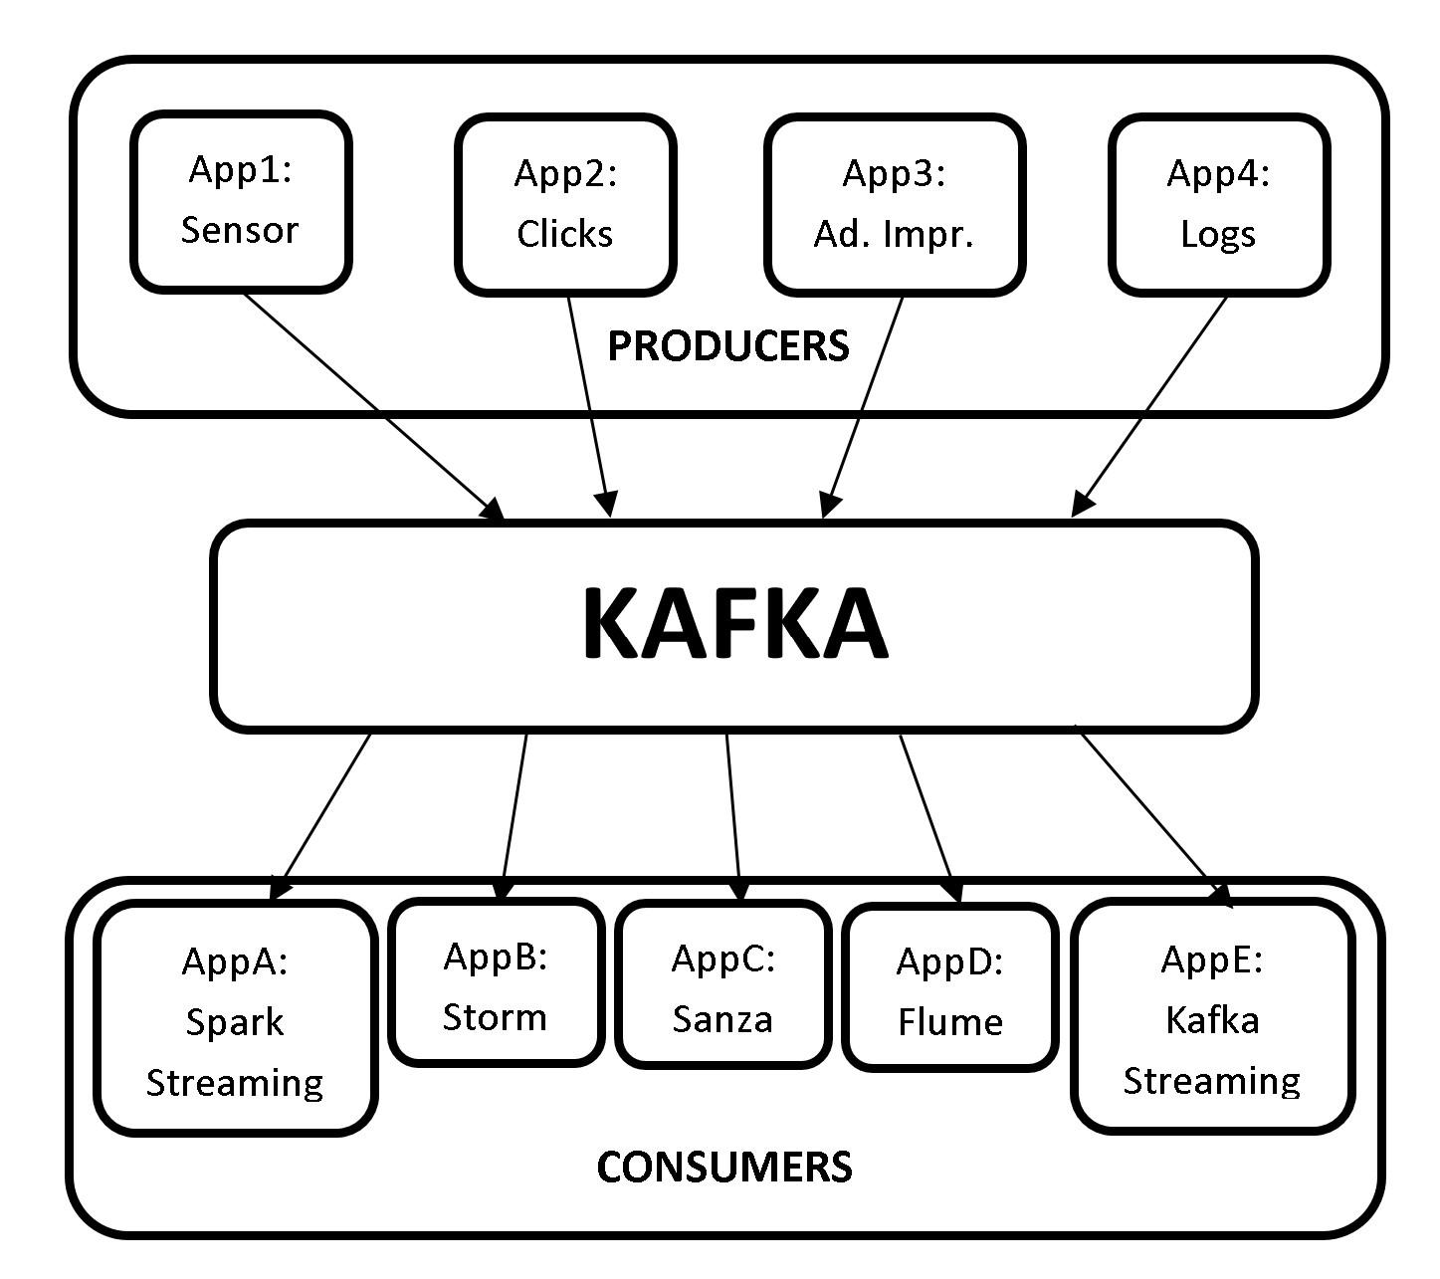

***1(e) Kafka Message Queue***

As seen from the picture above, we need not build interfaces and test them to transfer data every time a new application is implemented. All the producers generate the data to Kafka and the consumers pull the data from Kafka, making it a central repository.

**Confluent Overview**

Confluent is a data streaming platform based on Apache Kafka, and is founded by the creators of Apache Kafka. Confluent expands the capabilities of Apache Kafka not only to Publish-Subscribe messages, but also to a full-scale event streaming platform that enables to store and process real-time streams. Confluent Data Streaming Platform consists of Apache Kafka as core component.

Confluent data streaming platform provides the following components, making it a complete distribution of Apache Kafka.

* **Apache Kafka:** Apache Kafka is the core component of Confluent Platform. Apache Kafka is an open-source, distributed, persistent and fault-tolerant message streaming platform or a central repository, which can handle high volume (trillions) of Publish-Subscribe messages every day.

However, Apache Kafka is not a complete data streaming platform. It only provides data storage and interfaces for reading and writing data. It does not directly integrate with other services such as RDBMS. With Confluent’s other components, the capabilities of Kafka can be extended such that it can integrate with other services.

* **Kafka Connect:** Kafka Connect is used to transfer data to and from Kafka. HDFS, JDBC, S3, Elasticsearch, etc. are some of Kafka connectors that transfer data to and from Kafka.
* **Kafka REST Proxy:** The Kafka REST proxy provides a RESTful interface to a Kafka cluster. The Kafka REST proxy can be used to send and receive messages, view the state of the cluster and perform administrative actions.
* **Kafka Streams:** Kafka Streams is a powerful yet easy to use client library for stream processing and analysis. With Kafka Streams processing layer, we can perform transformations or analysis by reading the real-time data and write the results back to Kafka.
* **Schema Registry:** Schema Registry is a serving layer for metadata. Schema Registry provides a RESTful interface for storing and retrieving AVRO schemas. It makes sure that the data which is being sent and received is in a common format i.e., checking schema compatibility for Kafka. We shall look at this in detail in the upcoming chapters.
* **KSQL:** KSQL is a streaming SQL engine for Kafka to run queries on data stored in Kafka cluster. KSQL is used internally on Kafka streams for processing.

We shall be only be focusing at Apache Kafka throughout this book. However, let us look at a use case to better understand how all these components are integrated to form an end-to-end pipeline using Confluent Data Streaming platform.

**Kafka Use Case**

Let us now look at a Fraud Detection use case at high level, to better understand how all the components of Confluent can be integrated to form an end-to-end pipeline. We shall be looking at an use case of fraud detection in credit card transactions.

The usage of credit cards has been on the rise from the past few decades, and so are the frauds revolving around cards. People make transactions using credit cards round the clock. This transaction data can be analysed to prevent fraud in real-time and minimize monetary loss.

1. Let’s consider that all the credit card transactions are recorded in a web application.
2. These transactions are then transferred to Kafka message queue using the REST proxy server. The REST proxy server provides an interface to Kafka.
3. The transactions are then pulled from Kafka by Kafka Streaming or Spark Streaming to apply transformations or analysis. *Please note that Spark Streaming is generally used to process real-time messages similar to credit card transactions, since we feed the processed data to a Machine Learning model.*

After processing the streams, the data is internally fed to a Spark Machine Learning model to predict if the transaction is a fraud or not. Confluent Kafka does not provide Machine Learning module and hence Spark MLlib will be used for predictions.

1. The unpredicted raw data from Spark Streaming is also saved to Cassandra for further processing, if required.

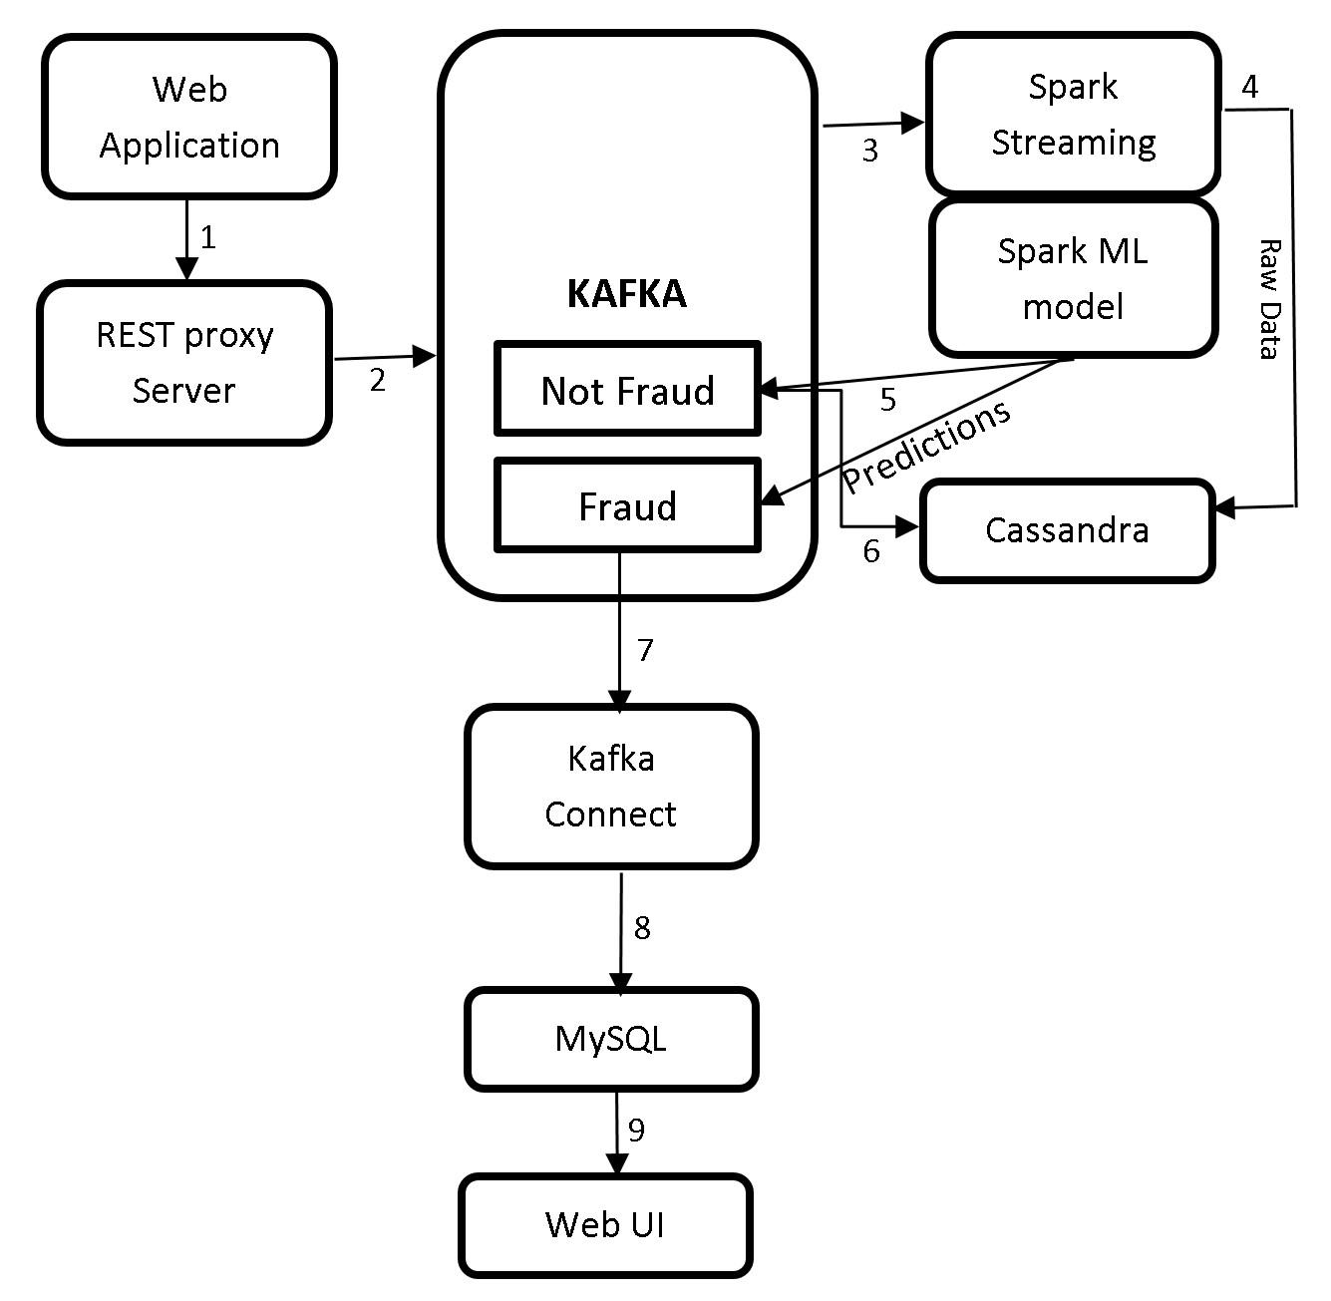

***1(f) Kafka Use Case***

1. There will be two outcomes for this predictions i.e., genuine transactions and potential fraud transactions. This data is sent to Kafka.
2. Usually there will be more genuine or non-fraud transactions than the fraud transactions. Hence, all the genuine transactions are sent to a NoSQL database such as Cassandra.
3. The potential fraud transactions are then transferred to a RDBMS database such as MySQL using Kafka Connect.
4. These records can then be pulled from MySQL and displayed on webUI.
5. The domain experts can then take necessary actions to determine if these predicted potential fraud transactions are actually fraud. If it is determined that a transaction is fraud, the card issuer can block or hold the card from making transactions to prevent further loss.

This is how the Confluent Kafka components can be used to build an end-to-end pipeline.

Before we wrap up this chapter let us see what is ZooKeeper and why does Kafka need ZooKeeper.

**Introduction to ZooKeeper**

**What is ZooKeeper?**

ZooKeeper is an open source, robust distributed coordination service for distributed applications. ZooKeeper is an open source Apache Software Foundation project, it’s available for free and ready to use. ZooKeeper helps in overcoming many of the common challenges faced by distributed applications. ZooKeeper can be used for synchronization, sequential consistency and coordination between distributed applications. It helps in maintaining the configuration information which can be shared to all the nodes in a distributed system. ZooKeeper also helps in group services such as leader election and many more. ZooKeeper is reliable and fast yet very simple to work with. With ZooKeeper you can build reliable, distributed data structures for group membership, leader election, coordinated workflow, and configuration services. You can also build generalized distributed data structures like locks, queues, barriers, and latches.

ZooKeeper provides an eventually consistent view of its *znodes* which are nothing but files or directories in a file system. It provides basic CRUD operations such as creating, updating, and deleting *znodes*. It provides an event-driven model in which clients can watch for changes to specific znodes, for example if a new child is added to an existing *znode*. ZooKeeper is a high availability service as it consists of a set of ZooKeeper servers known as *Ensemble* (cluster), with each of the server holding an in-memory image of the distributed file system to serve client read requests. Each server also holds a persistent copy on disk.

One of the servers in the *Ensemble* is dynamically chosen by consensus as the leader, and all other servers are followers. The leader is responsible for all writes and for updating the changes to its followers. When the majority of followers update a change successfully, the write succeeds and the data is still available even if the leader fails. When a leader fails, a new leader is again dynamically chosen by consensus within the *Ensemble*. This eliminates the single point of failure scenario, and the *Ensemble* keeps on doing its work as it should.

When a client connects to ZooKeeper, it is provided with the list of servers in the *Ensemble*. The client connects to one of the servers in the ensemble at random until a connection is established. Once connected, ZooKeeper creates a session with a pre-specified timeout period by client. The ZooKeeper client automatically sends heartbeats periodically to keep the session alive if no operations are performed for a while, and automatically handles failover. If the connection between ZooKeeper and client fails, the client automatically detects this and retries to connect to a different server in the *Ensemble*. After it is reconnected, the same client session is retained while the failure has occurred.

**ZooKeeper Data Consistency**

ZooKeeper provides with the following guaranteed consistencies:

**Sequential consistency:** Updates from a client to the ZooKeeper service are applied in the order they are sent. Since all writes go through the leader, the global order is simply the order in which the leader receives write requests.

**Single System Image:** The Single System Image guarantees that a client will see the same view of the ZooKeeper service regardless of the server in the ensemble that it is connected to.

**Atomicity:** There are no partial failures. The updates from a client to ZooKeeper service either succeed or fail. For example, assume a client sends an update to a server, but before the response is received the network connection is lost or the server goes down. Now, did the update get through to the server? If yes, did the operation complete successfully? The only way to know the answers to all these questions is when the server/network is back up again. ZooKeeper though cannot help with network problems or partial failures, but it handles through atomicity. If the network/server goes down during an update operation, the operation is marked failed, else it is marked as success.

**Reliability:** If the update is successful, it is persistent and will not be rolled back. The update will only be overwritten when client makes a new update. The updates are still available even when the server fails.

**Consistent Client View:** A client’s view of the system is guaranteed to be up-to-date within a certain time bound, generally within tens of seconds. If a client does not observe system changes within that time bound, then the client assumes a service outage and will connect to a different server in the *Ensemble*.

**ZooKeeper Architecture**

The ZooKeeper architecture consists of leader and follower servers. The collection of these servers is known as *Ensemble.* The number of servers in a ZooKeeper Ensemble should always be an odd number. The reason behind this is because we need majority during the voting process of electing a leader. Let us now look at the responsibilities of leader and follower servers.

* **Leader**: When an *Ensemble* is first started, voting process to choose a leader takes place. During the voting process a leader is elected and the process is complete as soon as a simple majority of followers have synchronized their state with the leader. After leader election is complete, leader is responsible to handle all the write requests from clients, and changes are committed to all followers. Once a majority of followers have persisted the change, the leader commits the change and notifies the client of a successful update. There should always be a leader. If leader is down, all the existing followers go through the voting and elect a new leader.
* **Followers**: Followers function is similar to that of the leader by allowing clients to connect them and send, read, and write requests to them, but the writes are forwarded to leader.
* **Observers:** Observers are the non-voting members of an *Ensemble* which do not participate in the voting process, but only hear the voting results*.* When there are more followers who participate in voting, the write performance significantly drops, and hence Observers are added to *Ensemble* as to address this issue. Observers improve ZooKeeper’s scalability, and we can increase the number of Observers as much as we like without harming the performance of votes. Observers function is exactly the same as Followers, where clients connect to them and send, read, and write requests to them. Observers forward these requests to the Leader like Followers do, but they then simply wait to hear the result of the vote.

**Why does Kafka need ZooKeeper?**

Kafka cannot be started without ZooKeeper. We must first start ZooKeeper service before we start Kafka. The ZooKeeper service will be running on a separate server and not on the servers running Kafka Brokers. Based on the explanation of Zookeeper in the sections above, Kafka needs ZooKeeper for the following.

* **Electing a Controller:** Kafka consists of brokers to handle requests such as sending and receiving messages. The broker acts as a mediator for both producers and consumers to handle the requests. A broker is a Kafka server. Multiple brokers form a Kafka cluster. Since a Kafka cluster has multiple brokers, we need to elect a leader among these brokers to maintain the cluster state. The broker which we elect as a leader is called controller and is responsible to maintain the leader-follower relationships. In case of a failure of a broker, the controller’s responsibility is to tell all the replicas to act as partition leaders, in order to fulfill the duties of the partition leaders on the broker that is about to fail. ZooKeeper is used to elect this controller. ZooKeeper also makes sure there is only one leader, and also elects a new leader in case of failure.
* **High Availability:** ZooKeeper keeps tracks of membership of all the brokers, and periodically checks if any of the brokers that are part of the cluster have failed. It maintains High availability of Controller Broker.
* **Topic Configuration:** ZooKeeper makes track of existing topics, partitions for each topic, replica locations, preferred leader and configuration override information for each topic.
* **Access Control Lists:** ZooKeeper maintains Access Control Lists for each topic, i.e., the read and write permissions of clients.

Do not worry if you do not understand the new concepts at this time. We shall look at brokers, replications, partitions, topics etc. in detail in the next chapter. It will be clear why we need ZooKeeper once we understand the architecture of Kafka in detail.

That’s all for the theory for this chapter.

**LAB EXERCISE**

"There are no activities required for this lab"

**SUMMARY**

Kafka is an open-source, distributed, persistent and fault-tolerant message streaming platform or a central repository, which can handle high volume (trillions) of Publish-Subscribe messages every day. Publish-Subscribe messaging system is a system where data is produced (Publish) by producers and consumers consume (subscribe) the data.

Kafka is written in Scala and is built on top of the ZooKeeper coordination service. The integration of Spark and Kafka enables real-time streaming data analysis. Kafka was built at LinkedIn and later donated to the Apache Software Foundation, making it open-source.

ZooKeeper is an open source, robust distributed coordination service for distributed applications. ZooKeeper is an open source Apache Software Foundation project, is available for free and ready to use. ZooKeeper helps in overcoming many of the common challenges faced by distributed applications. ZooKeeper can be used for synchronization, sequential consistency and coordination between distributed applications. It helps in maintaining the configuration information which can be shared to all the nodes in a distributed system.

**CHAPTER 2: THE KAFKA FRAMEWORK**

**Theory**

In the previous chapter, we have looked at an overview of BigData with brief introduction to Apache Hadoop and Apache Spark frameworks. We have also had a comprehensive introduction of Apache Kafka and Apache ZooKeeper. Let us now deep dive and learn more about Apache Kafka. Let us first look at the architecture, APIs and CLI of Apache Kafka and then proceed to the labs to and install Apache ZooKeeper and Apache Kafka on to our machines.

**Kafka Architecture**

We have looked at an use case of Kafka in the previous chapter, which shows a high level representation of Kafka architecture. Let us now look at the Hive architecture in detail.

The Kafka architecture is as shown in the picture below.

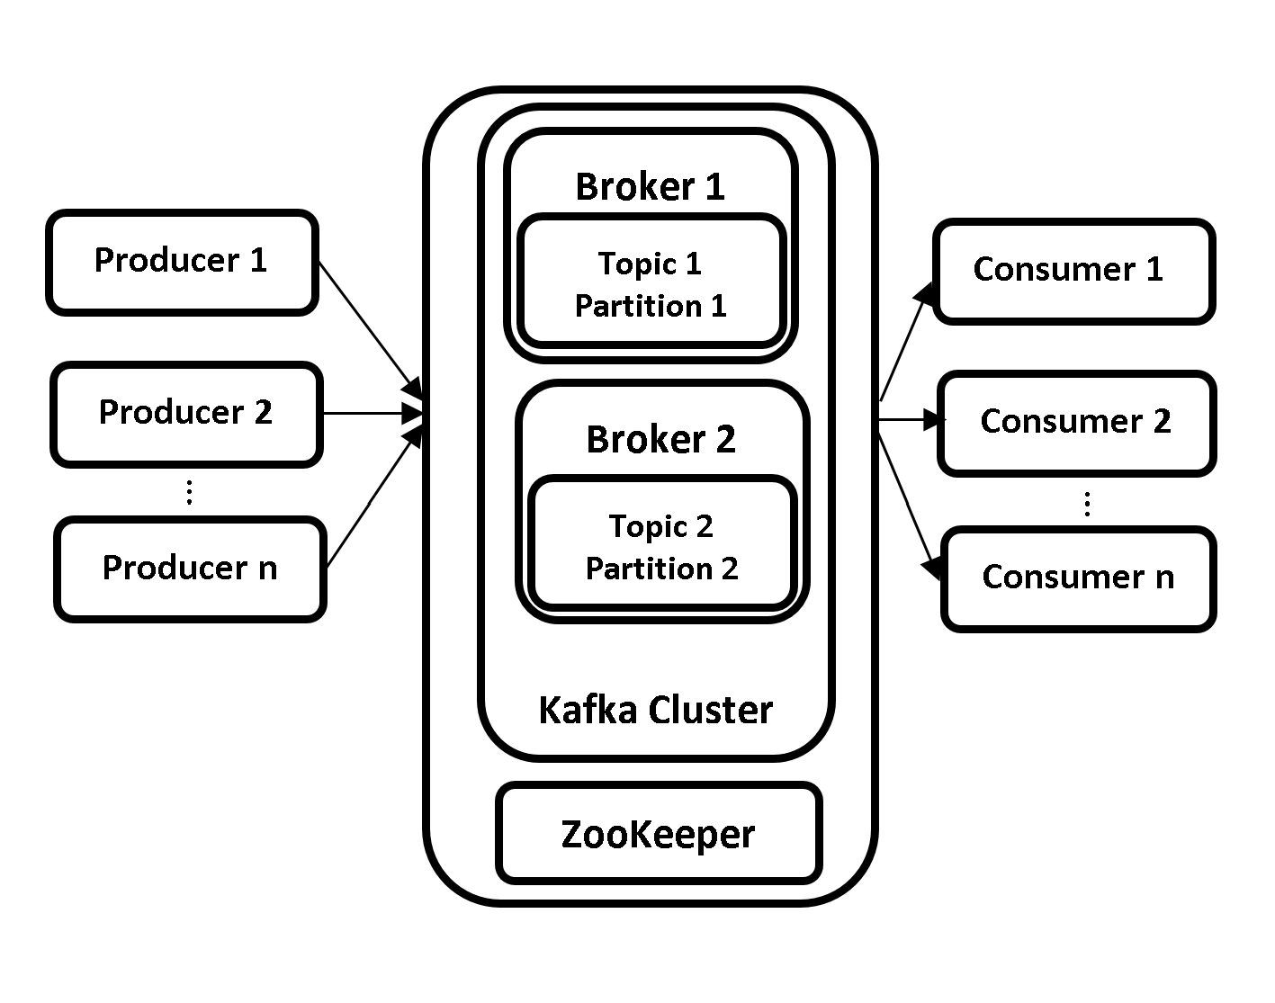

***2(a) Kafka Architecture***

The Kafka architecture consists of the following components.

* Brokers
* Producers
* Consumers
* Topics
* Partitions
* Replications
* ZooKeeper

Let us now look at overview of each of the component.

Topics

Kafka is capable of streaming messages from multiple sources. A topic is a name given to each source in order to distinguish and store the incoming messages. Topics are used to group similar messages together. Producers write messages to Topics and Consumers read data from Topics with the help of Brokers. A new directory is created with the name of the topic’s partition whenever a new topic is created. A leader broker is responsible for all the read and write operations for that partition.

Partitions

Kafka Topics are further divided into Partitions to achieve scalability. A Topic can have multiple Partitions. A Partition is a log where the messages are appended as received. The messages are distributed across multiple Brokers with the help of Partitions, thus making Kafka a distributed message queue. This allows multiple Consumers to read data from a topic in parallel.

Producers

Producers are the Kafka clients which create and send new messages to the Brokers. Producers create messages for one or more than one Kafka Topics. Producers are the source of data for Kafka Cluster. There can be multiple producers in a Kafka cluster. Each message (Partition) produced contains an offset. Offset is the integer metadata associated with each message (Partition) which increase for each message that is produced by the Producer.

Consumers

Consumers are the Kafka clients which read data from Brokers. There can be multiple consumers in a Kafka cluster. Consumers read the data from Topics to which they are subscribed to. The data is read in the order of which it was produced. The Consumers know which messages have already been consumed with the help of Offsets. Partitions have a unique offset for each message. Consumer simply stores the last offset it consumed in ZooKeeper or Kafka. This will help Consumer to restart consuming the messages exactly from where it stopped.

Brokers

Kafka cluster consists of daemons known as Brokers. A Kafka cluster consists of one or more Brokers. Brokers are the most important components and work horses of a Kafka Cluster and, without Brokers there is no Kafka. As the name suggests, Brokers act as middlemen between the Producers and Consumers. Brokers receive messages from Producers, assign them with offsets and store them on disk into Kafka Topics. Similarly, it responds to Consumers’ data pull requests from Kafka Topics.

In the production environment, there should be only one Broker per node in the Kafka cluster. However, there can be multiple brokers on a single node in the testing environment. The Brokers are further classified as Leader Broker and Controller Broker.

#### ***Controller Broker***

A Controller Broker is one of the Broker that is available in the pool of Brokers in a Kafka cluster. A Controller Broker is elected with the help of ZooKeeper as soon as the Brokers in Kafka cluster are started and, is considered as Master Broker. A Controller Broker is similar to any other Broker in the Kafka Custer but with extra responsibilities. There is only one active Controller Broker at all times.

The Controller Broker is responsible for assigning partitions to brokers, monitoring Brokers for failures and rebalancing partitions to other brokers in the event of failure. The Controller Broker is also responsible for the duties like any other Broker in the cluster, i.e., leading partitions, performing reads/writes and having partition replications.

#### ***Leader Broker***

Each Partition in a Kafka cluster has one Broker which acts as a Leader Broker. If the partition is created with a replication factor of more than one, the partitions are replicated to the Follower Brokers. Leader Broker manages the read/write requests for the partitions from Producers and Consumers and, the Follower Brokers simply replicate the partitions in Leader Broker. In case of failure of a Leader Broker, another Broker having the replications will take over the leadership making it redundant.

Replications

The partitions are replicated across the Kafka cluster to achieve high availability. This is to ensure that the data is not lost in case of a Broker failure in Kafka cluster. The replications are of two types. Leader and Follower Replicas. The messages transmitted from leader broker are leader replicas and the follower replicas are for fault tolerance in case of data loss available in follower brokers.

ZooKeeper

As learned in the previous chapter, ZooKeeper provides coordination service for Kafka cluster. Please check Why does Kafka need ZooKeeper? for more information.

We shall look at internals of all these concepts in detail in the upcoming chapters.

That’s all for the theory for this chapter. Let us move to the lab exercise to install ZooKeeper and Kafka into our machines.

**AIM**

The aim of the following lab exercises is to install and configure ZooKeeper and Kafka.

The labs for this chapter include the following exercises.

* Downloading and Installing JDK
* Downloading and Installing ZooKeeper
* Configuring ZooKeeper
* Downloading and Installing Kafka
* Configuring Kafka
* Starting ZooKeeper and Kafka

We need the following packages to perform the lab exercise:

* Java Development Kit
* Apache ZooKeeper
* Apache Kafka

We will be using Ubuntu 18.04 LTS operating system with at least 4GB of RAM throughout the book for all our exercises. Please make sure you install this version of OS before proceeding with Kafka installation.

**LAB EXERCISE 1: KAFKA INSTALLATION**

1. **Download and install JDK**
2. **Download and install ZooKeeper**
3. **Configure ZooKeeper**
4. **Download and install Kafka**
5. **Configure Kafka**
6. **Start ZooKeeper and Kafka**

**Task 1: Download and Install JDK**

**Step 1:** From the terminal, run the following commands to install JDK (Java Development Kit).

$ sudo apt-get update

This will update the package index. You might be asked to enter your password after you run the command above.

**Step 2:** Once you run the above command, run the following command to actually download and install JDK.

$ sudo apt-get install default-jdk

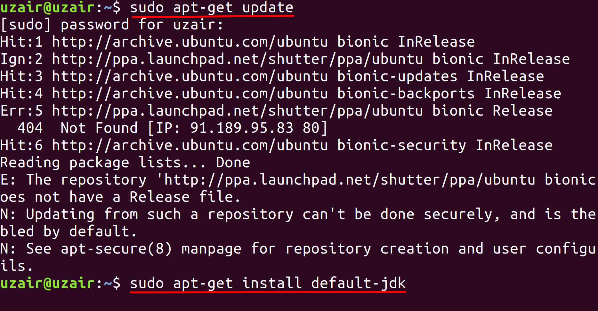

The prompt will ask you to hit ‘Y’ after running the above command as shown in the screenshot. Hit ‘Y’ from your keyboard to continue with the installation and finally hit the Enter key. This will download and install JDK on your machine.

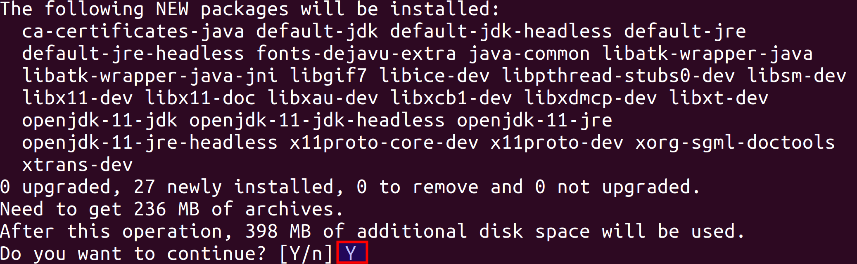

The installation process might take some time depending on your internet connection. Please allow it to download and install completely. You should see the following message when the installation is complete.

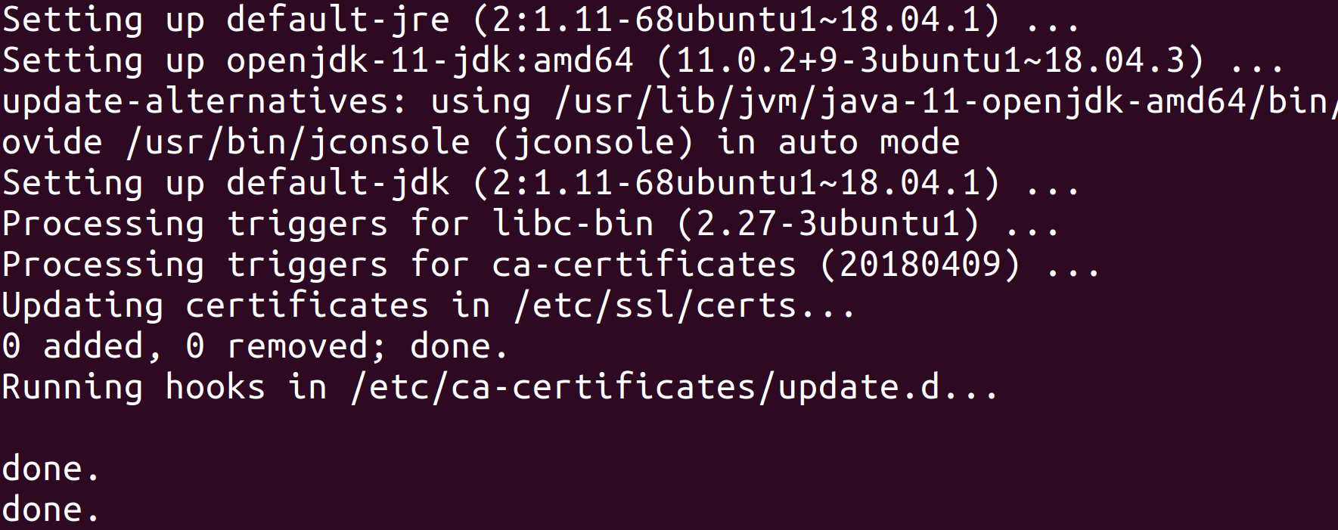

**Step 3:** Run the following command to check if Java has been installed successfully. The terminal should show the Java version as shown in the screenshot.

$ java –version

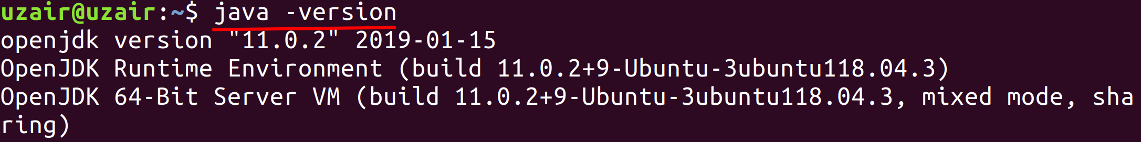

Please note that your version of JDK might be latest version from what you see in the screenshot.

**Task 1 is complete!**

**Task 2: Download and Install ZooKeeper**

**Step 1:** Let us ZooKeeper in standalone mode. Navigate to the download URL below and click to download the latest stable version for ZooKeeper (which is ZooKeeper 3.6.1 at the time of writing this book).

Download URL : <https://zookeeper.apache.org/releases.html>

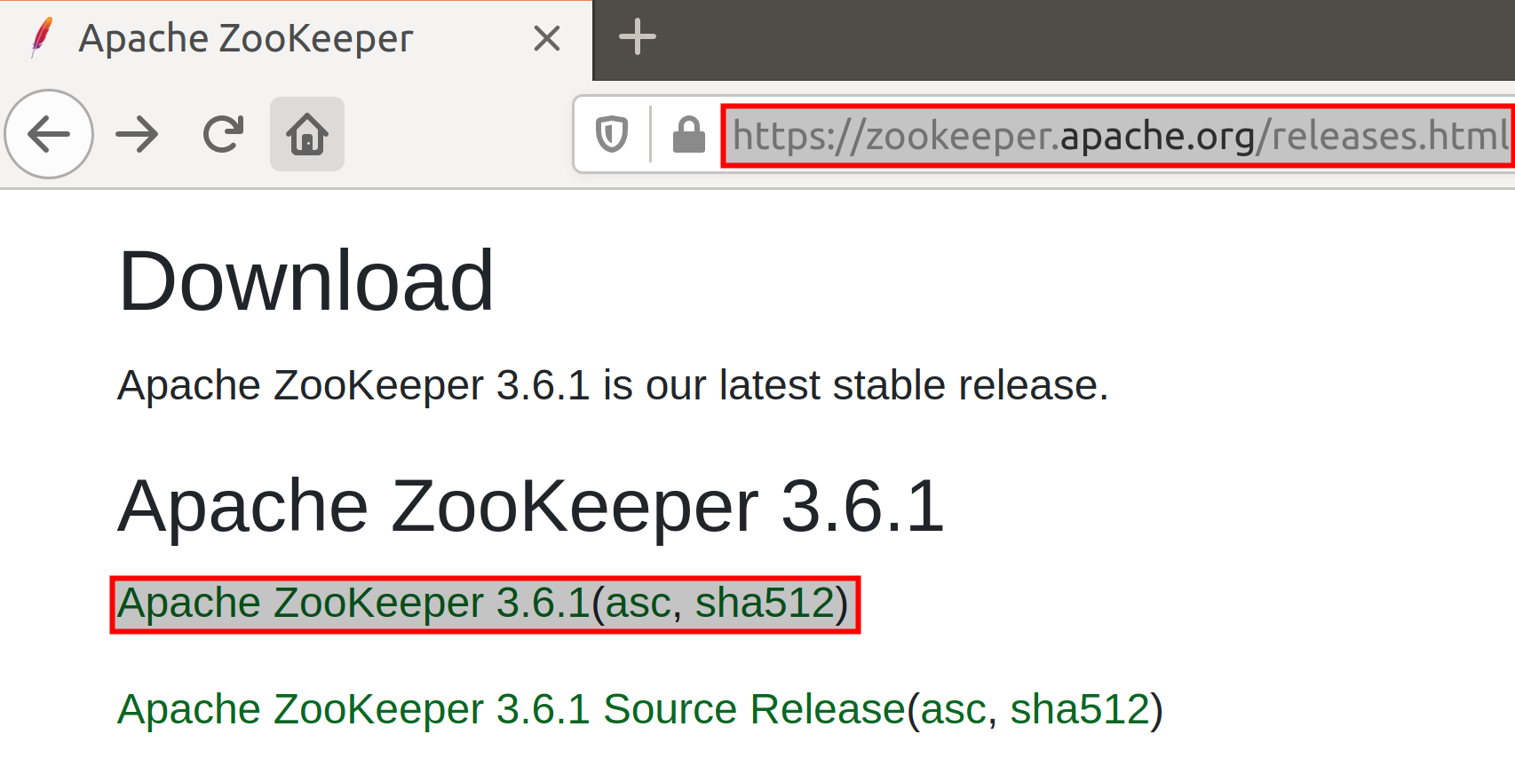

After clicking the download link, you will be taken to a page with mirror site to download ZooKeeper. Click the mirror link as shown below and your download should start. The download may take a while depending upon your internet connection.

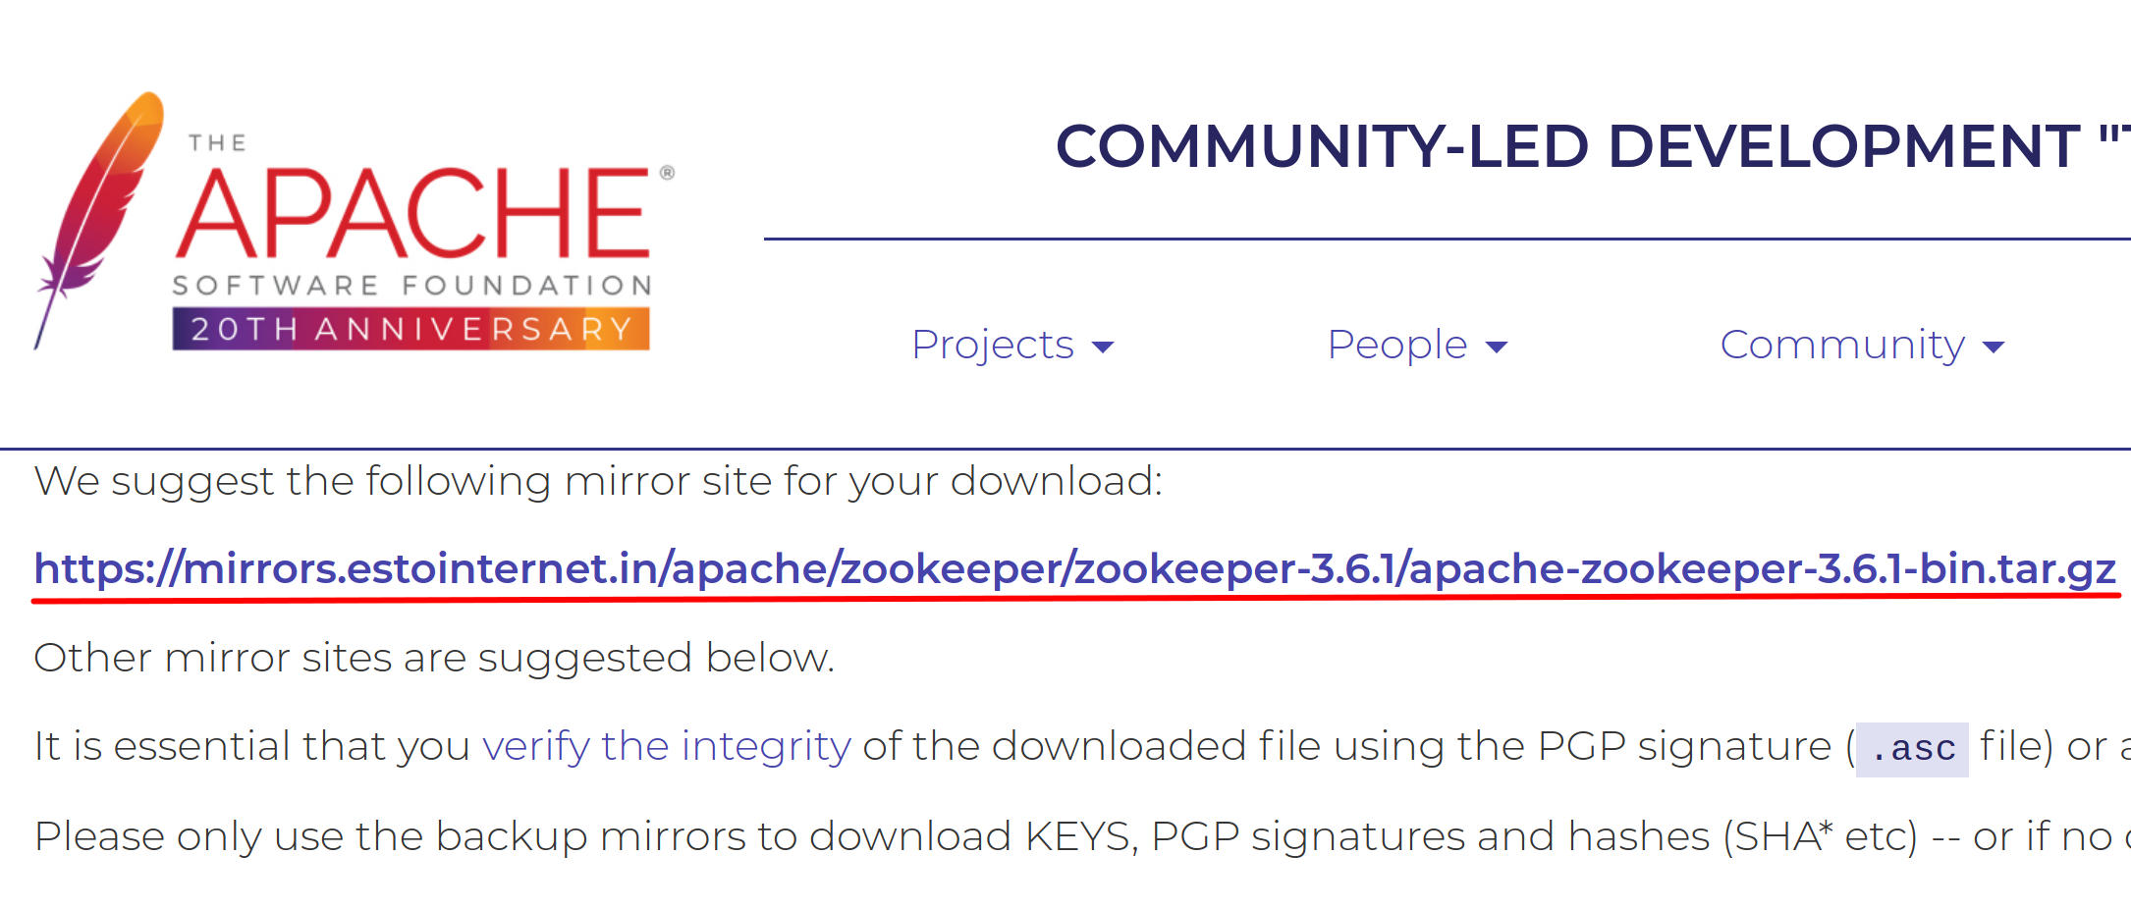

**Step 2:** The download will be saved to the *Downloads* directory by default. Execute the following command from your terminal to change the directory to *Downloads* folder.

$ cd Downloads

Once you are in the *Downloads* directory, you may optionally check if ZooKeeper has been downloaded using the *ls* command.

$ ls

Now that you are sure that you have the ZooKeeper tar file, untar the ZooKeeper tar file to */usr/share* directory using the command below.

$ sudo tar –xvf apache-zookeeper-3.6.1-bin.tar.gz –C /usr/share

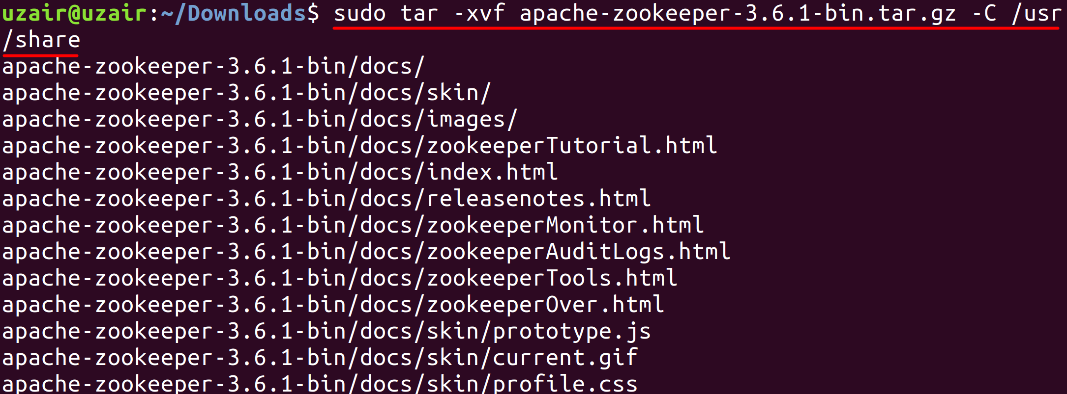

The file will start to untar to */usr/share* directory as shown in the screenshot above. You can verify the same by executing the following command below.

$ cd /usr/share

$ ls

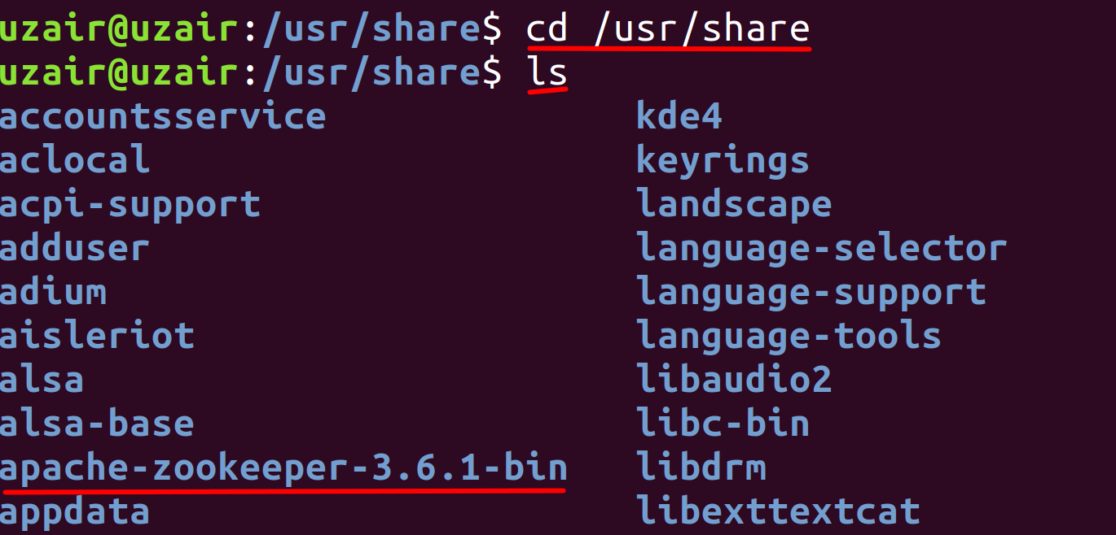

As we can see from the screenshot above, the ZooKeeper directory is listed.

**Step 3:** Let us make a softlink to the ZooKeeper directory so that we don’t have to refer ZooKeeper with entire name as above. This will also be useful for the future updates. Execute the following command.

$ sudo ln –s apache-zookeeper-3.6.1-bin zookeeper

Run the following command again to check if we were able to create the softlink successfully.

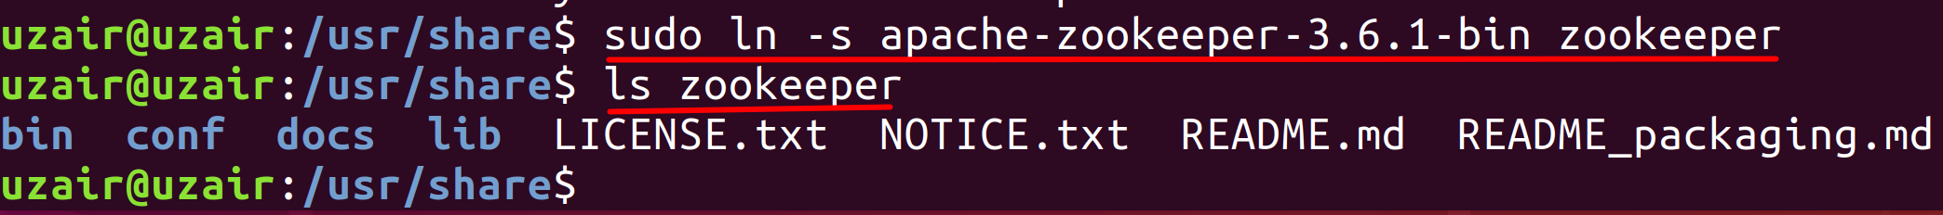

**Step 4**: Let us conclude the installation process by creating a directory where ZooKeeper will store its data.

$ sudo mkdir zookeeper/data

$ ls zookeeper

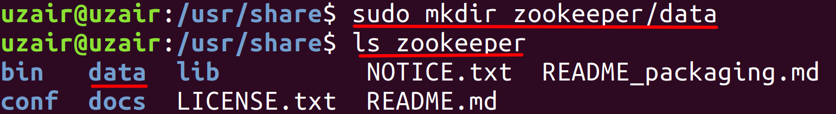

**Step 5:** Change the permissions of the ZooKeeper directory by running the following command:

$ sudo chown <username> /usr/share/zookeeper

<username> - Insert your username.

This completes the installation of ZooKeeper. Let us now proceed to next task to configure ZooKeeper.

**Task 2 is complete!**

**Task 3: Configure ZooKeeper**

**Step 1:**Let us now set up the environment variables for ZooKeeper. Execute the following command to do so.

$ sudo vi ~/.bashrc



The file should open as shown below.

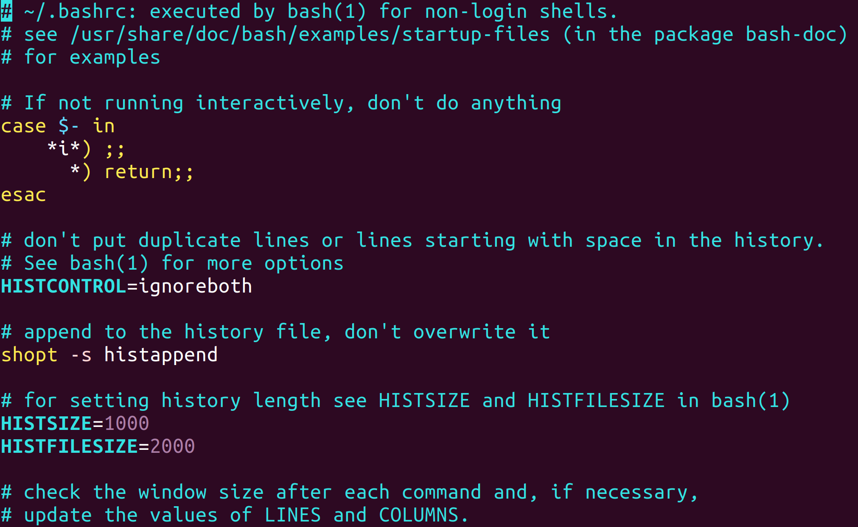

Now press *i* key to edit the file and append the following environment variable at the end of the file.

ZOOKEEPER_HOME=/usr/share/zookeeper

Export PATH=$ZOOKEEPER_HOME/bin:$PATH

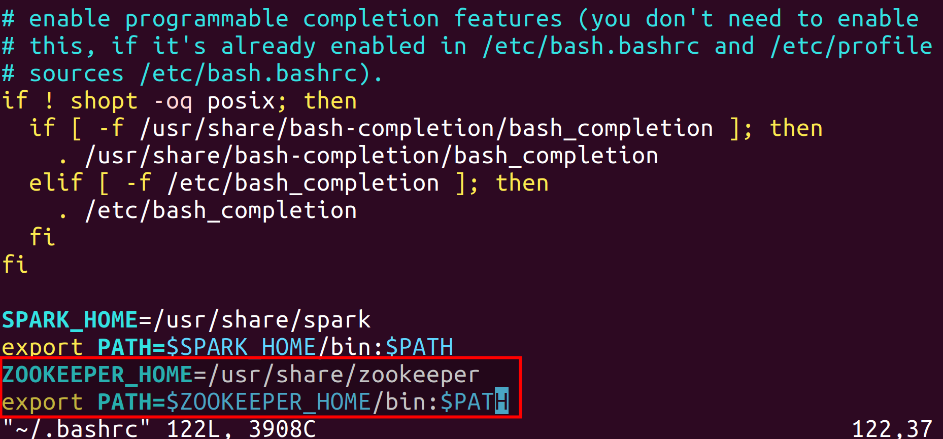

After you have finished appending the text above, hit the *Esc* on your keyboard to stop editing and then press *Shift - Z - Z* to exit out of the editor by saving the changes. (Please see that you need to press Z twice while holding Shift key.)

Now reload the modified *.bashrc* file using the following command.

$ source ~/.bashrc

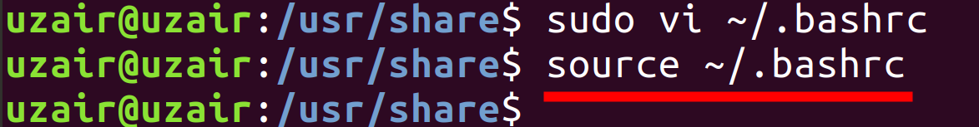

**Step 5:** Finally, let us create a ZooKeeper configuration file to include the data directory we created in the previous task along with other information. To create the configuration file run the following command from the command line interface.

$ sudo vi zookeeper/conf/zoo.cfg

Enter the following settings in the file and save it.

tickTime=2000

dataDir=/usr/share/zookeeper/data

clientPort=2181

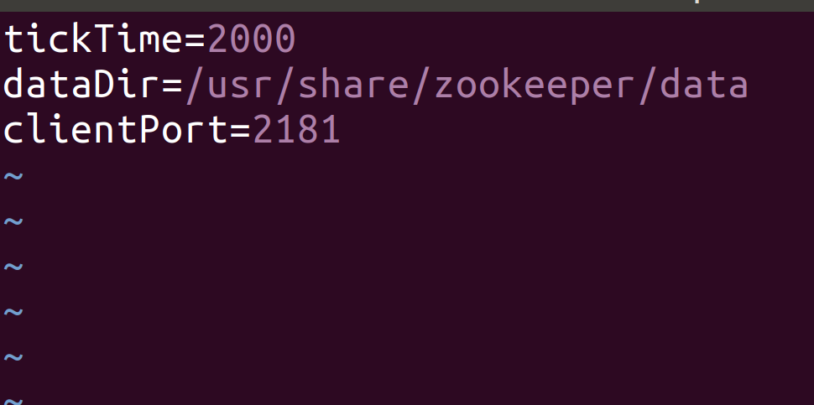

The above settings are enough for configuring ZooKeeper in standalone mode.

However, If you wish to install ZooKeeper in replicated mode, please enter the following settings in the configuration file and make sure you have the same settings in all the servers in ZooKeeper Ensemble.

tickTime=2000

dataDir=/usr/local/zookeeper-3.4.6/data

clientPort=2181

initLimit=5

syncLimit=2

server.1=<server_name>:2888:3888

server.2=<server_name>:2888:3888

server.3=<server_name>:2888:3888

.

.

.

**tickTime**: The basic time unit in milliseconds used by Zookeeper. It is used to do heartbeats and the minimum session timeout will be twice the *tickTime*.

**dataDir:** The location to store the in-memory database snapshots and, unless specified otherwise, the transaction log of updates to the database.

**clientPort**: The port to listen for client connections.

**initLimit:** It is the total amount of time allowed forthe quorum members (followers) to connect to and sync with the leader. If most of the quorum members fail to sync with the leader during this period, the leader powers are revoked and a new election for leader takes place.

**syncLimit:** It is the total amount of time allowed for the quorum members to sync with the leader. If the quorum member fails to sync during this period, it will restart itself. Clients will be routed to other quorum members if they were connected to this quorum member.

Next we specify the servers in ensemble each per line with a server number. There are two port settings. First port is used by followers to connect to the leader and the second is used for leader election. There are 3 port numbers to which servers listen on. The description is as follows.

2181: Port for client connections.

2888: Used by followers to connect to the leader.

3888: Used for leader election.

Additional to these settings, you will also have to create a file called *myid* in the data directory which contains a numeric identifier for each ZooKeeper server in the Ensemble. The range for that numeric identifier is 1 to 255. This denotes the server number set in the configuration file above. If you are creating the *myid* file in server.1 just enter 1 in the *myid* file and save it. Similarly, if you are creating the *myid* file in server.2 just enter 2 in the *myid* file and so on.

$ sudo vi zookeeper/data/myid

Enter the numeric identifier ranging from 1 to 255 in the file depending upon the server configuration file.

As soon as we start the server, it reads the *myid* file and determines which server it is based on the numeric identifier. Then it reads the configuration file for all the information regarding the ports and network addresses of other servers within the Ensemble.

**Step 6:** Change the ownership of the files zoo.cfg and myid (replicated mode), by running the following command.

$ sudo chown <username> zookeeper/conf/zookeeper.cfg

$ sudo chown <username> zookeeper/data/myid

***Run the above command only if you are installing ZooKeeper in replicated mode.***

This completes the installation of ZooKeeper.

**Task 3 is complete!**

**Task 4: Download and Install Kafka**

Now that we have ZooKeeper installed and configured, let us move ahead and install Kafka.

**Step 1:** Let us Kafka in standalone mode. Navigate to the download URL below and click to download the latest stable version for Kafka (which is Kafka 2.12-2.5.0 at the time of writing this book).

Note: 2.12 is the Scala version and 2.5.0 is Kafka version.

Download URL : <https://kafka.apache.org/downloads>

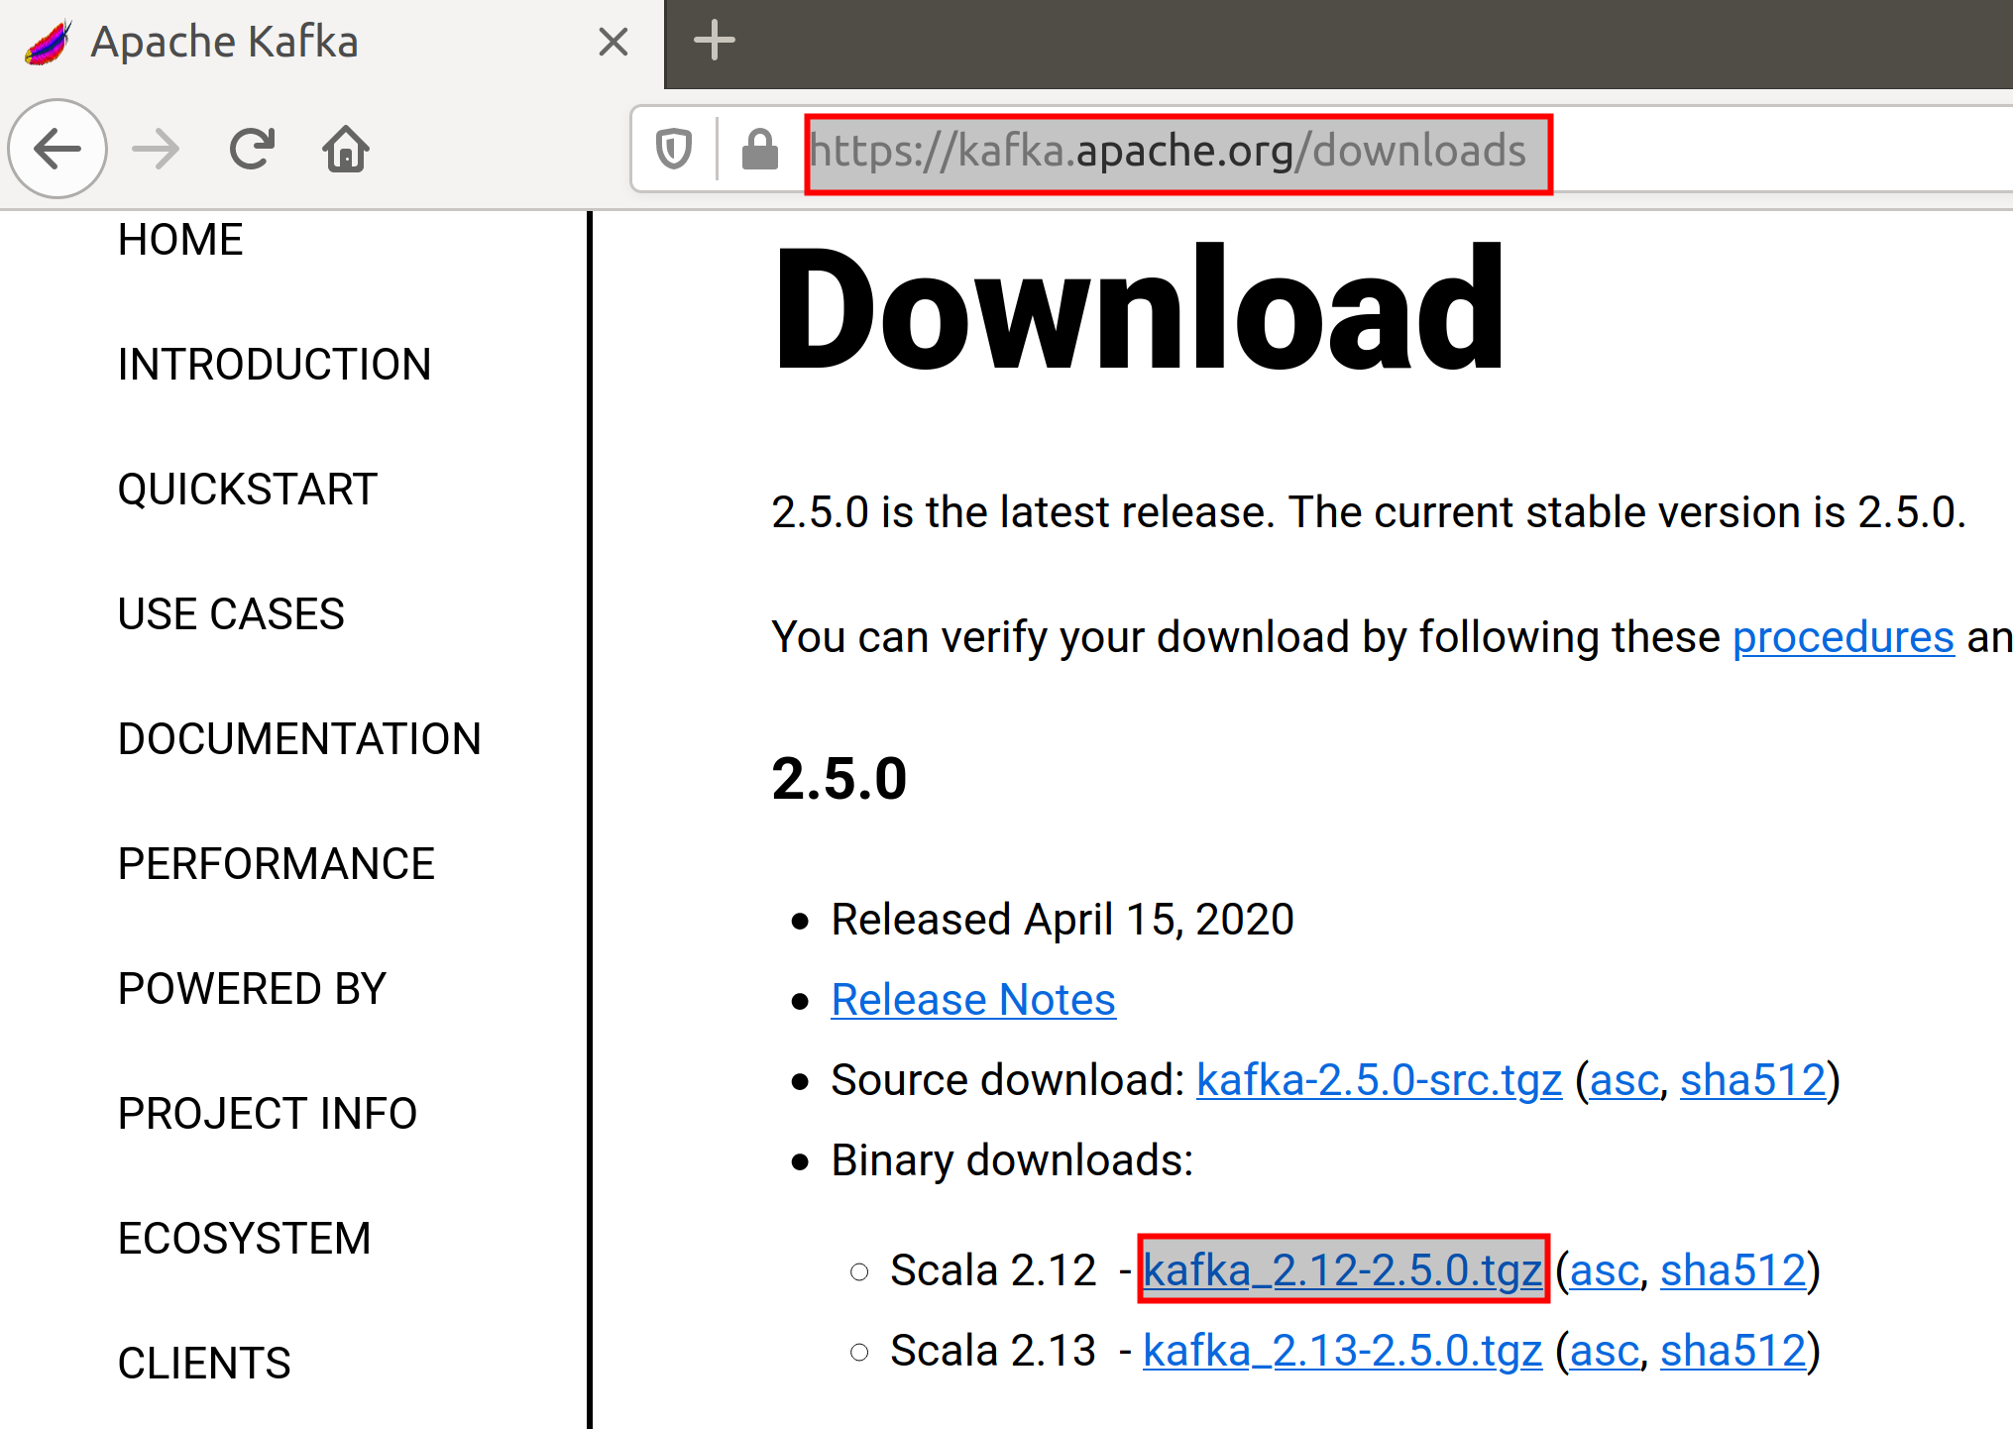

After clicking the download link, you will be taken to a page with mirror site to download Kafka. Click the mirror link as shown below and your download should start. The download may take a while depending upon your internet connection.

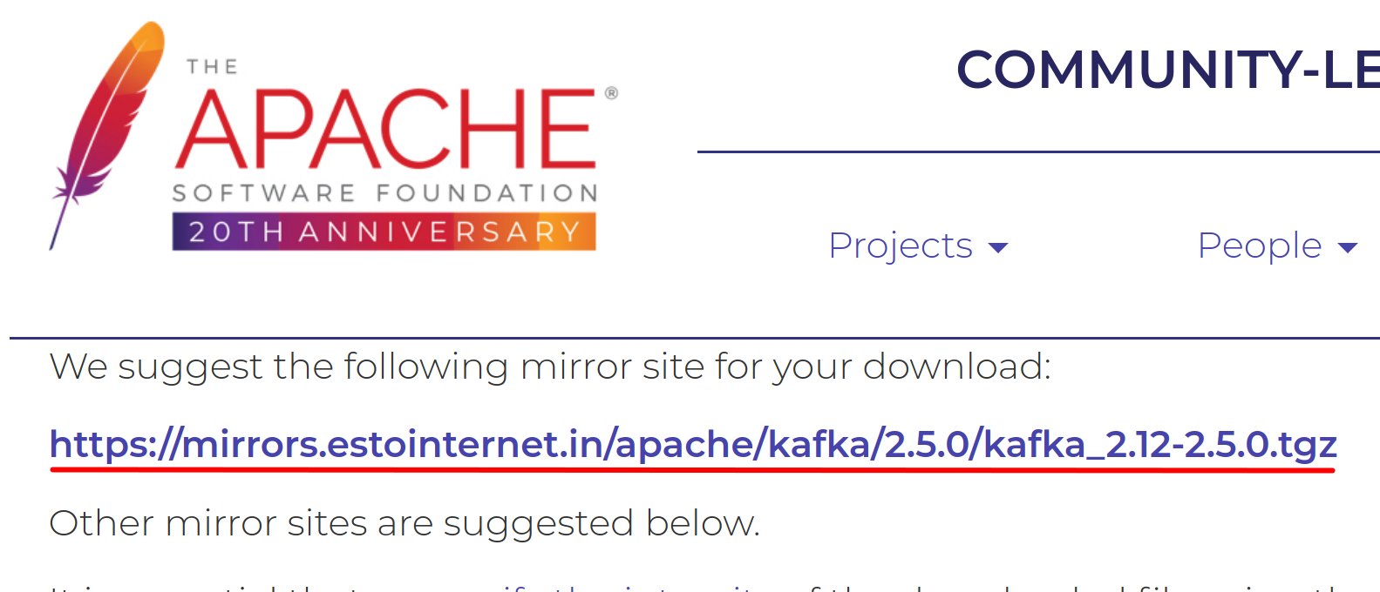

**Step 2:** The download will be saved to the *Downloads* directory by default. Execute the following command from your terminal to change the directory to *Downloads* folder.

$ cd

$ cd Downloads

Once you are in the *Downloads* directory, you may optionally check if Kafka has been downloaded using the *ls* command.

$ ls

Now that you are sure that you have the Kafka tar file, untar the Kafka tar file to */usr/share* directory using the command below.

$ sudo tar –xvf apache-zookeeper-3.6.1-bin.tar.gz –C /usr/share

The file will start to untar to */usr/share* directory as shown in the screenshot below.

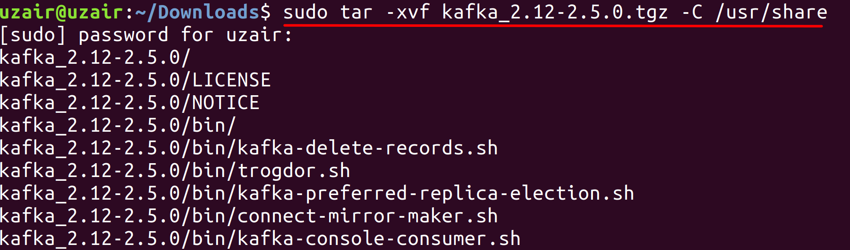

**Step 3:** Let us make a softlink to the Kafka directory so that we don’t have to refer Kafka with entire name as above. This will also be useful for the future updates. Execute the following command.

$ sudo ln –s kafka_2.12-2.50 kafka

Run the ls command again to check if we were able to create the softlink successfully.

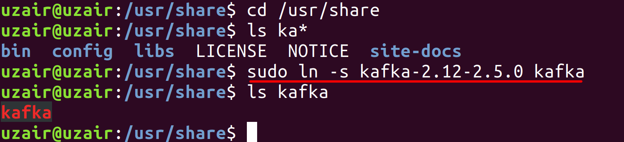

**Step 4:** Change the permissions of the Kafka directory by running the following command:

$ sudo chown <username> /usr/share/kafka

<username> - Insert your username.

**Task 4 is complete!**

**Task 5: Configure Kafka**

**Step 1:**Let us now set up the environment variables for Kafka. Execute the following command to do so.

$ sudo vi ~/.bashrc



The file should open as shown below.



Now press *i* key to edit the file and append the following environment variable at the end of the file.

KAFKA_HOME=/usr/share/kafka

Export PATH=$KAFKA_HOME/bin:$PATH

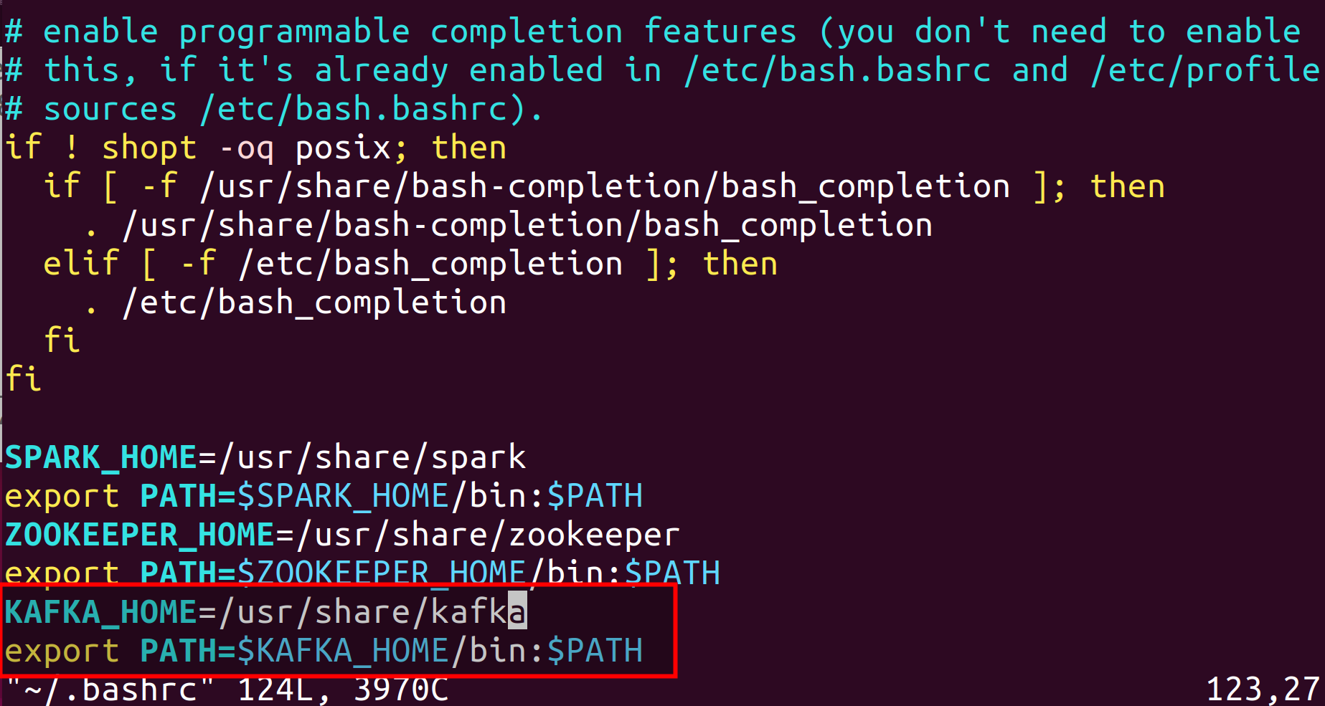

After you have finished appending the text above, hit the *Esc* on your keyboard to stop editing and then press *Shift - Z - Z* to exit out of the editor by saving the changes. (Please see that you need to press Z twice while holding Shift key.)

Now reload the modified *.bashrc* file using the following command.

$ source ~/.bashrc



This completes the installation for Kafka in standalone mode. The configuration file provided with the Kafka installation is sufficient to run Kafka for training purposes. However, when working in a real time environment, these configurations are not sufficient.

Let us now look at few of the configuration options available in Kafka.

**Step 2:** The configuration properties for Kafka are available in the following path.

/usr/share/kafka/config/server.properties

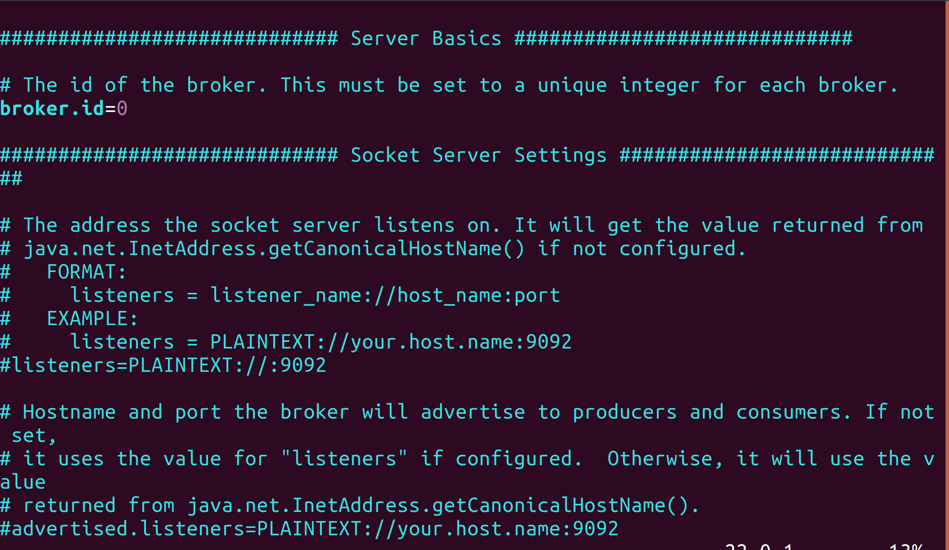

**broker.id:** The broker.id is the configuration property that is used to identify a broker in Kafka cluster. The broker.id must be a unique integer value for every single broker in the Kafka cluster and is set to 0, by default.

**listeners:** The listeners property is used to set the URIs as comma separated values, which the brokers will use to create server sockets. The value consists of hostname and port with the default port being 9092. The port number can be changed to any other available port.

**zookeeper.connect:** This configuration property is used to set the connection string of a ZooKeeper server in *hostname:port* format. Multiple hostnames can be provided separated with a comma. The default value is *localhost:2181* for this property. The hostname could be the hostname or ip address of the ZooKeeper server. Optionally, this property can also have a ZooKeeper chroot path as part of its ZooKeeper connection string which puts its data under some path in the global ZooKeeper namespace.

**zookeeper.connection.timeout.ms:** The value set in this property specifies the timeout value for connecting to ZooKeeper in ms. The default value is 18000.

**log.dirs:** We have learnt that messages in Kafka are persistent, i.e., the data received from Producers is stored on disk. This property specifies the location/path for data to be stored. There can be multiple paths specified as comma-separated list. Whenever multiple paths are specified, the broker stores the partitions in the path which has least amount of partitions. The default path is set to */tmp/kafka-logs*.

**num.partitions:** The num.partitions property is used to specify the default number of partitions per topic. The default value for this property is 1.

**num.recovery.threads.per.data.dir:** This property specifies the number of threads that will be used per data directory to recover the data at startup and flushing at shutdown. The default value for this property is 1.

**auto.create.topics.enable**: This property when set to true creates topics automatically whenever applications produce, consume or fetch metadata for a non-existent topic. The automatically created topic will have the default partitions and replications. It is always recommended to set this property to false so that the topics are not automatically created without your knowledge.

**log.retention.hours:** This property specifies the number of hours after which Kafka will delete the messages. There are other similar properties which deal with deletion of logs after a certain period of time. They are *log.retention.minutes* and *log.retention.ms*. All these properties perform the same operation. However, the property having the lowest time unit takes precedence, i.e., *log.retention.ms* has precedence over *log.retention.minutes* and so on. The default value for *log.retention.hours* is 168.

**log.retention.bytes:** This property determines the size of a message upon which it should be deleted. The size after which the log should be deleted has to be specified in bytes.

These are few of the configuration properties for configuring Kafka broker. You can find all the configuration properties in Kafka documentation URL available in the references link.

**Task 5 is complete!**

**Task 6: Starting ZooKeeper and Kafka**

Now that we have finished installation and configuration of ZooKeeper and Kafka, let us start them.

**Step 1:** First, start ZooKeeper by running the following command.

$ zkServer.sh start

You should see that the ZooKeeper server starts as shown in the screenshot below.

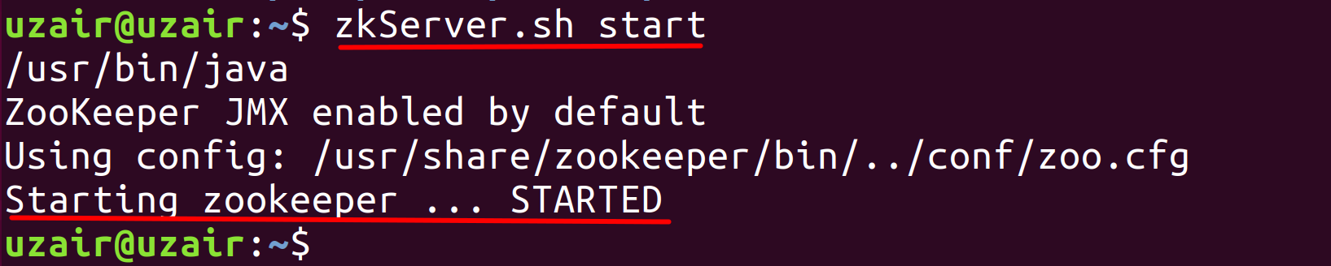

**Step 2:** Let us try connecting to the client port and run the command *srvr*. Run the following command first:

$ telnet localhost 2181

When you see connected to localhost, type the following command:

srvr

You should see the output as shown below.

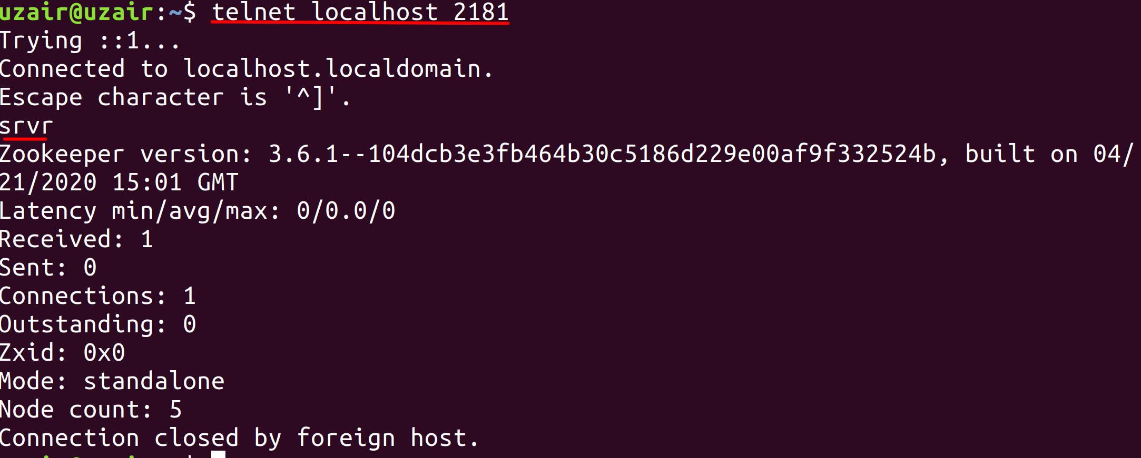

**Step 3:** Let us now start the Kafka server. Run the following command.

$ kafka-server-start.sh /usr/share/kafka/config/server.properties

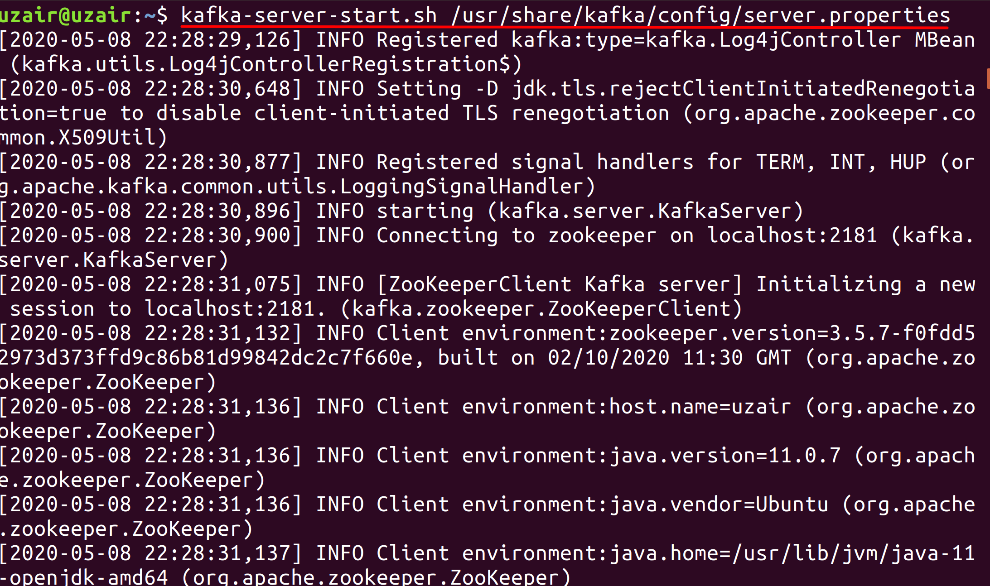

You should see a lot of information while Kafka starts. The last line would inform you that Kafka has been started as shown below.

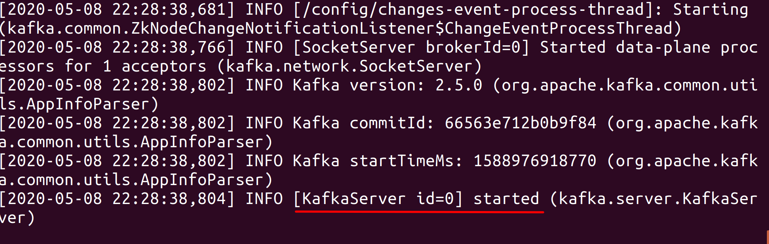

**Task 6 is complete!**

**SUMMARY**

Kafka is an open-source, distributed, persistent and fault-tolerant message streaming platform or a central repository, which can handle high volume (trillions) of Publish-Subscribe messages every day. Publish-Subscribe messaging system is a system where data is produced (Publish) by producers and consumers consume (subscribe) the data.

The Kafka architecture consists of the following components.

* Brokers
* Producers
* Consumers
* Topics
* Partitions
* Replications
* ZooKeeper

**CHAPTER 3: KAFKA IN-DEPTH – PART I**

**Theory**

In the previous chapter, we have looked at the architecture of Kafka with an overview of its components. We have also installed and configured Kafka in the labs. In this chapter and the next one, let us dig a little deeper and understand how Kafka works internally at core. It is paramount to understand the internal working of Kafka for efficient production and to troubleshoot issues, when necessary.

Let us look at the following internals of Kafka in this chapter.

* Topics Operations
* Topics Overview
* Data Model in ZooKeeper
* ZooKeeper Watches
* ZooKeeper’s role in cluster membership
* Election of Controller Broker
* Responsibilities of Controller Broker

**Topic Operations**

In the previous chapter, we have seen what are Topics. Now, let us look at various operations of Topics and see what happens internally when Topics are created, altered, deleted, etc.

**Creating a Kafka Topic**

A Kafka Topic can be created with the following syntax.

$ kafka-topics.sh \

--zookeeper <ZOOKEEPER_URL:PORT> \

--create --topic <TOPIC_NAME> \

--replication-factor <NO_OF_REPLICATIONS> \

--partitions <NO_OF_PARTITIONS>

*Please note that the ‘\’ symbol is not required if you specify the syntax in single line. The ‘\’ symbol is only used here since the syntax is specified in multiple lines.*

* The script to manage (create, alter, delete, list, etc.) Kafka Topics is *kafka-topics.sh*. This script is available in *<KAFKA_HOME>/bin/* directory. Therefore, we use the *kafka-topics.sh* script file to create a Kafka Topic.
* Next, we specify the URL and Port on which ZooKeeper is running using the --*zookeeper* switch.
* The next part of the syntax uses the *--create*, followed by the --*topic* switch to specify the name of the new topic that has to be created.
* The --*replication-factor* switch is used to specify the number of replications for the Kafka Topic.
* Similarly, the --partitions switch is used to specify the number of partitions.

Since Kafka is a persistent message queue, all the messages are stored on the disk. The path where the messages will be stored is set in the *server.properties* file pointed in the *log.dirs* property, as seen in the previous chapter.

We shall be looking at the contents of logs directory in the lab exercise for this chapter.

**Listing Kafka Topics**

The following syntax is used to list all the available Topics on the Kafka server.

$ kafka-topics.sh \

--zookeeper <ZOOKEEPER_URL:PORT> \

--list

We use the *kafka-topics.sh* script, followed by the ZooKeeper details and specify the --*list* switch to list all the Kafka Topics.

**Modifying Kafka Topics**

A Kafka Topic can be modified to change the number of partitions using the *--alter* switch in *kafka-topics.sh* script as shown below.

$ kafka-topics.sh \

--zookeeper <ZOOKEEPER_URL:PORT> \

--alter --topic <TOPIC_NAME> \

--partitions <NO_OF_PARTITIONS>

Note: Modifying the number of partitions will affect the partition logic or ordering of messages for consumers. Do not worry if you do not understand this. It will be clear once we look at Consumers in detail.

Please note that we cannot change the number of replications using the above syntax. We shall look at this in the upcoming chapters.

**Deleting Kafka Topics**

A Kafka Topic can be deleted using the following syntax.

$ kafka-topics.sh \

--zookeeper <ZOOKEEPER_URL:PORT> \

--delete --topic <TOPIC_NAME>

Please note that the topics cannot be deleted if *delete.topic.enable* property is not set to true.

**Topics Overview**

Let us now understand how Topics receive messages from Producers. Consider a Kafka cluster with 5 Brokers and a web server that generates logs as our Kafka Producer.

* First, start the ZooKeeper server and all the Brokers one by one. Post starting all the Brokers, create a Topic as explained in the previous section. Let us name the Topic as *logs*.
* The topic is created with 3 Partitions and a replication factor of 1. Once the Topic is created, three directories will be created under the path specified in *logs.dir* property on three different Brokers, i.e., one directory for each partition. The directories will have the names as logs-0, logs-1 and logs-2.
* Let us assume that the log directories are created in Brokers with ids 1, 3 and 5 as shown in the figure below.

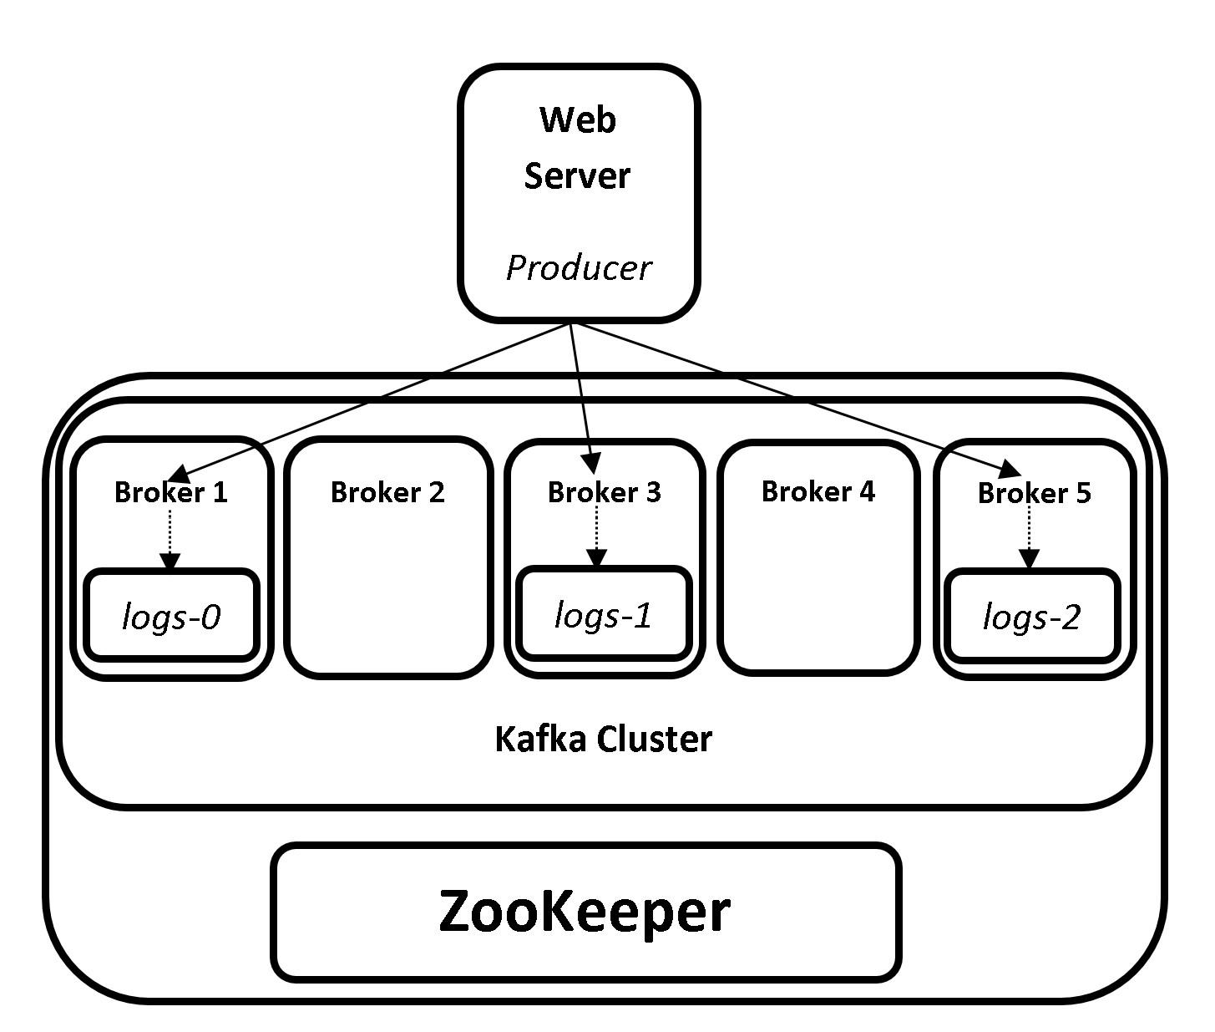

**3(a) Topics Overview – Single Producer**

* The Producer will now send the data to the Brokers 1, 3 and 5.
* The Broker 1 will write the data to *logs-0*, Broker 3 will write the data to *logs-1* and Broker 5 will write the data to *logs-2*.

Let us consider we have one more producer which generates Twitter data. The data is stored in the same process as above.

* Create a topic and name it *twitter*. The topic has 3 partitions with a replication factor of 1.
* Let us assume that the log directories are created in Brokers with ids 1, 2 and 4 as shown in the figure below.
* The Producer will now send the data to the Brokers 1, 2 and 4.
* The Broker 1 will write the data to *twitter-0*, Broker 2 will write the data to *twitter-1* and Broker 4 will write the data to *twitter-2*.

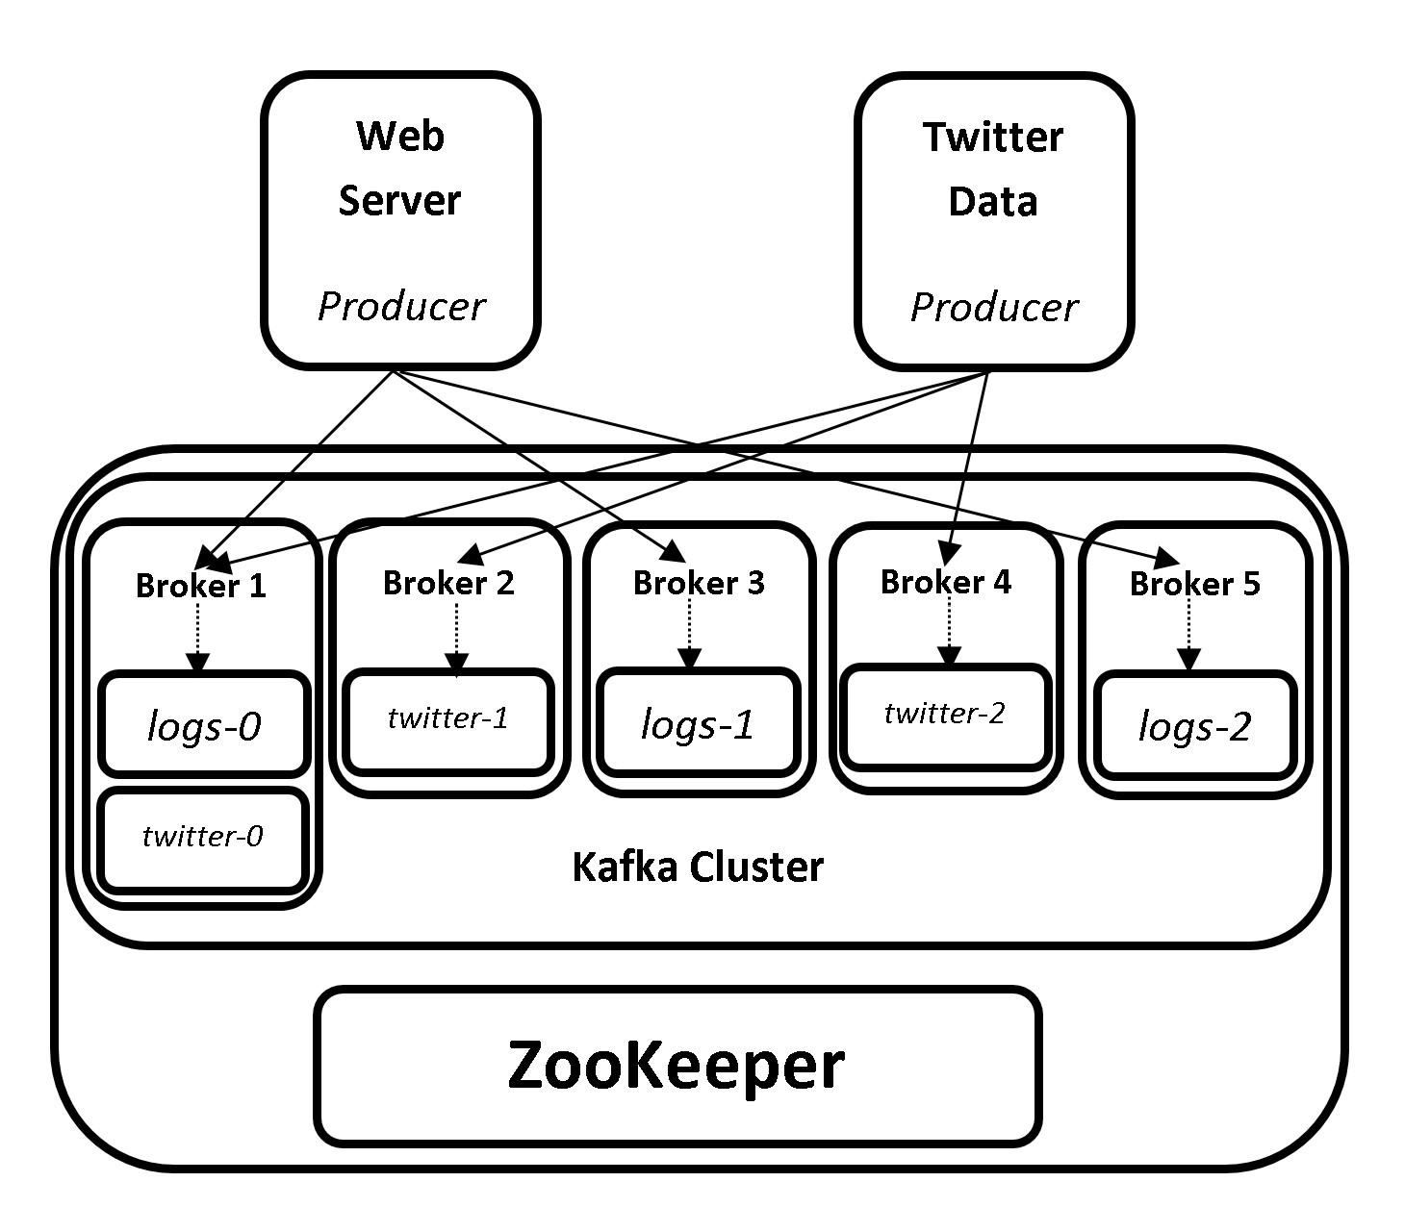

**3(b) Topics Overview – Multiple Producers**

From the above illustration, we can say that Kafka is a distributed, as the data is saved in the form of partitions across the cluster and, is persistent as the data is saved on disk.

In the illustration above, we have seen that when a directory is created in a Broker, the Broker takes all the ownership (read/write operations) of that directory. From our example above, Broker 1 is responsible for all the operations for *logs-0* and *twitter-0* partitions. But, how has the Broker 1 been assigned the ownership for *logs-0* and *twitter-0* partitions? Through which process has this responsibility assigned? Controller Broker is the answer for these questions. Move on to the next sections for a detailed explanation.

Before we learn about Controller Broker in detail, let us first understand the ZooKeeper data model and watches in ZooKeeper.

**Data model in ZooKeeper**

Data model in ZooKeeper is a distributed, hierarchical file system comprised of znodes (directories). The znodes are containers for data and other nodes. The znodes have associated data such as statistic information and versioning information. Znodes also store user data which is limited to 1 MB (per znode).











/App1/p_1 /App1/p_2 /App1/p_3

**3(c) ZooKeeper Data Model**

The znodes can be of Persistent or Ephemeral znodes and optionally sequential znodes.

|  |  |
| --- | --- |
| **Persistent znodes** | Persistent znodes persist even after the client session. expires or disconnected. Persistent znodes can have child. Persistent znodes are always present and is only deleted when clients explicitly deletes it. |
| **Ephemeral znodes** | Unlike persistent znodes, ephemeral znodes are automatically deleted by zookeeper as soon as the session in which they are created is closed or expired. Ephemeral znodes cannot have children, not even the ephemeral children. |
| **Sequential znode** | A sequential znode is given a sequence number while znode is being created. All znodes can optionally be sequential, for which ZooKeeper maintains a monotonically increasing counter which is automatically appended to the znode name upon creation. Each sequence number is guaranteed to be unique. |

**ZooKeeper Watches**

Watches notify clients when a znode has been changed. We can set watches on read or get notified when there is a write operation on a znode. For example, a client, say *x*, sets a watch on a znode and another client *y* performs a write request on that znode, a watch is triggered and client *x* is notified about the write operation. Client *x* and *y* are completely independent and do not know anything about each other’s existence, so long as they each know their own responsibilities in relation to specific znodes.

Also the watches are triggered only once and notify the client about the change. Once triggered, the client has to register again to get notified for future notifications. It is also possible that during the period between receipt of the notification and re-registration, other clients could perform write operations on the znode before the new Watch is registered by the client and the client may miss that update/notification.

**ZooKeeper’s role in cluster membership**

As we have learned in previous chapters, Kafka uses ZooKeeper to manage the Brokers which are the members of Kafka cluster. Each Broker has a unique id that is either set via *broker.id* property in the Broker’s *server.properties* configuration file or is automatically generated. The following actions happen when Brokers are started.

* Whenever a Broker is started, the Broker registers itself with its ID in ZooKeeper with information such as its hostname, port and other metadata. The Broker creates a directory in ZooKeeper known as Ephemeral node, to store this information. The list of Brokers will be available in the following ZooKeeper path: */brokers/ids*. For example, if the Broker id is 1, an Ephemeral node is created as */brokers/ids/1*. The Ephemeral node 1 consists of all the metadata information regarding Broker 1.
* All the different Kafka components such as other brokers, producers, consumers etc., subscribe (set ZooKeeper watch ) to the Brokers’ path above. This was they get notified whenever a change such as addition or removal of Brokers takes place.
* A Broker ID is always unique and a new Broker cannot be started with the same ID. If a Broker ID is started with same ID, an error is thrown since there is already a Broker running with the same ID.
* In case of Broker failure, the Ephemeral node created by that particular Broker which failed, will be removed from ZooKeeper. This will trigger a notification to all the Kafka components, which subscribed to Brokers’ path regarding the Broker failure.
* A new Broker with the same ID can then be commissioned and have the data restored with the help of replicas available in other Brokers. The metadata information of partitions stored in the failed Broker will be available with the Controller Broker (Details in the next section). Thus making Kafka fault tolerant.

This is how ZooKeeper helps in maintaining Brokers’ membership with Kafka cluster.

**Election of Controller Broker**

The Controller Broker can be thought as a master which controls the membership of all other Brokers in Kafka cluster. The Controller Broker is responsible to allocate partitions to the Brokers, also known as Leader Brokers. Controller Broker is not a special server, but one among the list of Brokers available in the Kafka cluster. The Controller Broker is elected with the help of ZooKeeper. Let us see how the Controller Broker is elected with the help of ZooKeeper and learn its responsibilities.

* Consider a Kafka cluster with few Brokers and a ZooKeeper server.

* When the Brokers are started in Kafka cluster, every Broker tries to create an ephemeral node (directory) called */controller* in ZooKeeper.
* The Broker that succeeds in creating this ephemeral node becomes the Controller Broker in Kafka cluster. Generally, the first Broker that starts in Kafka cluster succeeds in creating the ephemeral node and thus becomes Controller Broker.
* The other Brokers also try to create this node but fail to do so, as the Controller Broker is already elected. This ensures that there is only one Controller Broker at any given point of time.
* Since all the other Brokers now know there is a Controller Broker, they subscribe (set ZooKeeper watch) to the */controller* node to get notified of any changes that happen to this node.
* If the Controller Broker shuts down due to hardware failure or experiences connectivity issues with ZooKeeper, the */controller* ephemeral node will be deleted By ZooKeeper (See data model in ZooKeeper section for more information).
* Since the removal of */controller* node is a change, all the other Brokers that have set a watch to this node will be notified that the cluster no longer has a Controller Broker.
* All the Brokers will once again try to create an ephemeral node called */controller* in ZooKeeper. Whichever Broker succeeds in creating this node will become the Controller Broker and the rest of the Brokers will again set a ZooKeeper watch to this node.
* Every Controller Broker that gets elected is assigned with a controller epoch number, which is higher than the epoch that is assigned to previous Controller. So, if the Controller Broker that failed due to connectivity issues or any other reason, gets connected again, the rest of the Brokers will simply ignore its messages based on the Controller’s epoch number.

This is how a Controller Broker is elected and its high availability is ensured using ZooKeeper. We shall look this in real time in our lab exercises.

**Responsibilities of Controller Broker**

Controller Broker has a few more responsibilities apart from the responsibilities of a regular Broker in Kafka. The Controller Broker acts as a regular Broker for communication between Producer and Consumer, as well as the following responsibilities.

* The Controller Broker is responsible to assign partitions and replications to Brokers. The Controller Broker maintains metadata of Leader Brokers and Follower Brokers. Controller Brokers sets a ZooKeeper watch on the */brokers/ids* node and hence it gets notified when a new Broker has joined or left the cluster.
* The Controller Broker shares all the metadata information such as the Brokers leading partitions, the Brokers having replications with all the other Brokers in the Cluster. This way if the Controller Broker is down, the newly elected Controller Broker has all the metadata information to start its duties as a Controller. In simple words, every Broker on the cluster knows the metadata information of every other Broker. Thus any Broker has the potential to become a Controller Broker.
* The Controller Broker is also responsible for the duties like any other Broker in the cluster, i.e., leading partitions, performing reads/writes and having partition replications. In other words, the Controller Broker assigns partitions and replications to itself and also to other Brokers.
* The Controller Broker monitors Brokers for failures and rebalancing partitions to other Brokers in the event of failure. When a Broker goes down, the Controller Broker elects a new Partition leader which has the replications of failed Broker. The new Partition leader will now start serving the requests from Producers and Consumers while the Follower Brokers start replicating the messages from Leader Broker.

That’s all for the theory for this chapter. Let us move to the lab exercise to check all this theory in action.

**AIM**

The aim of the following lab exercises is to perform Kafka topic operations, work with ZooKeeper shell and demonstrate the election and responsibilities of a Controller Broker.

The labs for this chapter include the following exercises.

* Kafka Topic operations
* Hands-on ZooKeeper Shell
* Controller Broker Election

We need the following packages to perform the lab exercise:

* Java Development Kit
* Apache ZooKeeper
* Apache Kafka

**LAB EXERCISE 2: KAFKA IN-DEPTH – PART I**

1. **Kafka Topic Operations**
2. **Hands-on ZooKeeper Shell**
3. **Controller Broker election**

**Task 1: Kafka Topic Operations**

**Step 1:** Let us first start the ZooKeeper server, if not started already.

$ zkServer.sh start

You should see that the ZooKeeper server starts as shown in the screenshot below.



**Step 2:** Let us now start the Kafka Broker, if not started already

$ kafka-server-start.sh /usr/share/kafka/config/server.properties



You should see a lot of information while Kafka starts. The last line would inform you that Kafka has been started as shown below.



**Step 3:** Now that we have ZooKeeper and Kafka server up and running, let us perform few Topic operations. Open a new terminal and run the following command.

$ kafka-topics.sh \

--zookeeper localhost:2181 \

--create --topic http-logs \

--replication-factor 1 \

--partitions 3

You should see the confirmation message that the Topic is created as hown in the screenshot below.

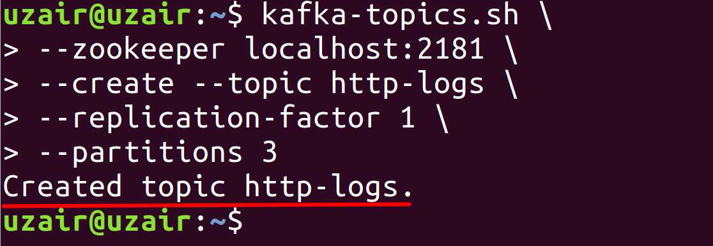

Since Kafka is a persistent message queue, the messages will be stored on disk. Let us now look the path where this new topic is created. This is the same path that is specified in the *logs.dir* property in *server.properties* configuration file. The path that is specified in *server.properties* configuration file is */tmp/kafka-logs*. Please check the previous lab exercise for more information on Kafka configurations.

Note: The default path specified to store Kafka logs is the *tmp* folder. This path should always be changed to a new path, as the *tmp* folder will be deleted automatically when you restart the server. We shall be changing this path later.

Enter the following commands to check the contents of the topic we created.

$ cd /tmp/kafka-logs

$ ll

You should see the following contents as shown in the screenshot below.

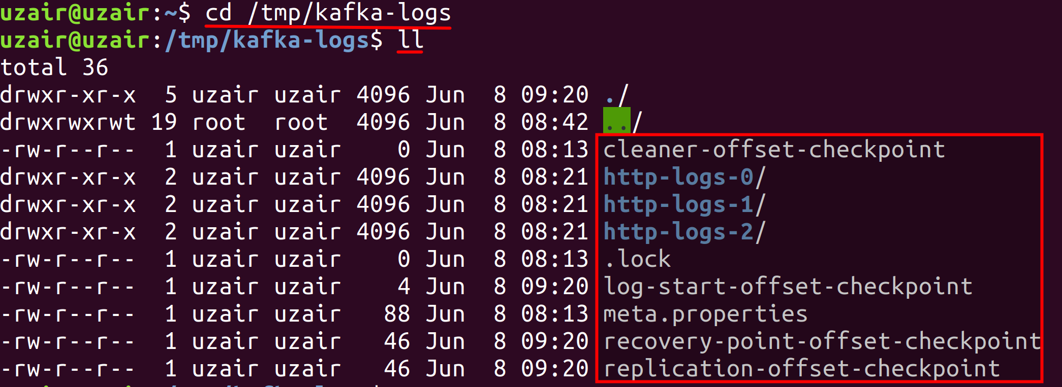

As seen in the screenshot above, three directories have been created for the topic as we have specified 3 partitions. The number of directories created will be directly proportional to the number of partitions specified while creating a topic. Since we are only working on single Kafka server, all the three partitions have been created in the same server. In multi-node Kafka cluster, these partitions will be created on any of the Kafka servers. The rest of the files in the kafka-logs directory contain the metadata information.

Now, let us look the contents of a directory of the partition.

$ cd http-logs-0

$ ll

The directory contains the following files.

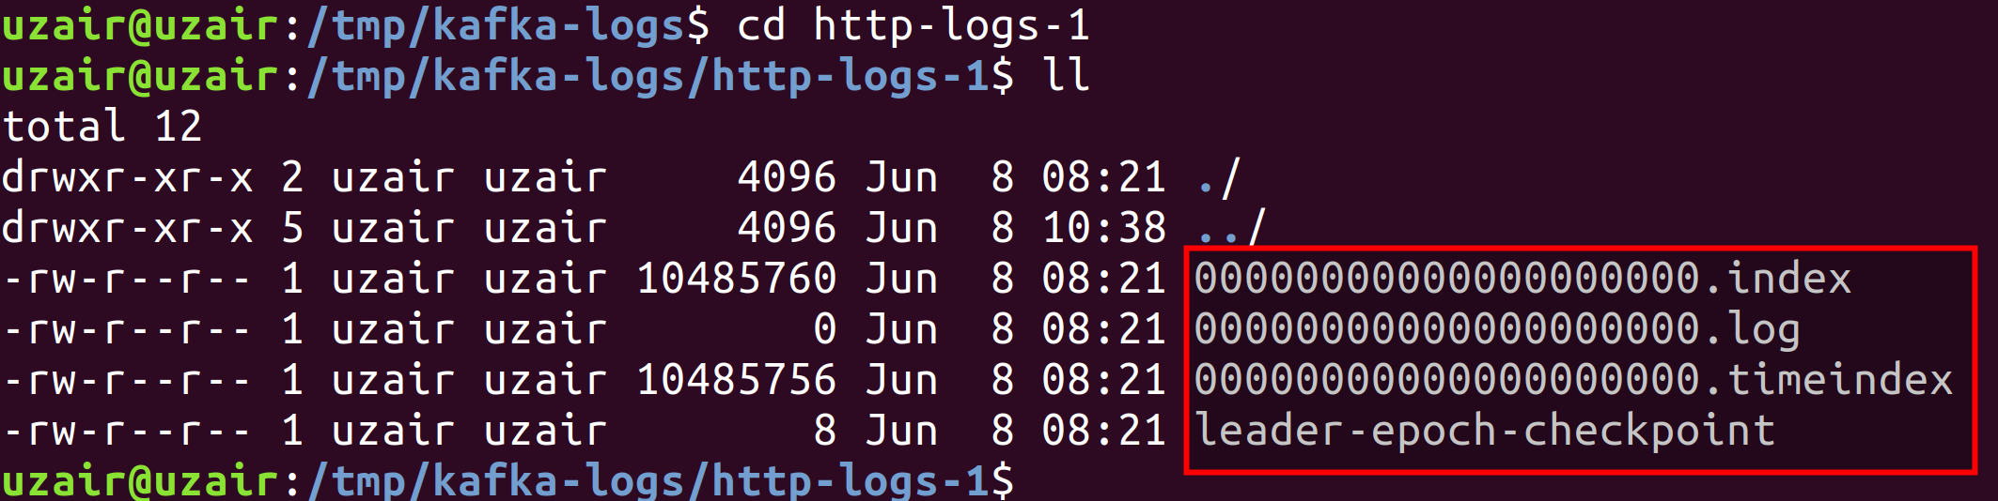

The file with *.log* extension is where all the messages from producers get appended. Any new messages generated are appended here by the Broker, thus making Kafka a persistent storage message queue.

**Step 4:** Let us now list all the Topics that are available in Kafka. Since we have only created one Topic, it is the only one that should return once we run the command below.

$ kafka-topics.sh \

--zookeeper localhost:2181 \

--list

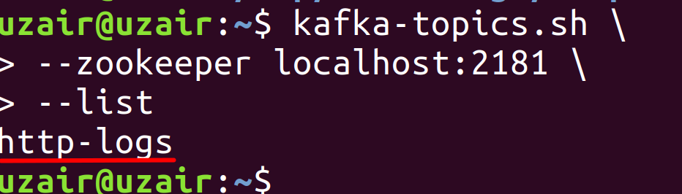

**Step 5:** Let us now modify the number of partitions for the topic we created in previous step to 4.

$ kafka-topics.sh \

--zookeeper localhost:2181 \

--alter --topic http-logs \

--partitions 4

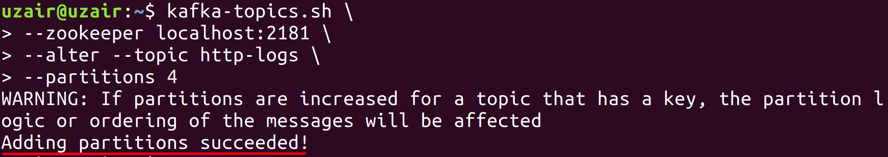

Please note that you can only increase the number of partitions and not decrease them.

You can check if this action has been successful by navigating to the *kafka-logs* directory.

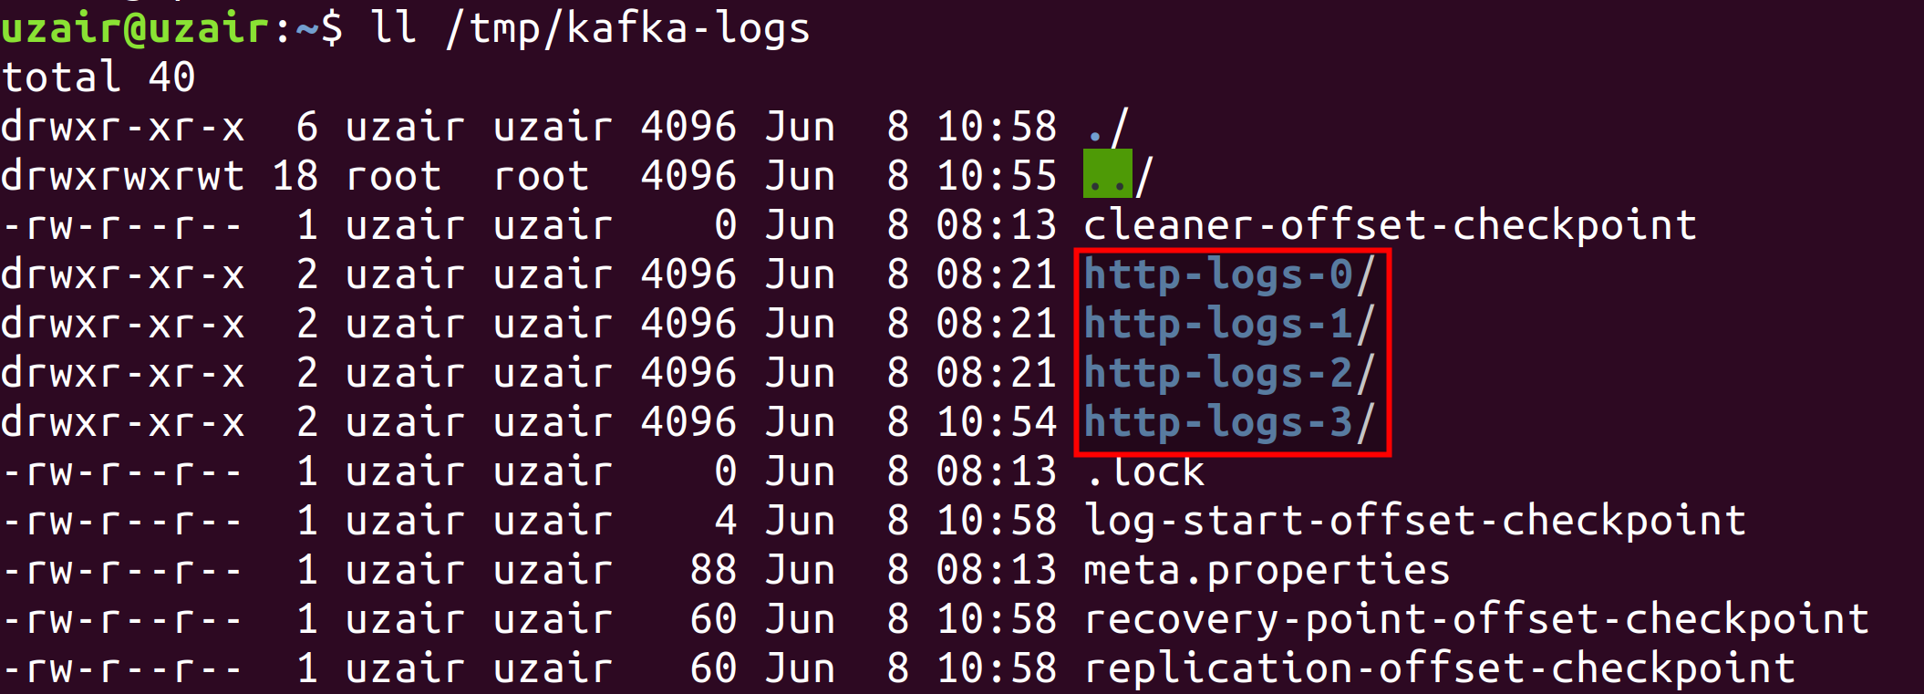

As you can see from the screenshot above, a new directory is created indicating the modification of partition was successful.

**Step 6:** Let us finally delete the Topic we created.

$ kafka-topics.sh \

--zookeeper localhost:2181 \

--delete --topic http-logs

You will see a message that the topic is marked for deletion as shown in the screenshot below.

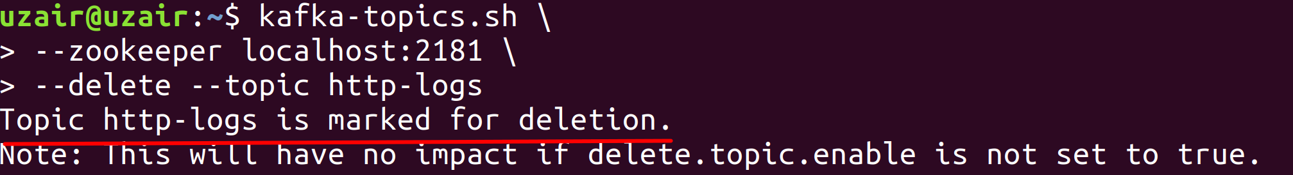

This is because Kafka will never delete a Topic right away. The Topic doesn’t get deleted if Producers are still producing messages for the Topic, or if the Consumers are still consuming the messages from the Topic. The Topic cannot be deleted if the *delete.topic.enable*  is not set to true. This is to ensure no data loss happens when a Topic is accidentally deleted.

**Task 1 is complete!**

**Task 2: Hands-on ZooKeeper Shell**

To better understand how ZooKeeper works as a coordination service, let us look at the file system in ZooKeeper.

**Step 1:** Before we look at the ZooKeeper shell, let us first stop the Kafka and ZooKeeper servers. Let us also remove the directories that got created in *tmp* folder while we created new topic in the previous task.

Let us first stop Kafka and ZooKeeper.

$ kafka-server-stop.sh

$ zookeeper-server-stop.sh

Make sure you stop the ZooKeeper server after you stop the Kafka server.

Let us now remove all the *kafka-logs* and *zookeeper* directory inside the *tmp* folder.

$ rm –rf /tmp/kafka-logs

$ rm –rf /tmp/zookeeper

$ rm –rf /tmp/hsperfdata_{insert_your_username_here}



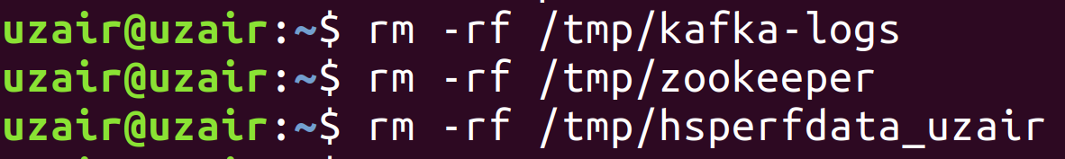

Let us now only start the ZooKeeper server.

$ zkServer.sh start

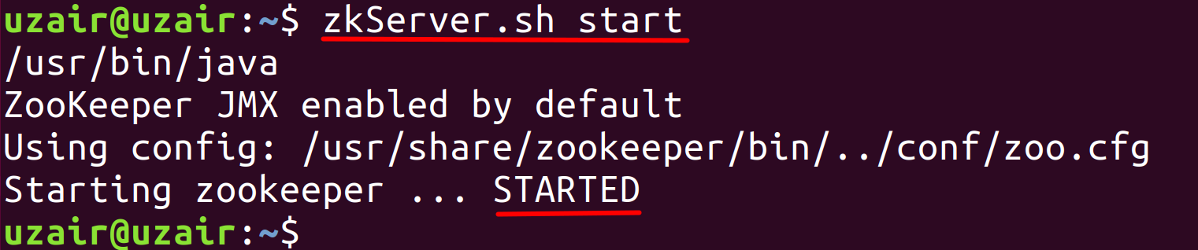

**Step 2:** Now that the ZooKeeper server has been started, let us connect to the ZooKeeper server using the ZooKeeper Shell. Run the following command to connect to the ZooKeeper server.

$ zookeeper-shell.sh localhost:2181

You should see the prompt as shown in the screenshot below.

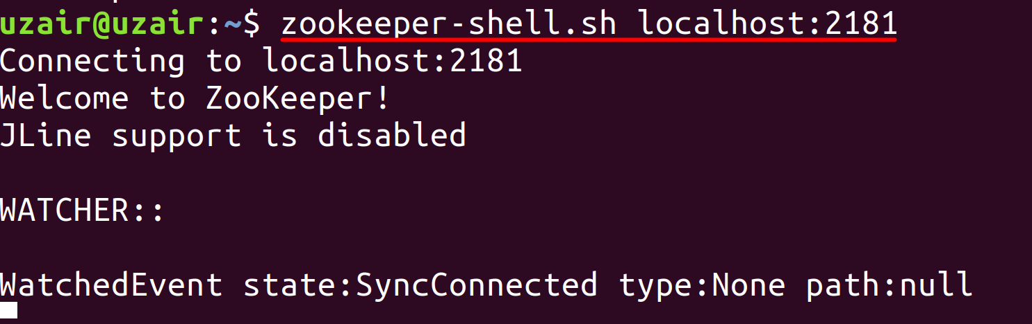

Please note that the ZooKeeper Shell is not very user friendly. The ZooKeeper shell lacks many features you would expect.

**Step 3:** Let us now check what all directories or files exist in the ZooKeeper file system. We shall be using the list command on the root path of ZooKeeper.

ls /

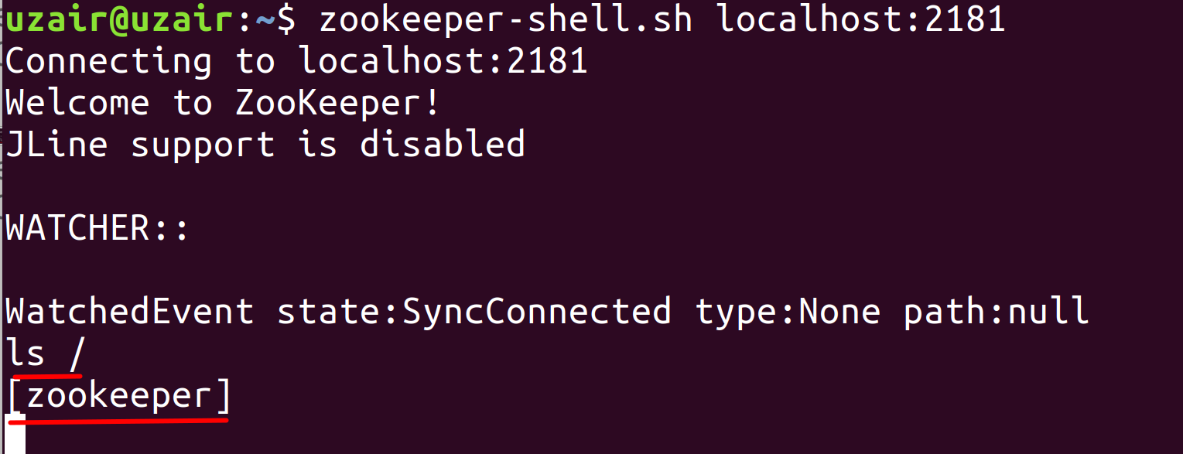

As you can see from the screenshot above there is only one item called *zookeeper*. This item can either be a file or a folder.

**Step 4:** Let us check if this item is a folder by running the list command.

ls /zookeeper

As you can see from the screenshot below, *zookeeper* is a directory and it contains two more items inside it. These items can again be either files or directories.

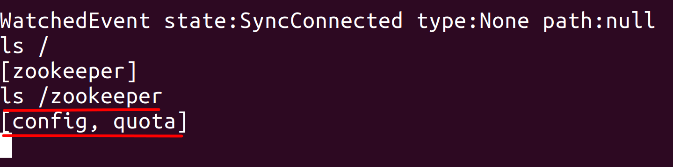

**Step 5:**  Let us now try to read these files using the *get* command as shown below. You may also check if they are directories using the *ls* command. You should only get the square brackets if the item is not a directory as shown below.

get /zookeeper/quota

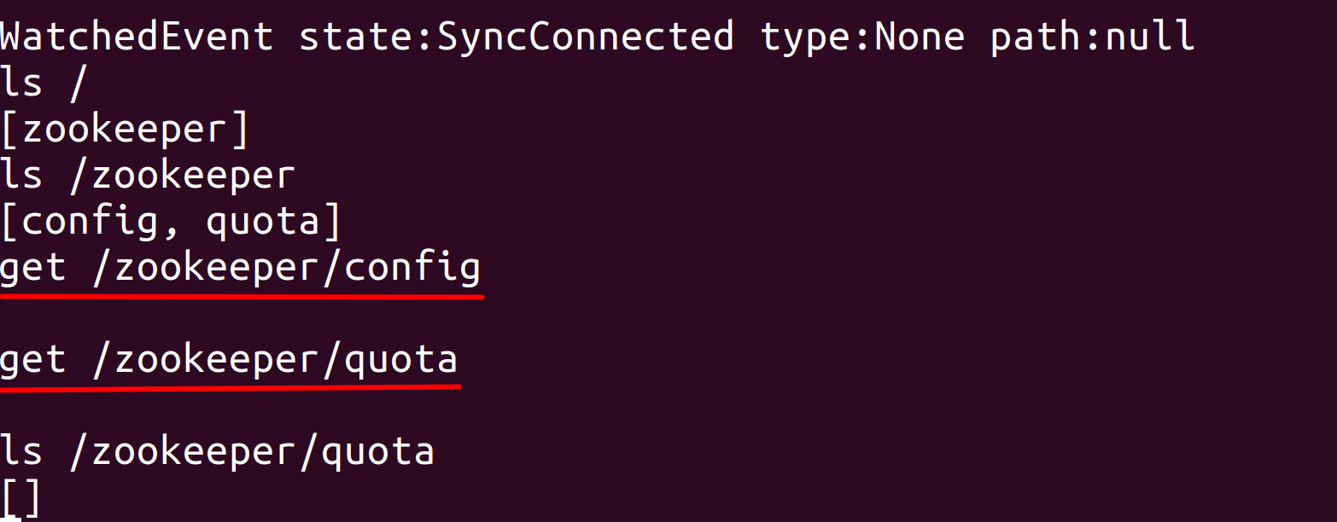

There nothing exists in those files as of now.

**Step 6:** Let is now start the Kafka server in a new terminal and check what all the files get generated within the ZooKeeper file system.

$ kafka-server-start.sh /usr/share/kafka/config/server.properties

Once the Kafka server has been started, switch to ZooKeeper shell and run the *ls* command on the root directory of ZooKeeper.

ls /

You should see the following nodes getting created in the Zookeeper as shown in the screenshot below.

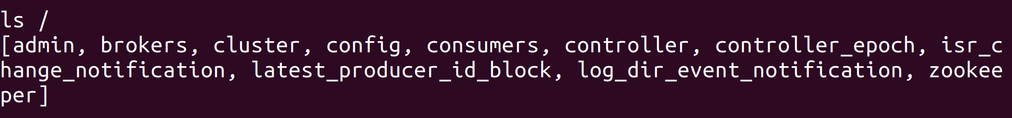

Earlier we only had the *zookeeper* node. After we have started the Kafka server all the above directories have been created.

**Step 7:** Let us now check what information the *controller* file consists of.

get /controller

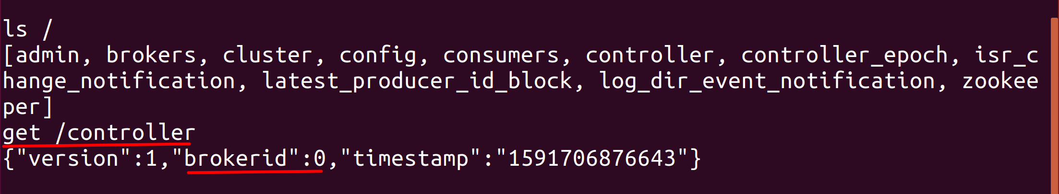

As you can see from the screenshot above, the *controller* file shows the *brokerid* as 0. The Broker with id 0 created this file on ZooKeeper and hence is the Controller Broker. It also shows the version and the timestamp at which it was created.

**Step 8:** Let us now check the contents of *brokers* directory.

ls /zookeeper/brokers

The screenshot below shows the contents of *brokers* directory.

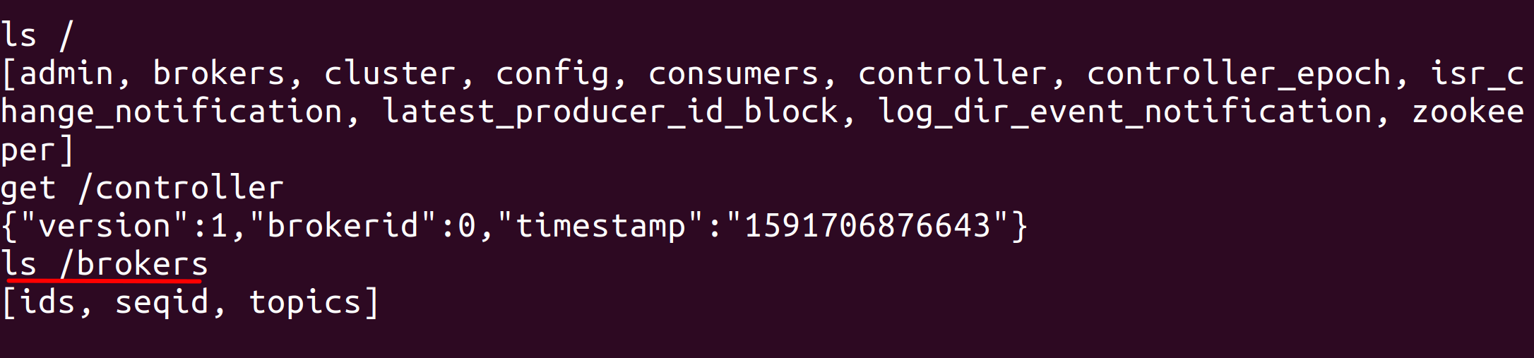

The *ids* folder contains the list of Broker ids that are the members of the Kafka cluster. We can check that using the *ls* command as shown below.

ls /zookeeper/ids

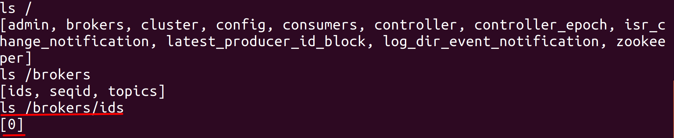

As we can see from the screenshot above, there is a folder named *0* inside */brokers/ids* folder. This indicates that there is one broker as part of the Kafka cluster with id 0.

**Task 2 is complete!**

**Task 3: Controller Broker election**

We have learned how a Controller Broker is elected using ZooKeeper in the theory. Let us now test that theory and see the election in real time.

**Step 1:** Let us create multiple Brokers in a single server so that we have multiple Brokers to demonstrate the election of Controller Broker. Please note that we are only creating multiple brokers in single server for training and demonstration purposes. Never create multiple Brokers in single server in production environment.

Stop the Kafka and ZooKeeper servers in order and also remove the data from *tmp* folder as shown below.

$ kafka-server-stop.sh

$ zookeeper-server-stop.sh

$ rm –rf /tmp/kafka-logs

$ rm –rf /tmp/zookeeper

$ rm –rf /tmp/hsperfdata_{insert_your_username_here}





**Step 2:** In a multi-node Kafka cluster, every server has its own *server.properties* configuration file. We have to start each Kafka server individually by referring to its *server.properties* configuration file. In standalone single Kafka server, we can create multiple *server.properties* configuration files to simulate a multi-node Kafka cluster.

We should first create three *server.properties* configuration files (*server1.properties, server1.properties and server2.properties)* and make sure the Broker id, port number and the *logs.dir* path is different in all the three configuration files.

In the terminal navigate to the following path and copy the *server.properties* file 3 times as shown below.

$ cd /usr/share/kafka/config

$ sudo cp server.properties server1.properties

$ sudo cp server.properties server2.properties

$ sudo cp server.properties server3.properties

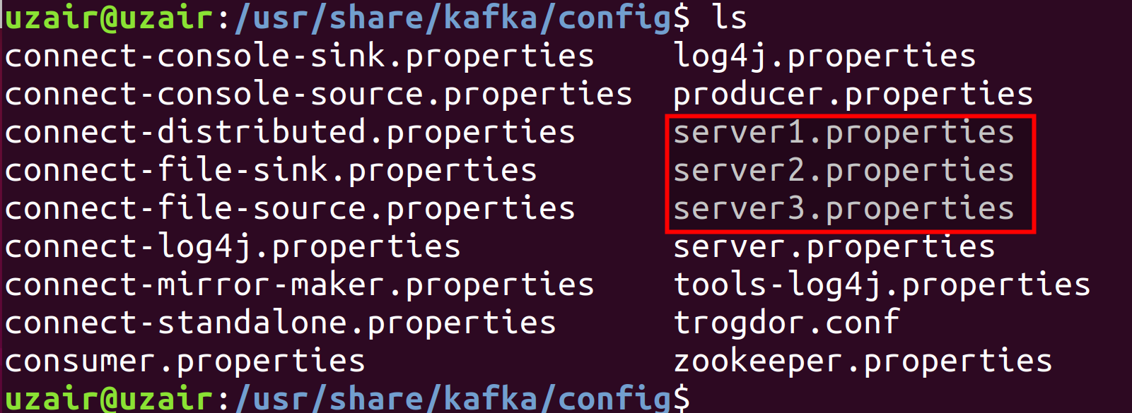

**Step 3:** Let’s make sure the Broker id, port number and path to Kafka logs is different in all three *server.properties* configuration files.

Edit the *server1.properties* file to have the Broker id as 1, port number as 9091 and Kafka logs as */tmp/kafka-logs-1*.

$ sudo vi server1.properties

*Press ‘i’ key to edit.*

You should see the values as per the screenshot below.

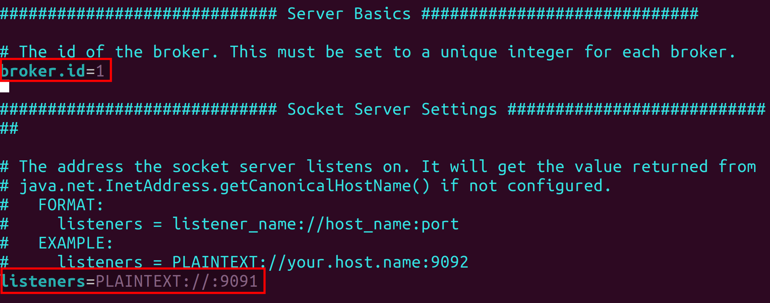

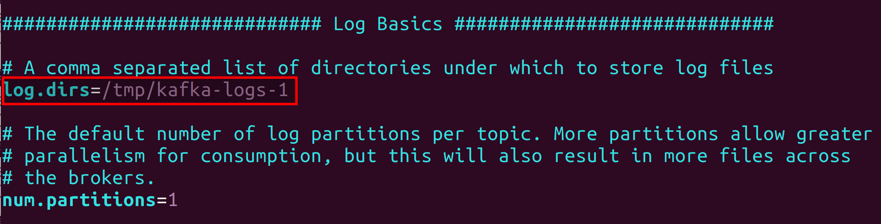

*Make sure you remove ‘#” symbol before any of the properties highlighted above.*

Press “esc” to come out of edit mode and save the file by pressing ‘:’ and ‘x’ key.

Repeat the same process and edit the *server2.properties* file. Edit the Broker id to be 2, the port to be 9092 and Kafka logs path to */tmp/kafka-logs-2*. The file should have the values as highlighted in the screenshot below.

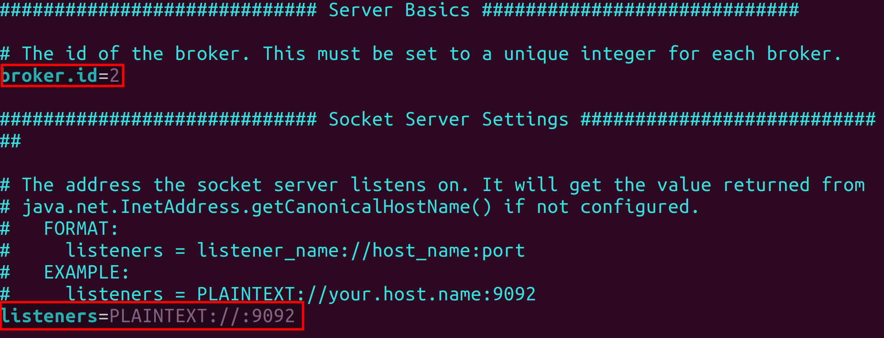

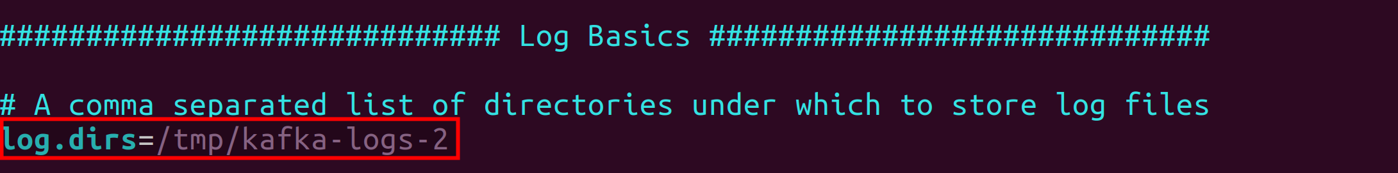

Finally, repeat the same process and edit the *server3.properties* file. Edit the Broker id to be 3, the port to be 9093 and Kafka logs path to */tmp/kafka-logs-3*. The file should have the values as highlighted in the screenshot below.

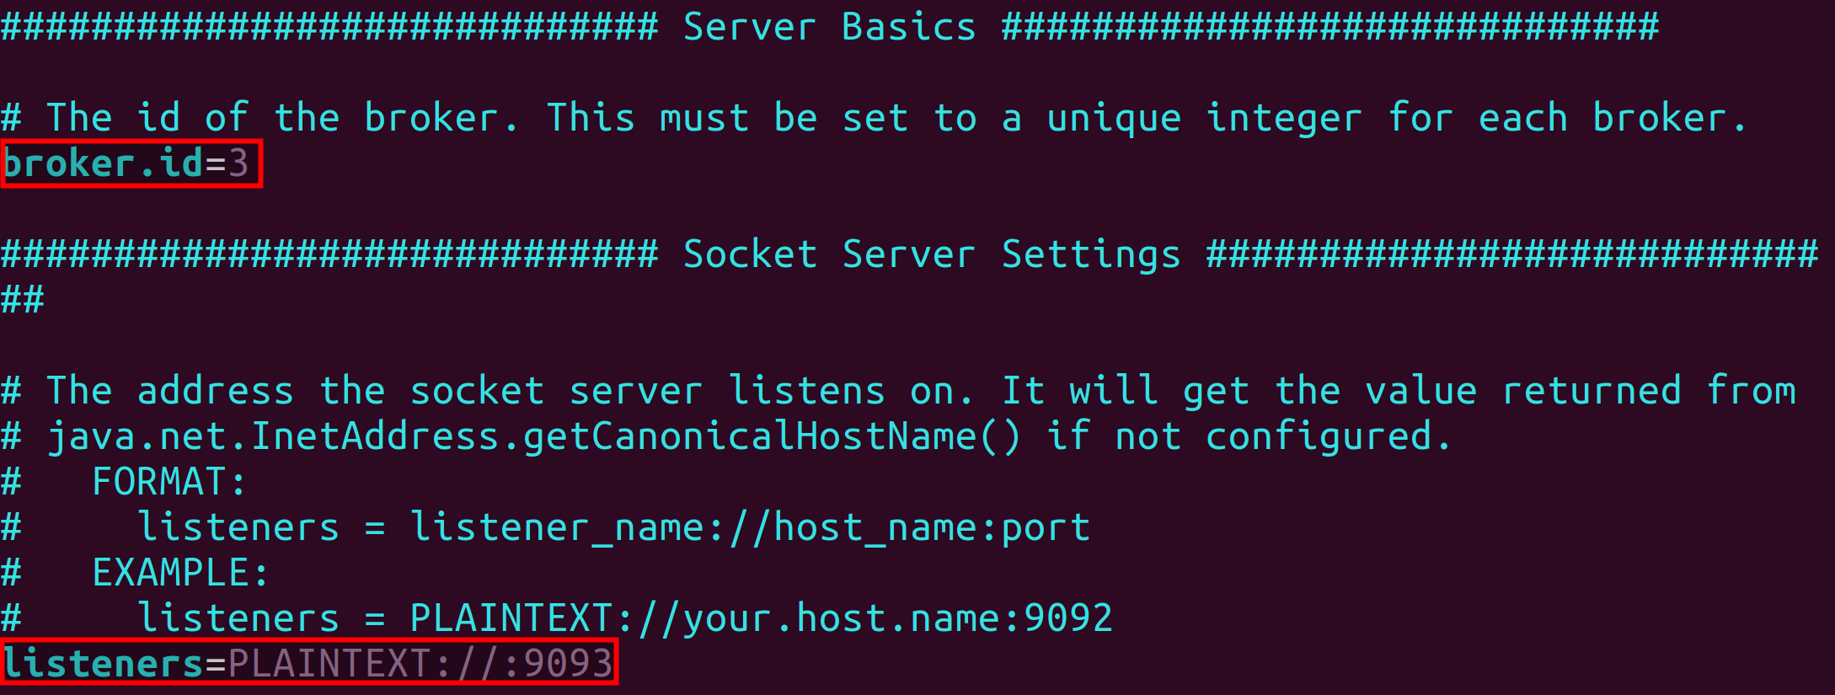

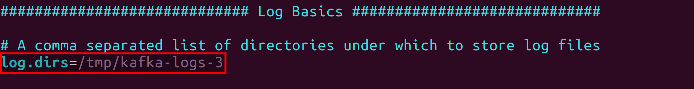

**Step 4:** Let us now start the ZooKeeper server and connect to the ZooKeeper server using ZooKeeper shell.

$ zkServer.sh start

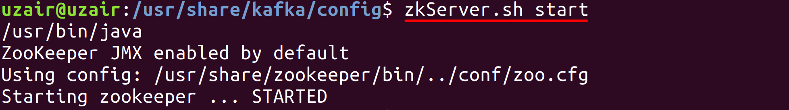

$zookeeper-shell localhost:2181

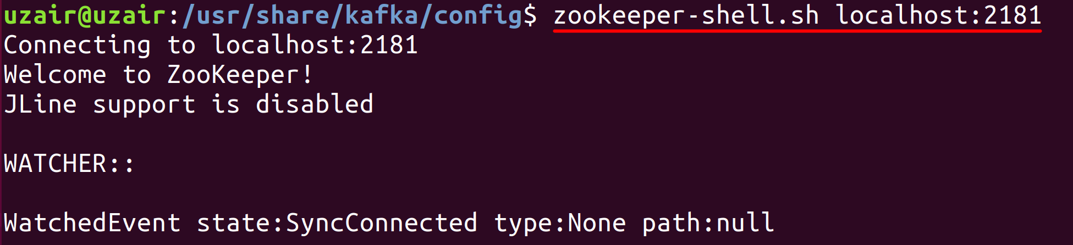

Let us check the content that exists in ZooKeeper by running the *ls* command on root directory.

$ ls /

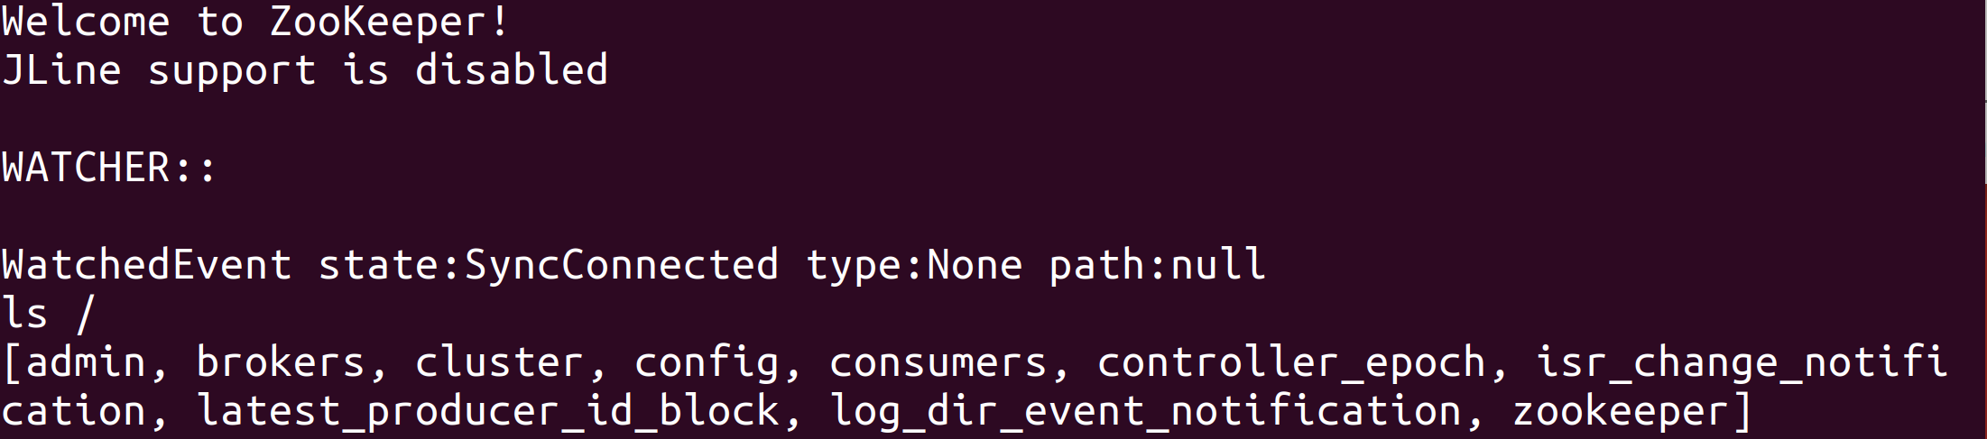

You might see the items in the root path as shown above, but there will not be any Brokers. We can *ls* on the */brokers/ids* path to check that there are no Brokers in Kafka cluster.

$ ls /brokers/ids



**Step 5:** Let us now start the first broker. Run the following command from a new terminal. Do not close the ZooKeeper shell.

$ kafka-server-start.sh /usr/share/kafka/config/server1.properties

Since this is the first Broker that has been started in the cluster, it will try and succeed in creating the *controller* node in ZooKeeper. Since the *controller* node does not exist in ZooKeeper already, it becomes the Controller Broker.

You should see the *controller* file in ZooKeeper file system as shown in the screenshot below. All the Brokers when joined to this cluster, will put a ZooKeeper watch on this file so that ZooKeeper notifies them whenever a change happens to the file.

ls /

You Should also see the Broker with id 1 having membership in Kafka cluster.

ls /brokers/ids

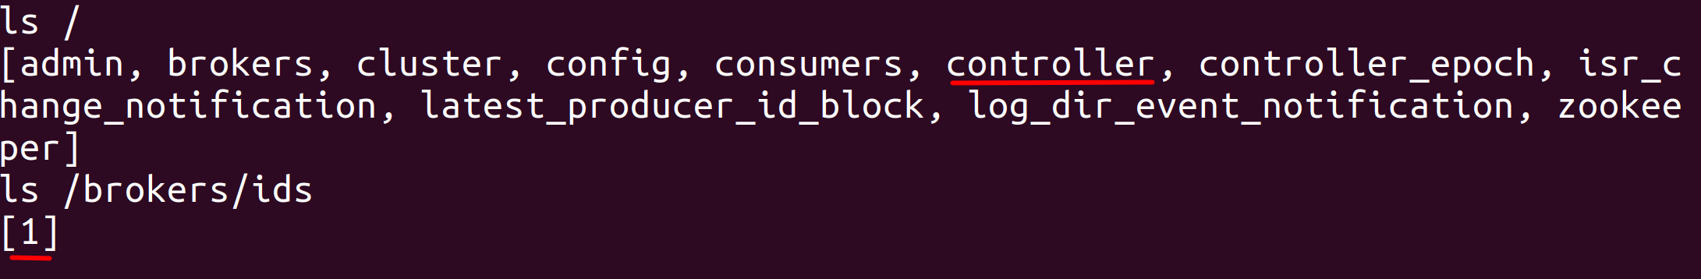

Let us see if the Broker 1 is the controller broker.

get /controller

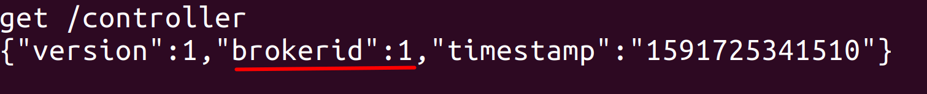

Let us also check the content in the */brokers/ids/1* file.

get /brokers/ids/1

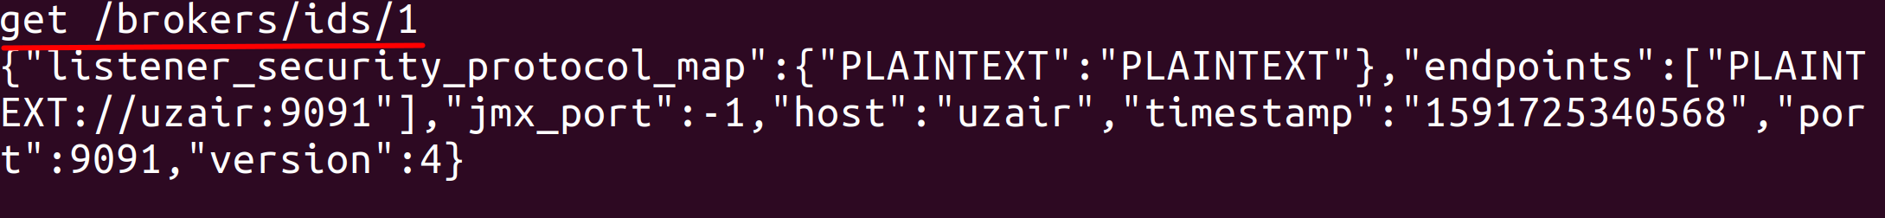

This file contains the endpoints (ip address), port number, host and other information about the Broker.

Let us finally check if the path to store Kafka logs has been created for Broker 1. Open a new terminal and run the command as shown below.

$ ll /tmp

As you can see from the screenshot, the path for Kafka logs has been successfully created.

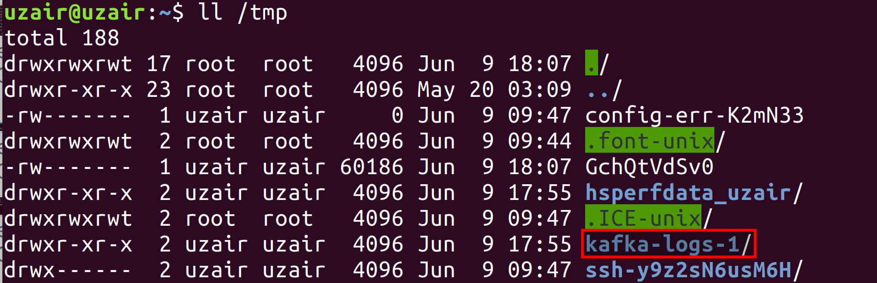

**Step 6:** Let us now start the second Broker.

$ kafka-server-start.sh /usr/share/kafka/config/server2.properties

Go back to the ZooKeeper shell and check if the new Broker has joined the Kafka cluster.

ls /brokers/ids



A path for Broker 2 should also be created in the *tmp* directory as shown below.

$ ll /tmp

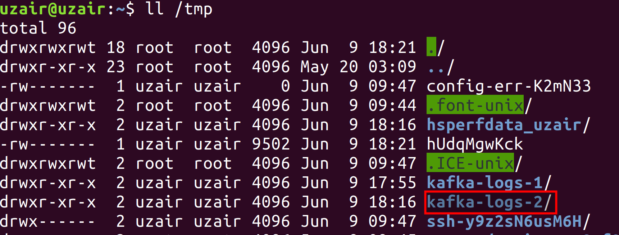

**Step 7:** Let us finally start Broker 3.

$ kafka-server-start.sh /usr/share/kafka/config/server3.properties

Go back to the ZooKeeper shell and check if the new Broker has joined the Kafka cluster.

ls /brokers/ids

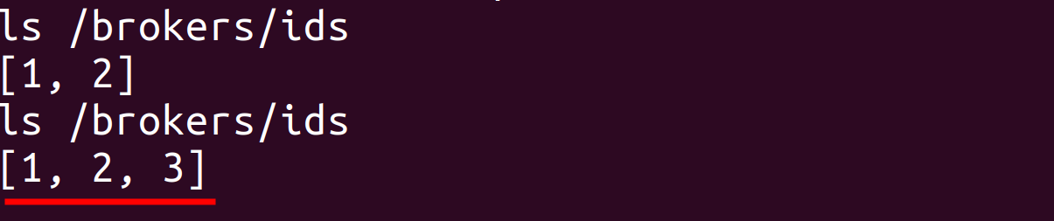

Every time a new Broker is started, a new file is created in *ids* directory and the file name is same as the Broker id.

A path for Broker 3 should also be created in the *tmp* directory as shown below.

$ ll /tmp

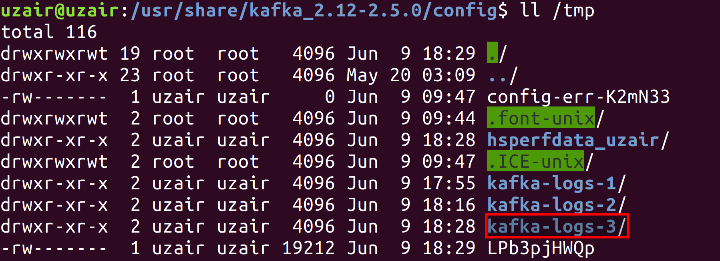

**Step 8:** Let us now create a Topic and see how the partitions are distributed within the 3 brokers. Let us create a Topic called *twitter* with 3 partitions and replication factor as 1.

$ kafka-topics.sh --zookeeper localhost:2181 --create --topic twitter --replication-factor 1 --partitions 3



Let us check the Kafka logs directory for each Broker.

$ ll /tmp/kafka-logs-1

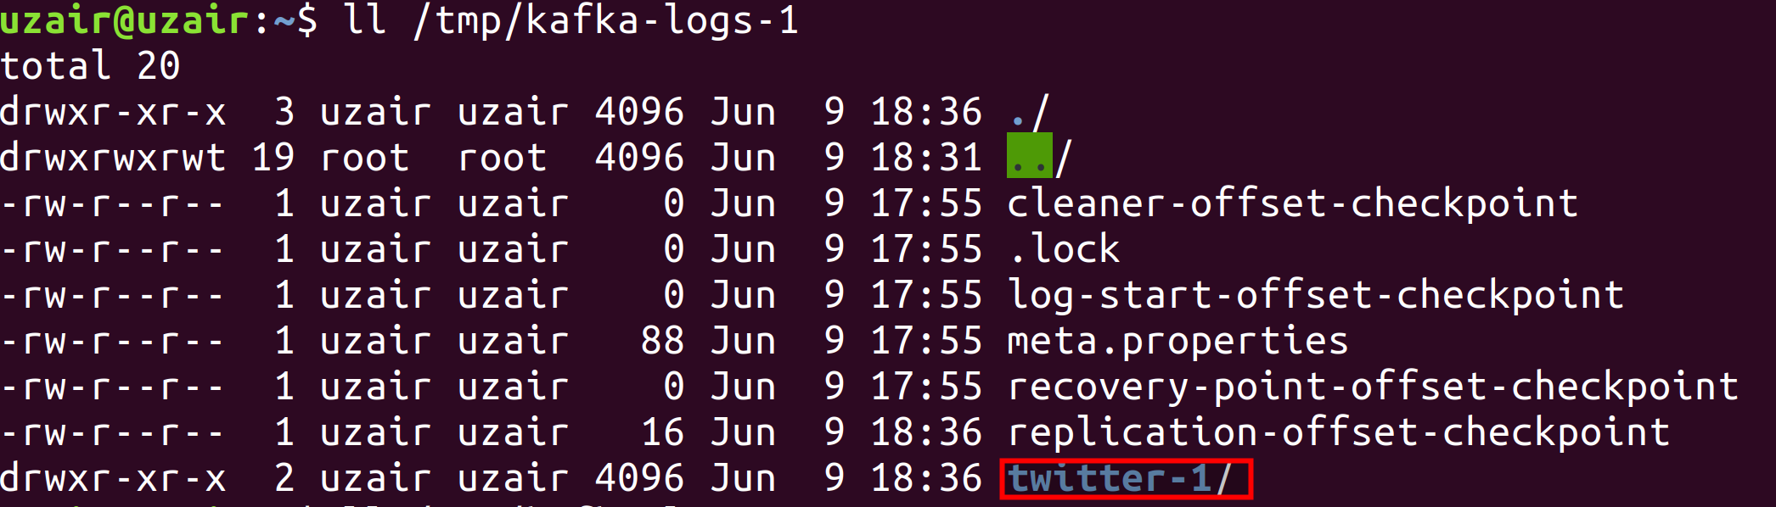

$ ll /tmp/kafka-logs-2

$ ll /tmp/kafka-logs-3

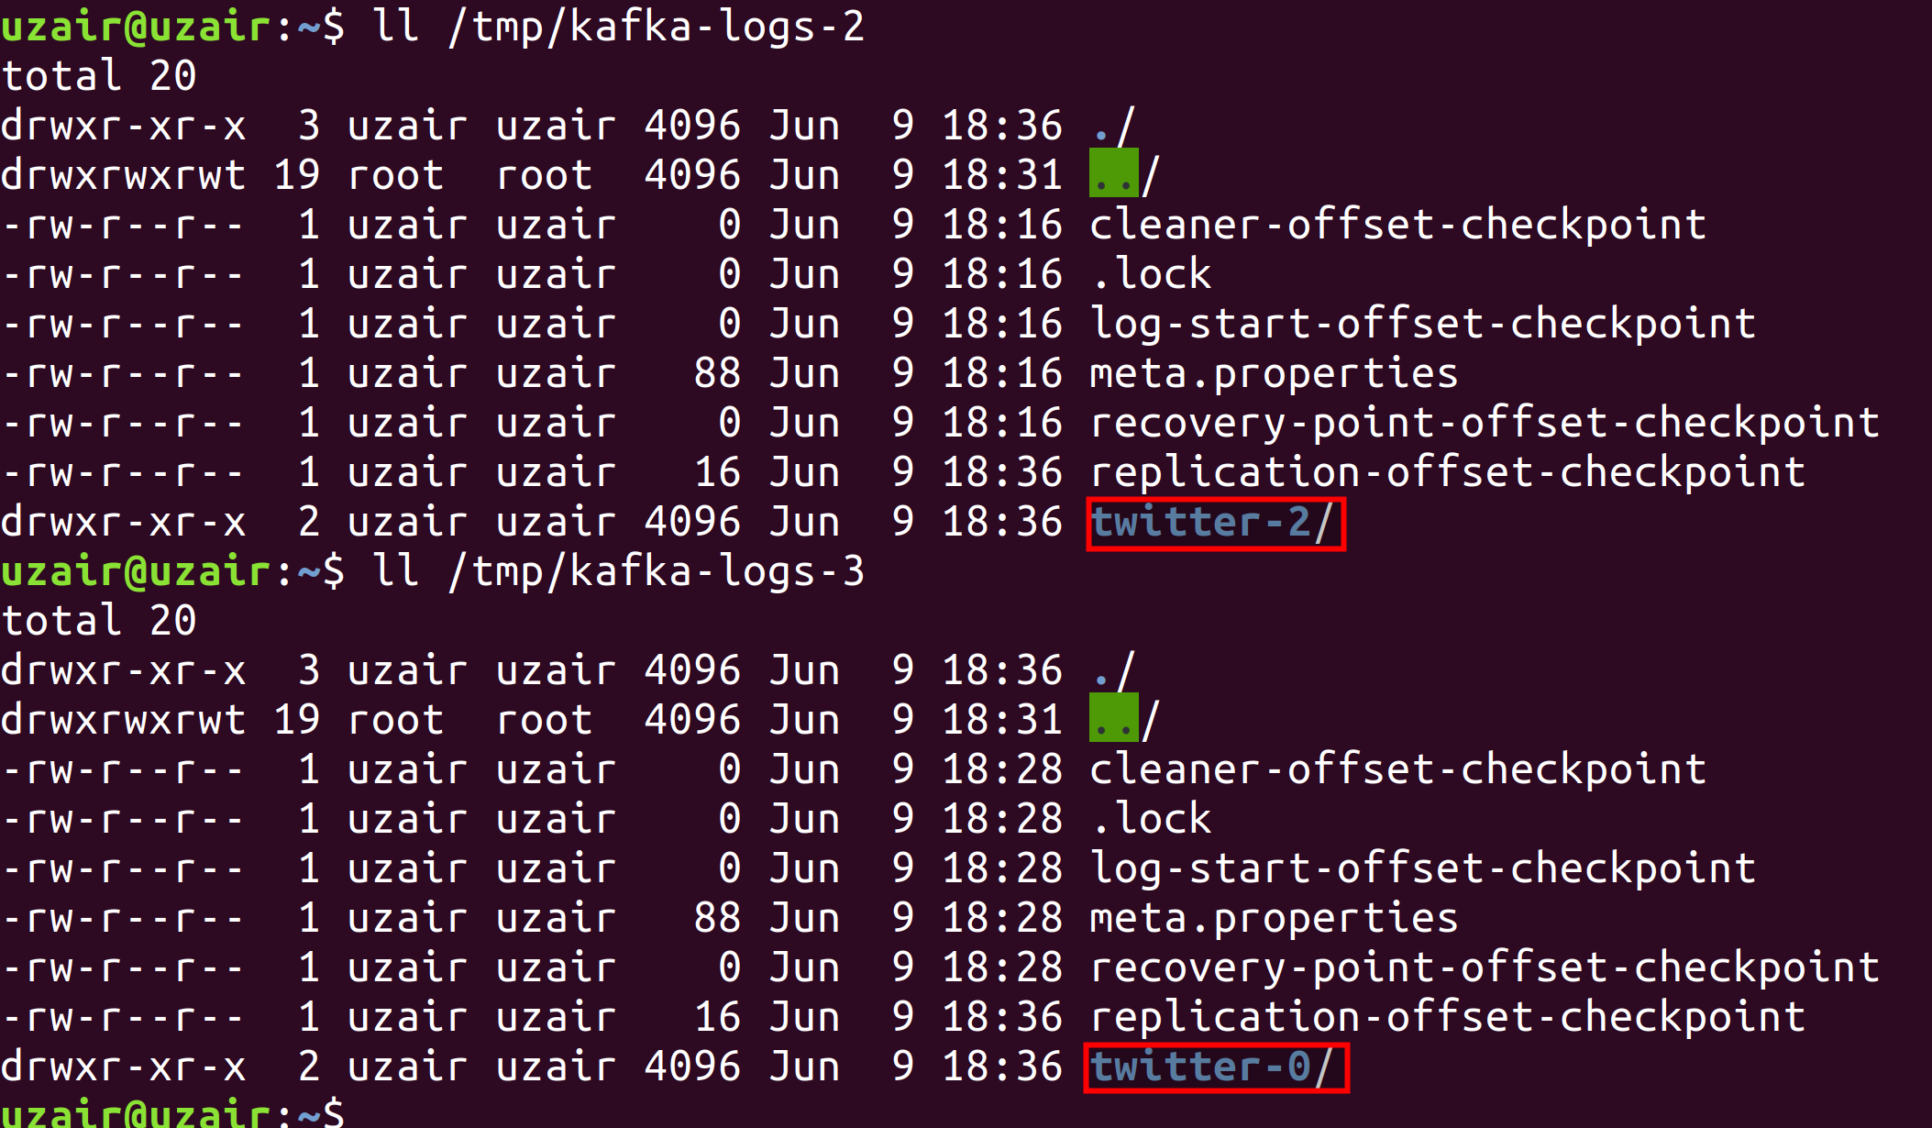

This is how the data is distributed across the cluster in a Kafka cluster.

**Step 9:** Let us stop the Controller Broker i.e., Broker 1 to simulate failure and see which Broker gets successful in creating the *controller* file in ZooKeeper to become the Controller Broker.

You can either press Ctrl + C keys or run the stop command to shut down the Kafka Broker 1.

After the Broker 1 is shut down, go back to the ZooKeeper shell and check the list of available Brokers.

ls /brokers/ids

You should see that Broker 1 is no longer the member of Kafka cluster.

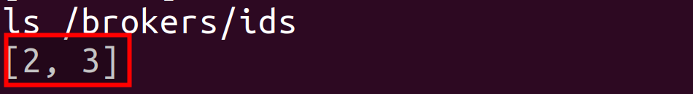

Now, check the contents of *controller* file to see which Broker was successful in becoming the Controller Broker.

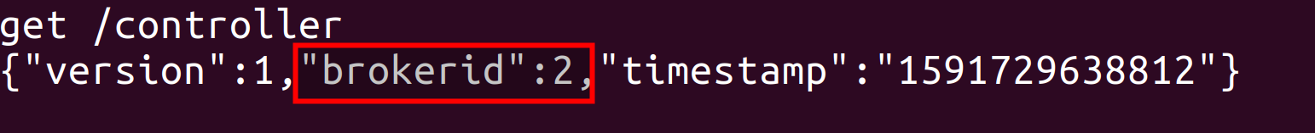

As you can see from the screenshot above, Broker 2 is now the Controller Broker.

When Broker 1, i.e., the previous Controller Broker was down, the *controller* file gets deleted in ZooKeeper. Since all the other Brokers subscribe to this file, they get notified about the deletion of file, i.e., the Controller Broker failure. All the Brokers will once again try to create the *controller* file. Whichever Broker succeeds in creating the *controller* file becomes the Controller Broker. This entire process happens in milliseconds ensuring the high availability of Controller Broker.

You may try shutting down the Broker 2 to check if the Broker 3 will become the Controller Broker.

**Task 3 is complete!**

**SUMMARY**

In this chapter, we have looked at Topic operations, Topic Overview, Data model in ZooKeeper, ZooKeeper watches, Election and responsibilities of Controller Broker. We have seen how the Topics receive messages from Producers. We have also seen how ZooKeeper helps Kafka in Controller Broker election ensuring high availability and coordination.

In the labs, we have performed, Topic operations, had hands-on the ZooKeeper shell and demonstrated the Controller Broker election.

**CHAPTER 4: KAFKA IN-DEPTH – PART II**

**Theory**

In the previous chapter, we got familiar with internals of Topics, ZooKeeper, Election and responsibilities of Controller Broker. In this chapter, let us learn about the remaining Kafka components in-depth.

Let us look at the following internals of Kafka in this chapter.

* Replications
* Partitions
* Bootstrap Server

**Replications**

Replication in Kafka plays an important role in durability of data. Replication guarantees that data or messages are not lost when there is a Broker failure. As learned in the previous chapters, messages are classified in the form of Topics and stored in Brokers. A Topic is divided into multiple Partitions and each Partition can have any number of replications. Since the replicas of a Partition are stored across multiple Brokers, an individual Broker failure does not lead in data loss. Let us understand the concept of replication with an example.

* Consider a Kafka cluster with six Brokers and a RFID sensor application as Producer that sends messages to Brokers in Kafka cluster.
* The producer sends sensor messages to a Topic called *sensor*. The *sensor* Topic contains three partitions with a replication factor of two.

The following details are used while creating a Topic:

*Topic* – sensor

*Partitions* – 3

*Replication* *factor* – 2

After the Topic *sensor* is created, the partitions and replications are stored in the Brokers, as shown in the figure 4(a). There are three partitions with a replication factor of two and are stored in six Brokers.

* There are two types of replicas in Kafka. They are the *Leader replica* and *Follower replica*. When a new Topic is created, Kafka elects a partition as Leader replica using its leader election algorithm. The first replica is elected as the leader from the list of replicas.

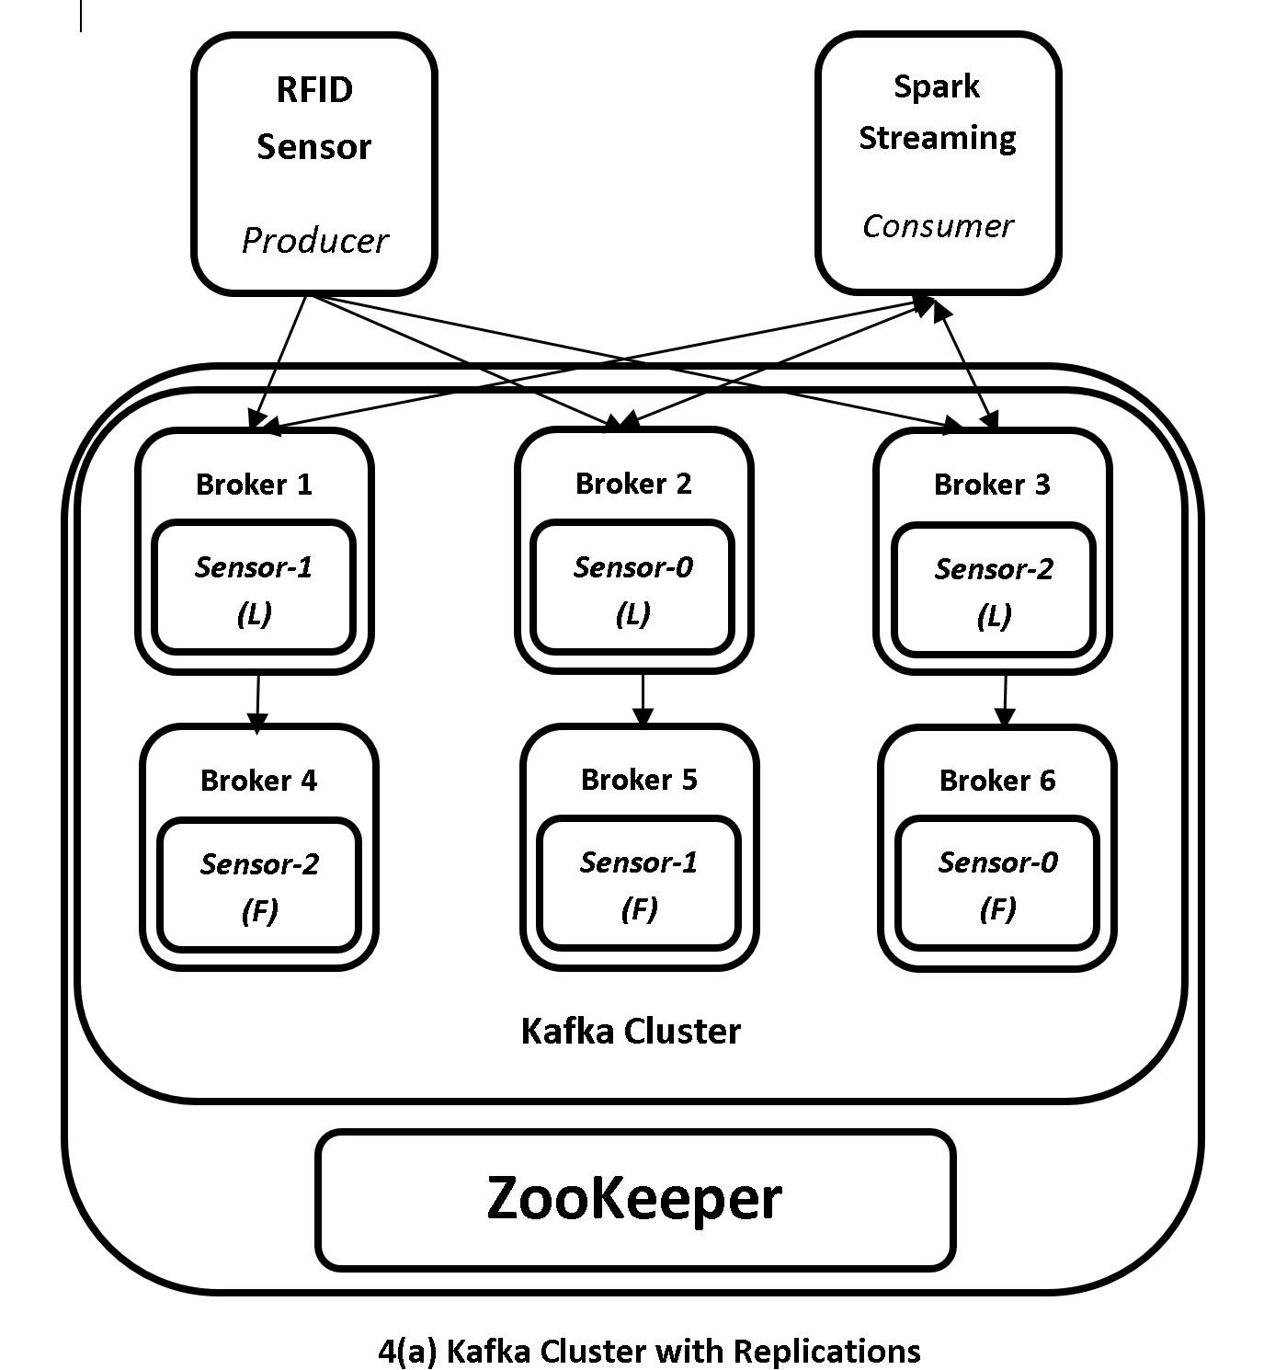

* Let us consider that the replicas in Broker 1, 2 and 3 are the Leader replicas, while the replicas in Broker 4, 5 and 6 are Follower replicas as shown in the figure 4(a). The Leader replicas are denoted with ‘L’ and Follower replicas are denoted with ‘F’.
* All the Producer and Consumer communication happens through the Broker that hosts the *Leader replicas*. In our example, the Producer sends data to Broker 1, 2 and 3 i.e., the Brokers hosting Leader replicas. The Producer does not send the data to Broker 4, 5 and 6. Similarly, the Consumer requests the data from Broker 1, 2 and 3 and not from Broker 4, 5 and 6.
* The Brokers containing replicas of Partitions that are not Leader replicas are the *Follower replicas*. The Follower replicas act similar to Consumers but internally within the Kafka cluster. The Follower replicas request data from Brokers hosting Leader replicas and replicate all the messages from Leader Broker. The Brokers containing Follower replicas do not communicate with Producers or Consumers. Their job is to replicate the data received by the Brokers that contain Leader replicas and update the newly received messages.

In our example above, Broker 6 (Follower) sends a request to Broker 2 (Leader) to replicate the data in Broker 2. Similarly, Brokers 4 and 5 request Brokers 1 and 3 for replicating the data. This helps Follower Brokers to maintain the current state of data to that of Leader Brokers.

* The Brokers can host both a Leader replica or a Follower replica. There is no such requirement that a Broker hosting a Leader replica shouldn’t host a Follower replica. In the example above, the Brokers 1, 2 and 3 can also host follower replica partitions of other Topics and similarly Brokers 4, 5 and 6 can host Leader replica partitions of other Topics. A Broker can also be called as a Leader Broker or a Follower Broker with respect to the Topic’s Partition it hosts.
* The Leader Broker is also responsible to keep track of current state of data being replicated by its Followers. The Followers have the up-to-date data replicated with the help of Leader. However, there could be scenarios where the Followers are not in sync with Leader due to network and hardware issues. If a Follower does not send a fetch request to Leader for more than 10 seconds or the message sent by the Leader has not been acknowledged by the Follower, the Follower is considered as out of sync with the Leader. This out of sync Follower replica will never become a new Leader replica in the event of current Leader failure.

On the other hand, the Follower replica that maintains the current state of data as of the Leader replica is known as in-sync replica (ISR). This ISR is eligible to become a new Leader in the event of current Leader failure. The maximum amount of time a Follower replica can lag before it is considered out of sync is controlled by the *replica.lag.time.max.ms* configuration property.

* In the event of Broker failure that hosts Leader replica, the Controller Broker gets notified about the failure using ZooKeeper (Please check previous chapter for more information about ZooKeeper and Controller Broker). The Controller Broker contains all the metadata information regarding Leader and Follower replicas. The Controller Broker will then look for a Follower replica that was in-sync with Leader that failed. Once it finds the in-sync replica, it is made the new Leader replica. This ensures high availability of Kafka cluster.
* For our example, let us assume that Broker 2 that hosts the *sensor-0* partition replica is down due to a hardware failure. The Controller Broker that keeps a watch (subscribe) on Brokers’ ids directory will be notified about the failure as the Broker ID 2 node will be deleted. The Controller Broker with the help of metadata information will look for a Follower copy that is in-sync with the Leader. In this case it is the Broker 6 that hosts the Follower replica of *sensor-0* and hence it will be made the Leader replica.
* With Broker 6 now hosting the Leader replica, how does the Producer know that the Broker 2 has failed and Broker 6 now hosts the Leader replica? The Producer will generate the data and send the data to Broker 2 as usual. But this time the Producer will get an exception called *LeaderNotAvailable*. The Producer will then contact the Controller Broker requesting the metadata. The Controller Broker will respond to the metadata request of the Producer notifying the newly elected Broker hosting the Leader replica. The Producer will then send data to Broker 6. This ensures that the communication between the components of Kafka cluster is always available.
* We have used a replication factor of 2 in our example above for simplicity. However, the recommended replication factor at which the partitions should be replicated is 3.

To summarize, replication helps in achieving high availability of communication between Kafka components.

**Partitions**

Partitions are the unit of storage for messages in Kafka. A Topic can be divided into any number of Partitions. The Partitions cannot be split across Brokers in a Kafka cluster or within the disks on the same Broker. So, the maximum size of a Partition cannot exceed the size of the disk. The number of Partitions are specified while creating a Topic. The path at which the Partitions will be stored is specified in the configurations file, as we have seen in previous chapters.

But how does Kafka decide which Partition is stored in which Broker? To answer this question, continue below to understand how partitions are assigned in Kafka.

**Assigning Partitions**

After a Topic is created, Kafka allocates partitions to available Brokers in the cluster. Consider the example from previous section. We have a Topic with 3 Partitions with a replication factor of 2. This translates to a total of 6 partition replicas on 6 Brokers. Kafka makes sure the following conditions are met while assigning partitions.

1. All the Partition replicas for the Topic are distributed evenly among the list of Brokers. Each Partition is assigned per Broker in case of our example.
2. Replicas of the same Partitions are not assigned to the same Broker. For our example, sensor*-0* Partitionis assigned to Broker 2 while the other replica partition is allocated to Broker 5. Kafka doesn’t assign both the Leader replica and Follower replica to the same Broker. This assures that the Follower replica in Broker 5 is still available if Broker 2 is down due to network issues or hardware failure.
3. Kafka can also be configured for rack awareness, if available. If the Kafka cluster spans multiple racks, the Partitions can be assigned in Brokers available on different racks. Assigning Partitions with rack awareness makes sure that in the case of a rack failure, the data is still available in the Brokers on other racks.

The Leader replica of a Partition is assigned by selecting a random Broker in the Kafka cluster. The rest of the Leader Partitions are assigned in a round-robin approach. The Follower replicas are assigned with increased offsets from their Leader. For example, if a Leader replica is assigned to Broker 3, it’s Follower replicas will be assigned to Broker 4, Broker 5 and so on.

The above approach is not true when rack-awareness is available for Kafka cluster. In case of rack-awareness, a Broker is selected from each rack in alternation. If the cluster contains of a total of 10 Brokers with 5 Brokers on each rack, a Broker list for rack awareness is prepared as 0, 5, 1, 6, 2, 7, 3, 8, 4 and 9. The list contains alternating Brokers from rack 1 and rack 2. So, if a Leader replica of a partition is on Broker 6, its replica will be on Broker 2. This means that the Leader replica is on a Broker in rack 1 and the Follower replica is on a Broker in rack 2. In the event of rack 1 failure, the follower replica is still available in another rack.

**Bootstrap Server**

Bootstrap servers are a list of servers (Brokers) used by the clients (Producers and Consumers) to establish an initial connection with the Kafka cluster. Once a connection is established, the clients get the full list of Brokers available in that cluster using the metadata information. The metadata information is shared with every Broker in the cluster by the Controller Broker. The client will then look for the Brokers hosting the partitions for that Topic using the metadata information and starts communicating with those Brokers.

Let us understand this better with an example.

* Consider a Kafka cluster with 6 Brokers and a Producer that generates sensor data. Also, consider a Topic with 3 Partitions and a replication factor of 1.
* The Producer has now started generating the messages. But how does the Producer know which Brokers host the Partitions it has to send the messages to? This is where the Bootstrap servers play their role.
* In the Producer code, we need to specify a list of host:port pairs of Brokers in a configuration property called *bootstrap.servers*.
* The Producer will use the first host:port pair of the Broker to establish an initial connection with the Kafka cluster.
* The Producer will then request the metadata information of the Kafka cluster. The Broker will respond with the metadata information.
* The client will then look up for the Brokers containing the Partitions for that Topic and start generating messages to the Partitions.
* How many Broker host:port pairs should be provided as the value for *bootstrap.servers* configuration property? It is recommended to provide at least 2 Broker host:port pairs. This is to ensure that the client is able to connect with Kafka cluster, even if one of the Broker is down.

In the labs, we shall be looking an example Producer code to understand how the *bootstrap.servers* configuration property is specified.

That’s all for the theory for this chapter. Let us move to the lab exercise to install IntelliJ IDEA and Scala language to our virtual machines. This will be required when we start writing Producer and Consumer code in the upcoming chapters.

**AIM**

The aim of the following lab exercises is to download and install IntelliJ IDEA and Scala. We’ll then see how to specify Bootstrap servers in Producer code.

The labs for this chapter include the following exercises.

* Download and Install Scala
* Download and Install IntelliJ IDEA
* Configuring IntelliJ IDEA
* Specifying Bootstrap servers

We need the following packages to perform the lab exercise:

* Java Development Kit
* Apache ZooKeeper
* Apache Kafka
* Scala
* IntelliJ IDEA

**LAB EXERCISE 3: KAFKA IN-DEPTH – PART II**

1. **Download & Install Scala**
2. **Download & Install IntelliJ IDEA**
3. **Configuring IntelliJ IDEA**
4. **Specifying Bootstrap Servers**

**Task 1: Download and Install Scala**

Let us now install Scala. We will be writing the Producer and Consumer code in Scala in the upcoming lab exercises.

**Step 1:** Run the following command from the terminal to install Scala.

$ sudo apt-get install scala

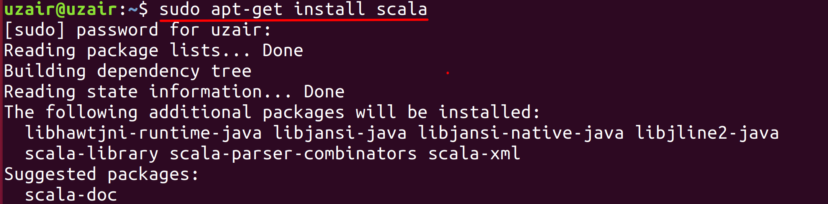

The prompt will ask you to hit ‘Y’ after running the above command as shown in the screenshot. Hit ‘Y’ from your keyboard to continue with the installation and finally hit the Enter key.

**Step 2:** Verify your Scala installation version by running the following command.

$ scala -version



**Step 3:** After the installation is completed successfully, type *scala* in your terminal and you will be prompted with a Scala prompt.

$ scala

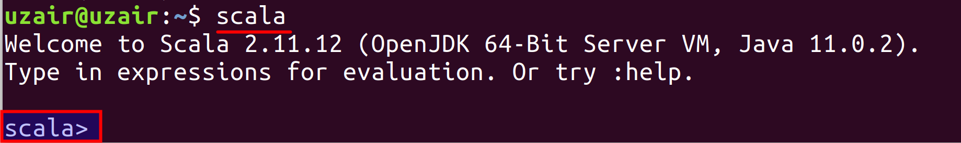

This completes the Scala installation. The *scala* prompt is the interactive shell where you can write and run Scala code. This interactive shell is also known as REPL.

**Step 4:** You can now start writing Scala code! Let’s start by printing the classic “Hello world!” from the shell. To do this simply type the following code and hit enter on your keyboard.

scala> println(“Hello World!”)

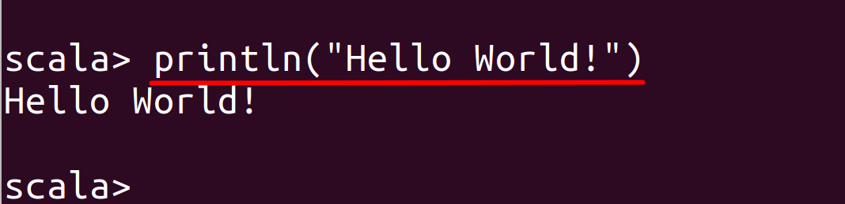

As you can see from the screenshot, the output is shown below immediately as soon as you hit enter.

**Step 5:** To quit the Scala REPL, you use the following command.

scala> :q

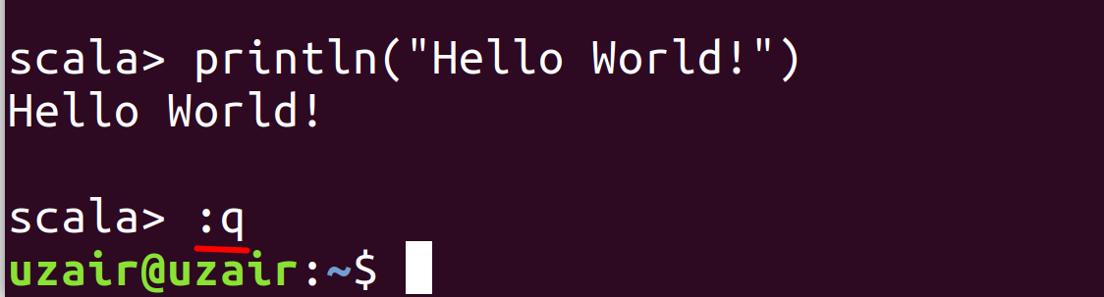

You are now back to the terminal prompt.

**Task 1 is complete!**

**Task 2: Download and Install IntelliJ IDEA**

We shall be using IntelliJ IDEA to write client code throughout the lab exercises. In this task we shall download and install IntelliJ IDEA and then install Scala plugin so that we can write Scala code.

**Step 1:** Navigate to the following URL from your web browser and click on the “Download” button for *Community* edition as shown in the screenshot below.

<http://bit.ly/2V1HFYO>

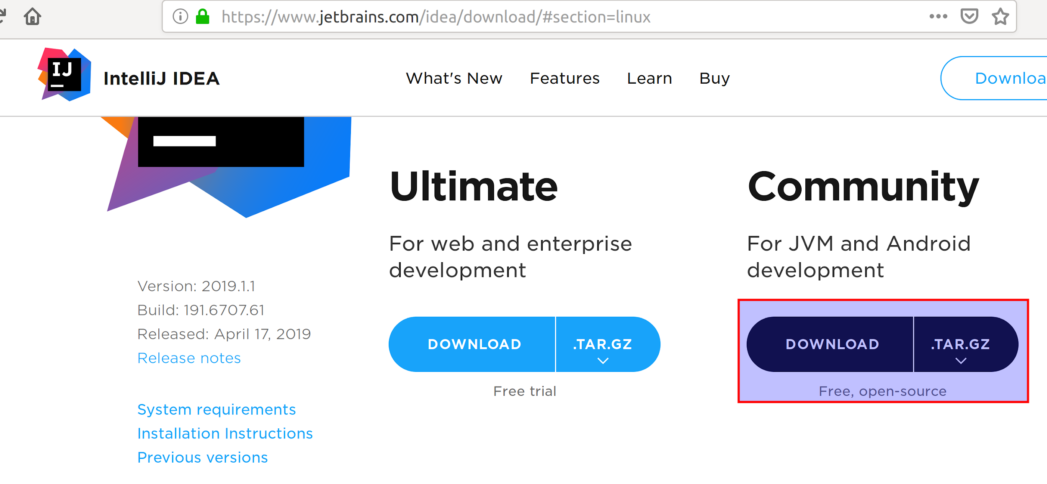

The file should begin to download automatically to the *Downloads* folder. The download might take a while depending upon your internet connection.

**Step 2:** Once the download is complete, open the terminal and run the following commands to untar. We shall be extracting the tar ball to the /opt directory.

$ sudo tar –xzf Downloads/ideaIC-2019.1.1.tar.gz –C /opt



Please note that your version of IntelliJ might be different. Please replace the version correctly.

**Step 3:** Now run the following command to install IntelliJ.

$/opt/idea-IC-191.6707.61/bin/idea.sh

Please note that your path or the version might be different.

You should now see a prompt asking to import settings. Simply click “OK”.

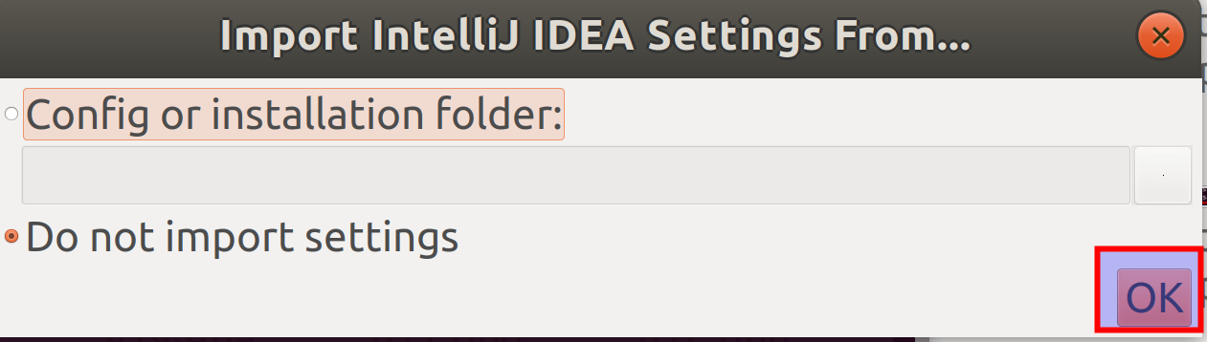

**Step 4:** You should now be prompted with a *Privacy Policy* window. Click on the check box to accept the policy and click on “Continue” button as shown in the screenshot.

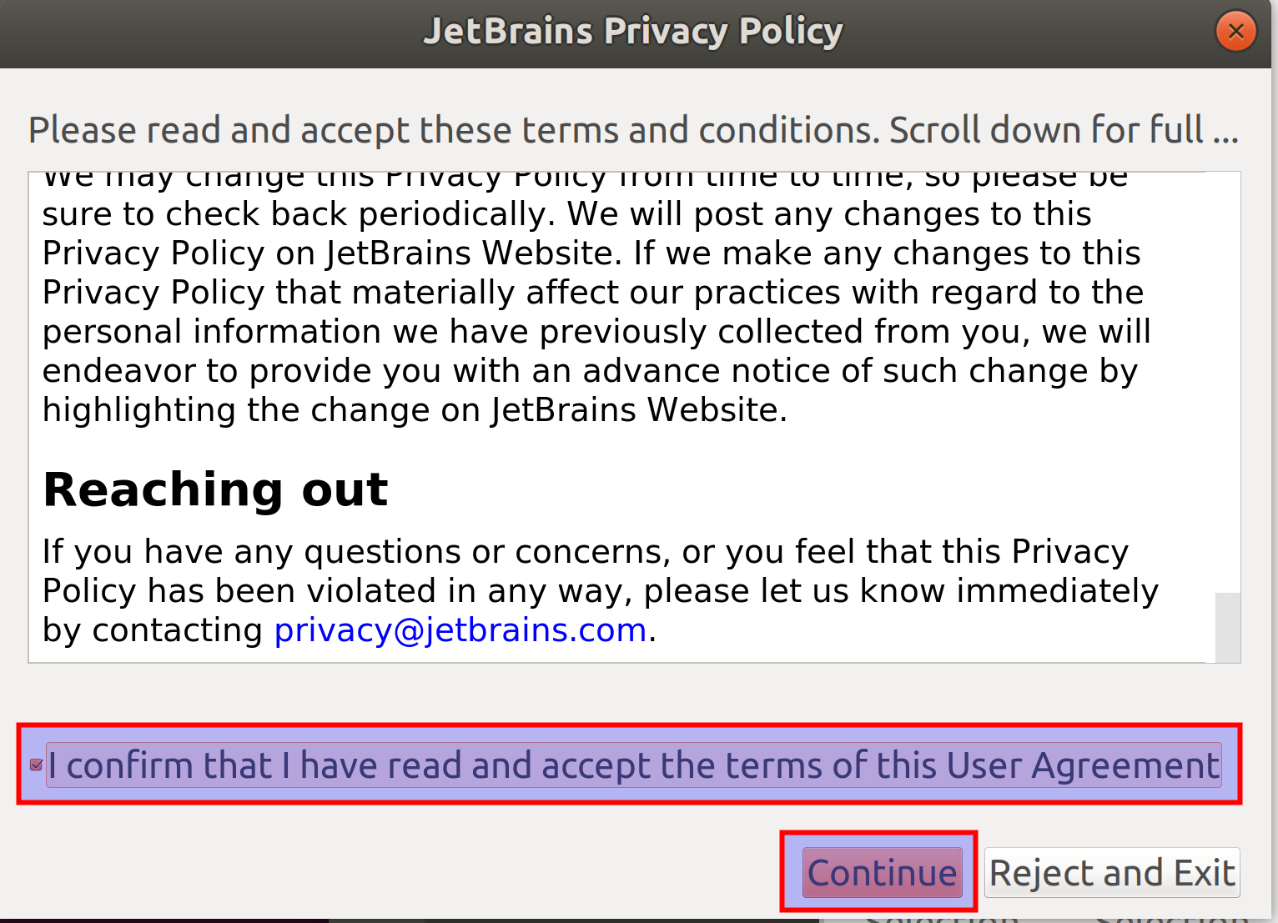

In the next prompt, click on “Don’t Send”.

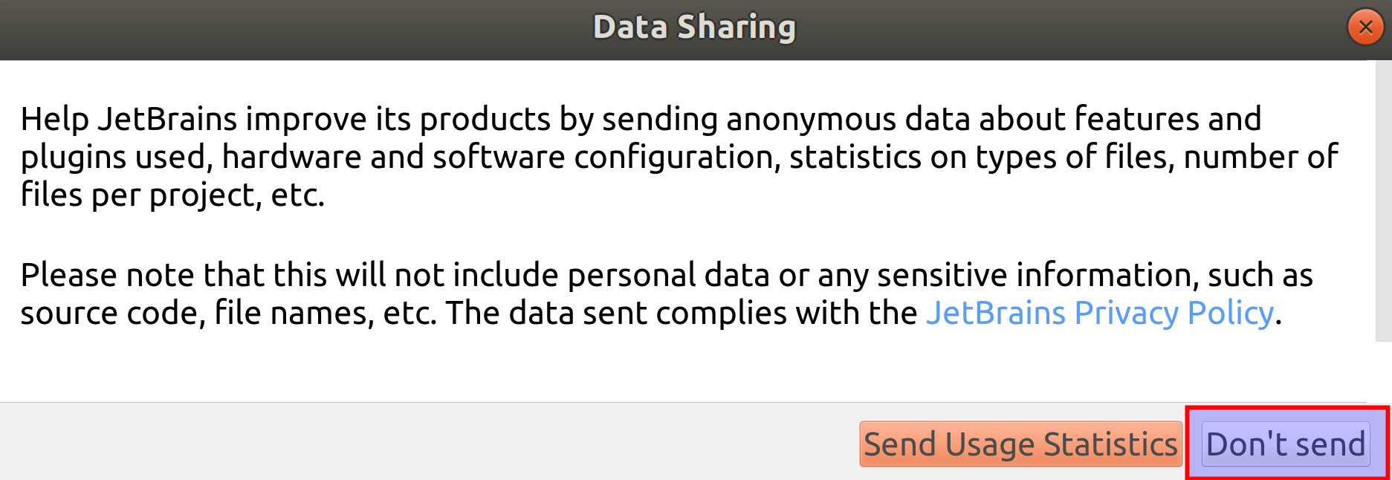

**Step 5:** You will now be prompted to select a theme. Please select a theme you are comfortable with and click on the “Skip remaining and Set Defaults” button as shown in the screenshot.

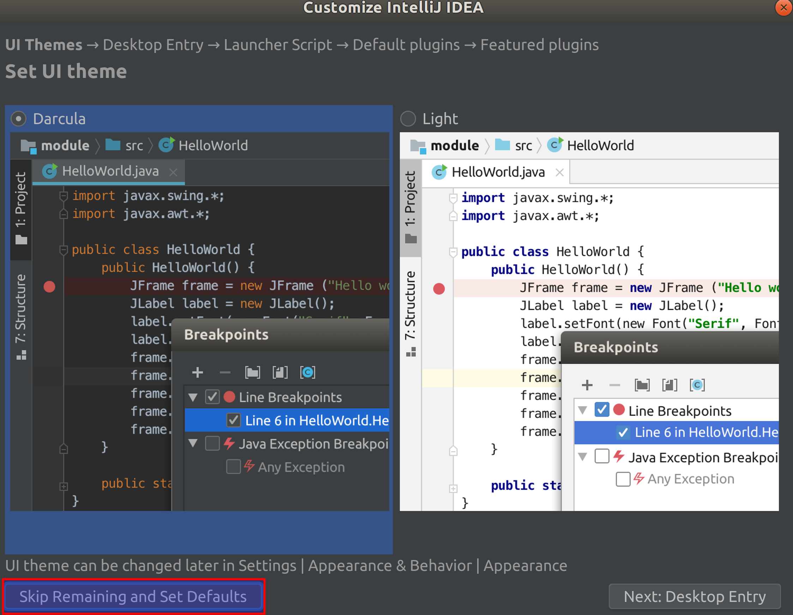

You should now see the welcome screen as shown below.

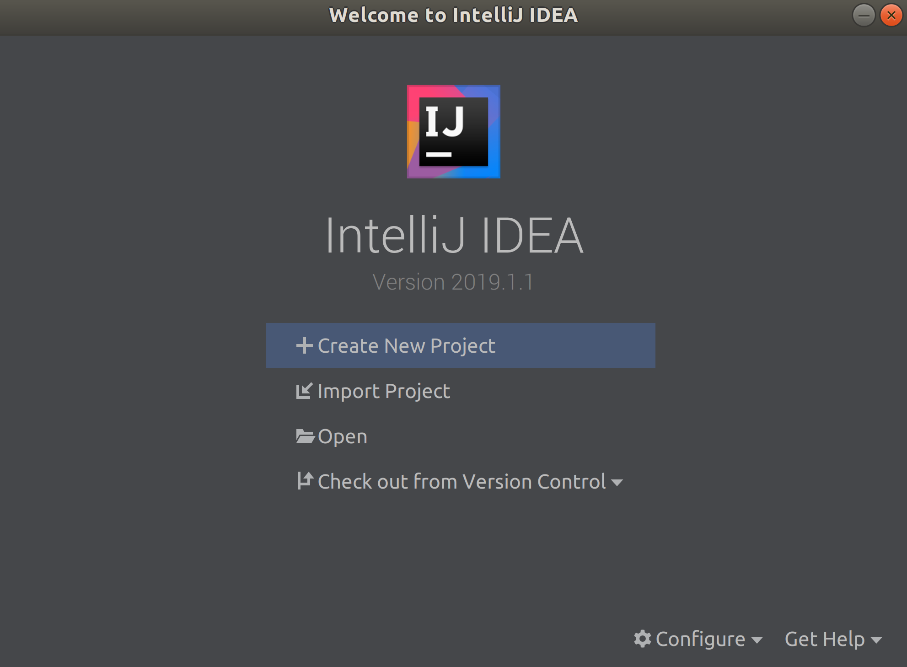

This concludes the installation of IntelliJ IDEA. But to run Spark Scala code, we need to install Scala plugin.

**Step 6:** Click on the “Configure” button as shown in the screenshot and click on “Plugins” in the dropdown menu.

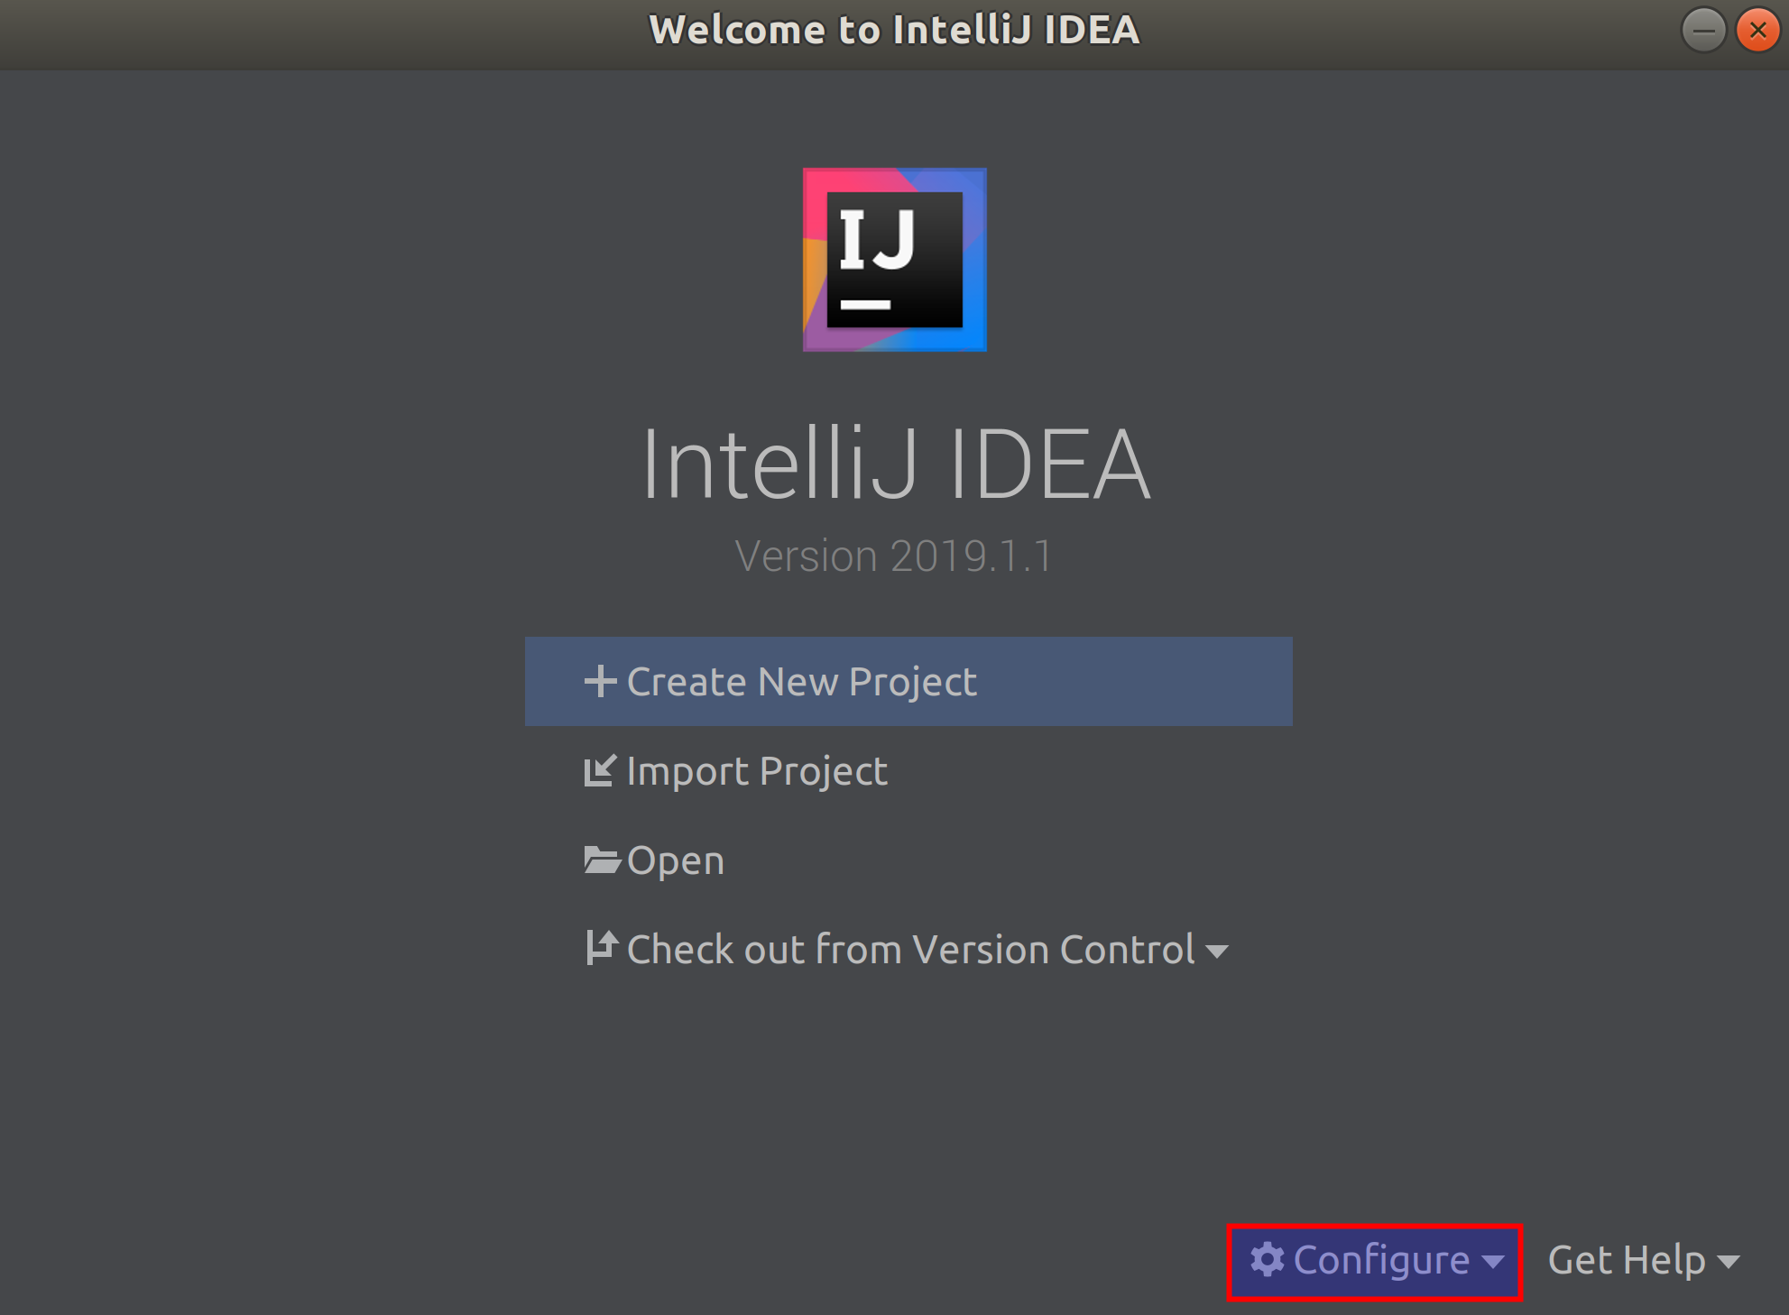

**Step 7:** The marketplace for plugins will be opened. Click on the “Install” button for “Scala” plugin as shown in the screenshot. If you do not see “Scala” right away, search for “Scala” in the search bar above and then click the “Install” button.

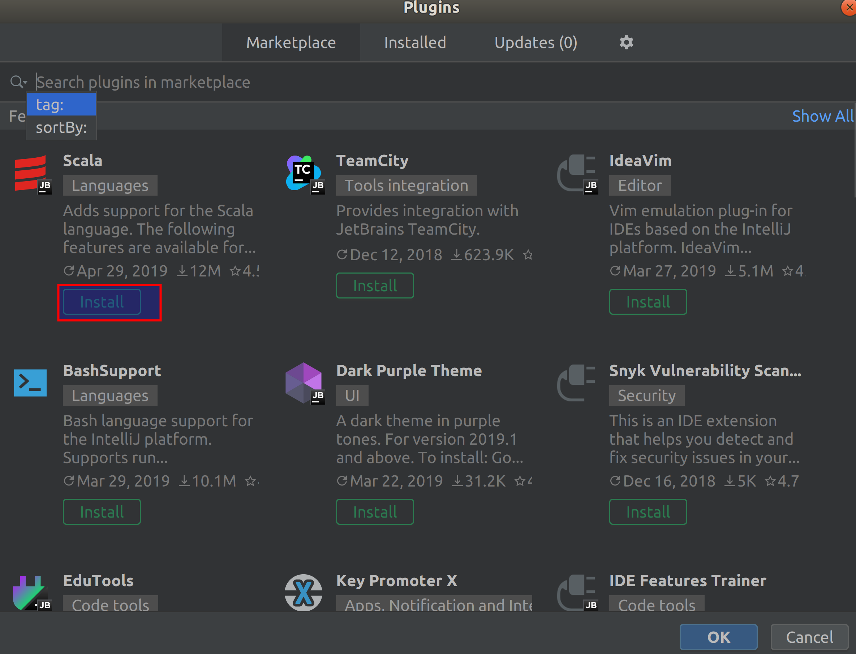

This action should begin the download. Once it is downloaded, you will be asked to Restart IDE. Please click on “Restart IDE” button. Click “Restart” in the conformation pop up.

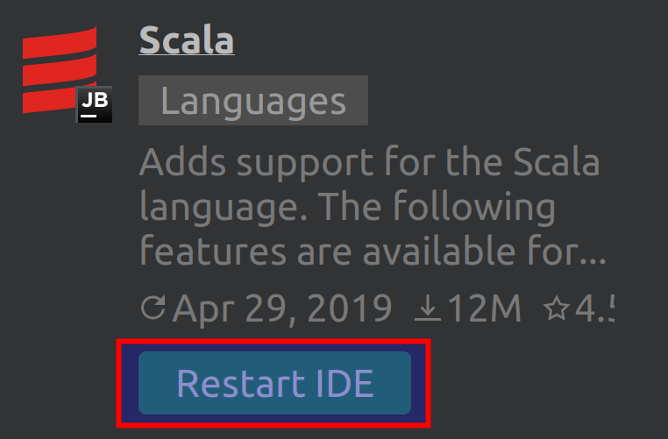

The IDE will now restart and show the welcome screen again. With this, you have successfully installed IntelliJ IDEA with Scala plugin.

**Task 2 is complete!**

**Task 3: Configuring IntelliJ IDEA**

**Step 1:** Click on the “Create New Project” button on the welcome screen.

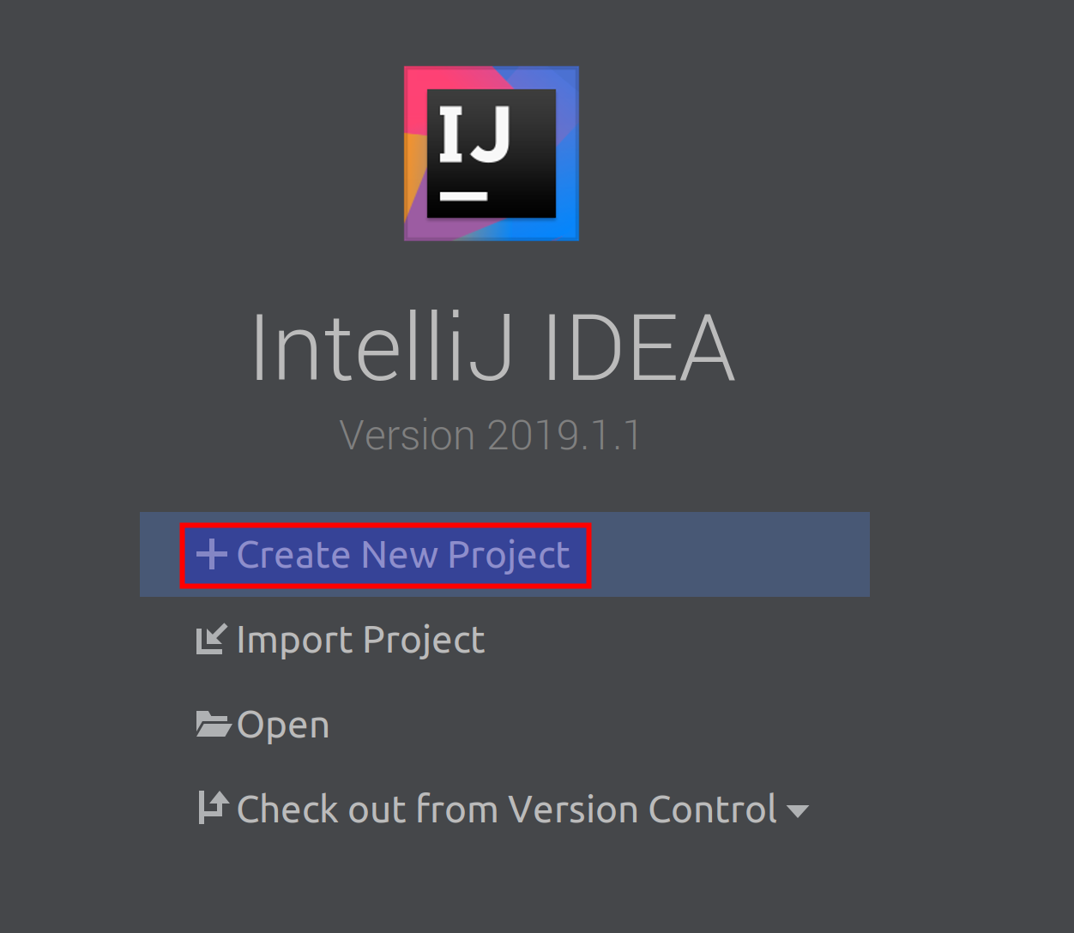

**Step 2:** You will then be taken to “New Project” screen. Click on Scala in the left panel, select “SBT” and then click “Next” as shown in the screenshot below.

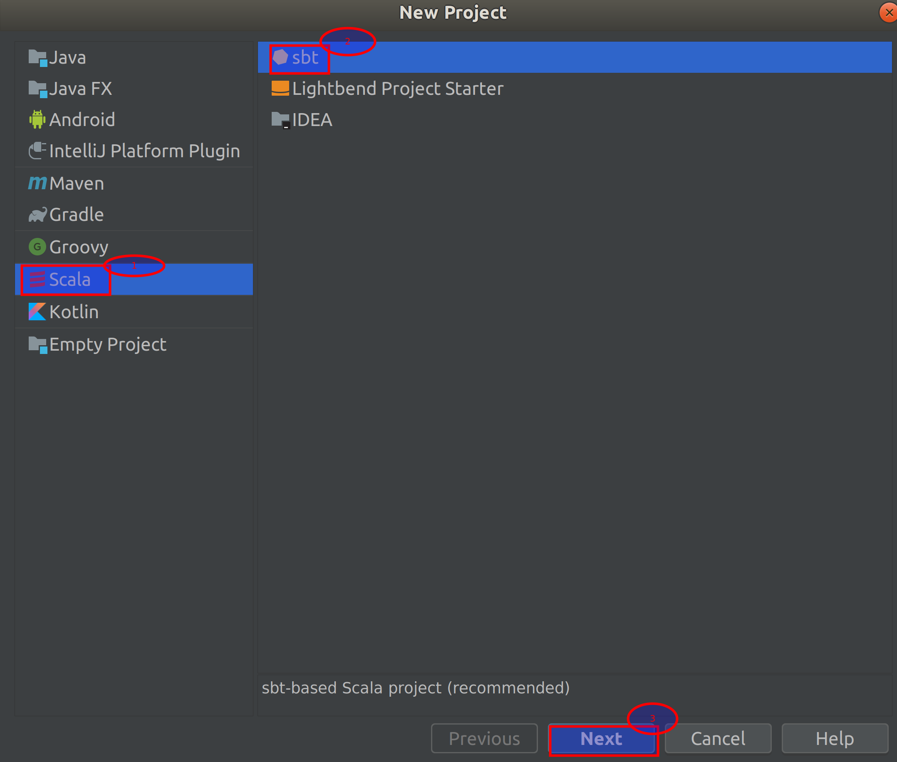

**Step 3:** After clicking “Next” in the previous step, you will be taken to prompt to enter project name. Enter project name as “Kafka”. Make sure the JDK, SBT and Scala versions are selected automatically as shown in the screenshot. Also, check the “Sources” checkbox for both SBT and Scala if not already checked. Finally click the Finish button.

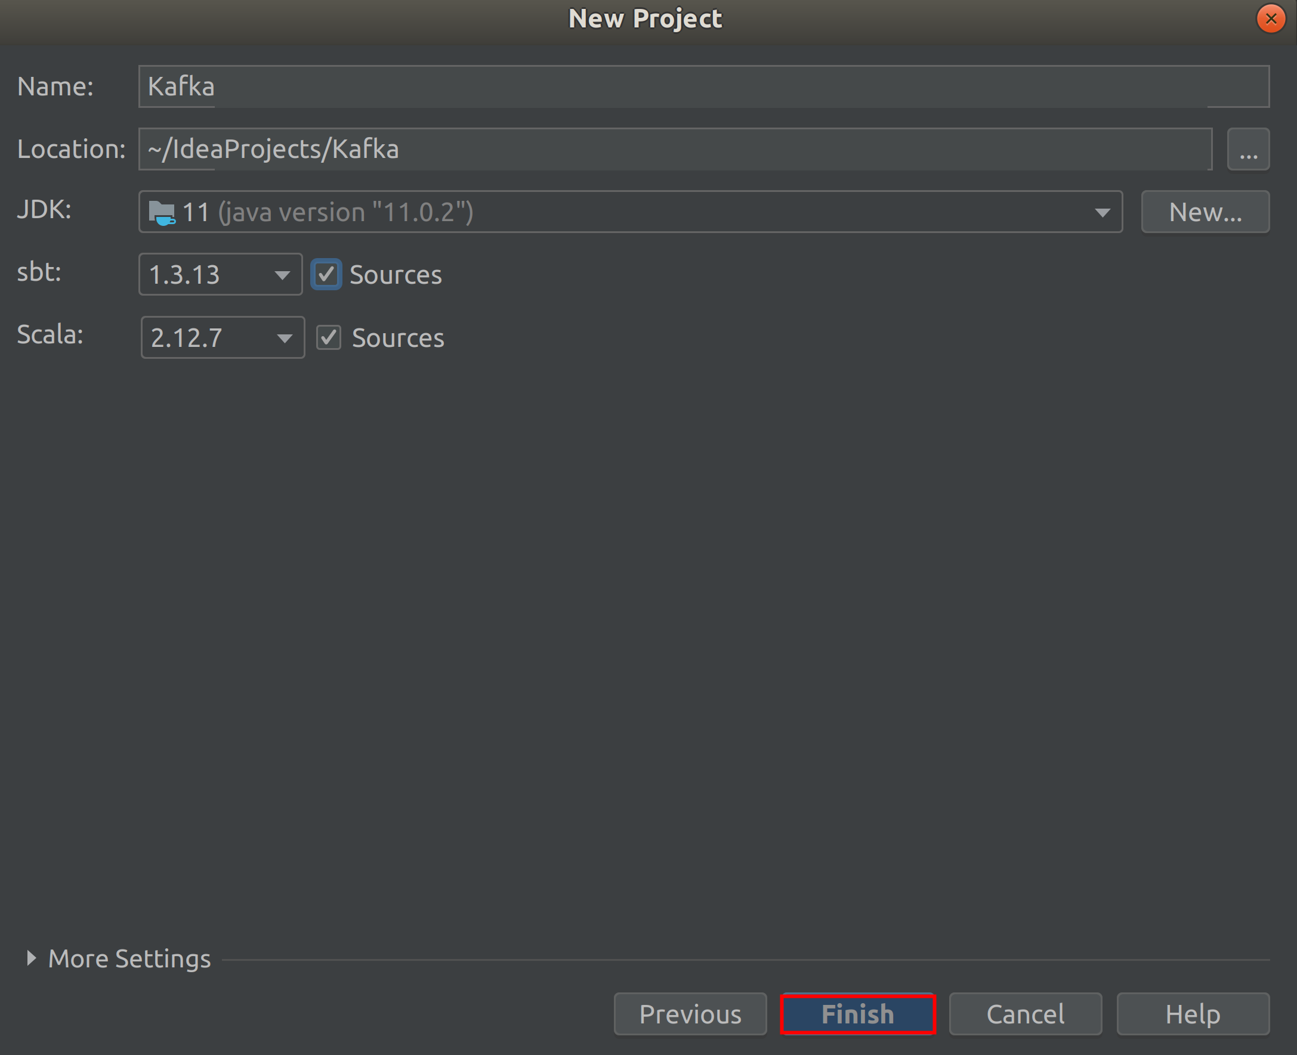

**Step 4:** You will now be taken to the IDE interface. Click on the “Project” as shown in the screenshot if not already open.

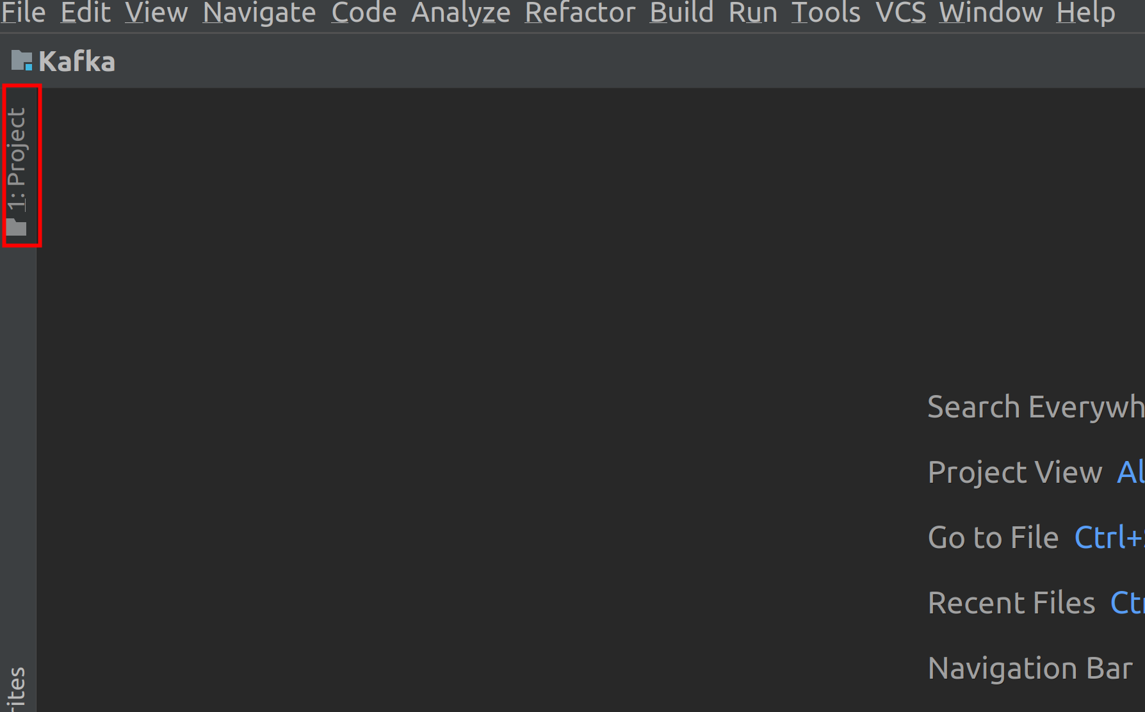

Expand the *Kafka* project by clicking on the small triangle to the left of it, if not already expanded and double click on *build.sbt* file as shown in the screenshot.

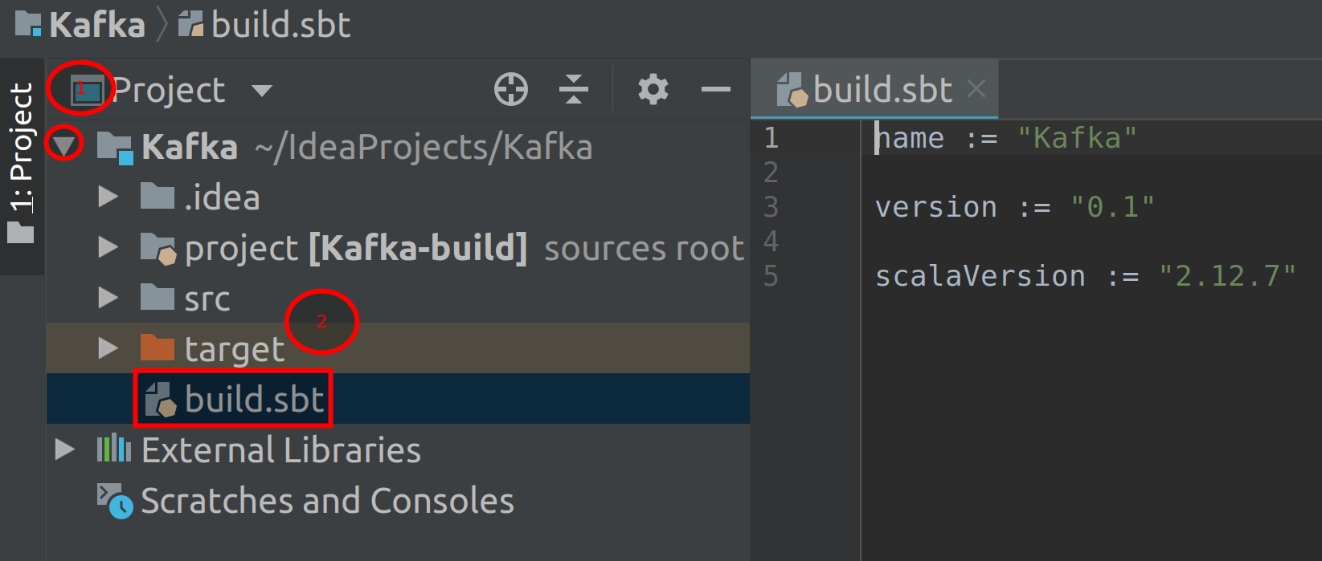

**Step 5:** Now go to the Maven Repository for Kafka using the URL below.

https://bit.ly/3iJGkOw

Click on the *Kafka Clients* link as shown in the screenshot.

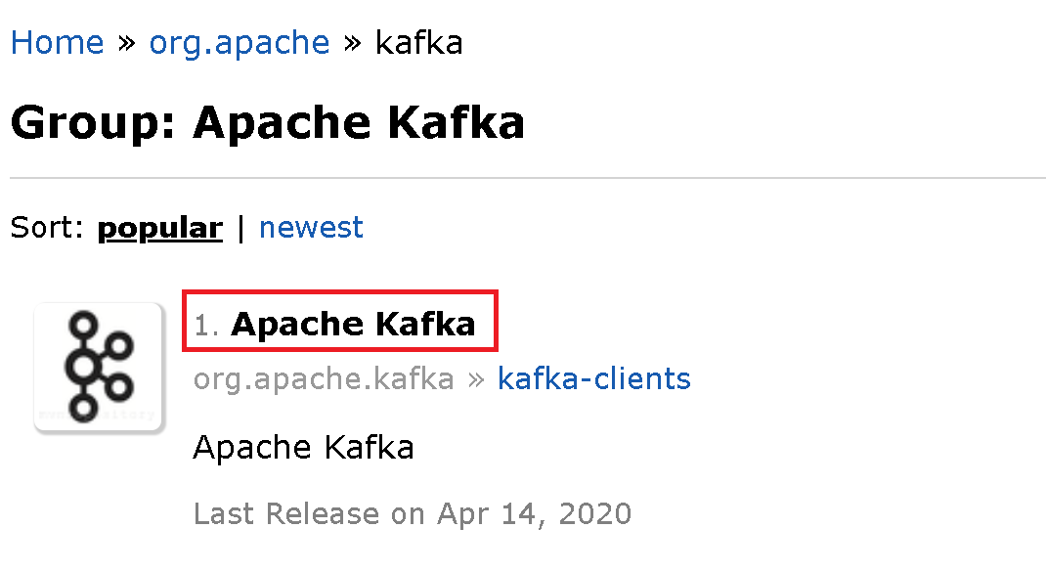

Next, select the version of Kafka you have installed. We have installed Kafka 2.5.0 in this book and hence we will be clicking on *2.5.0* link for Kafka. Please select the correct version as per your installation.

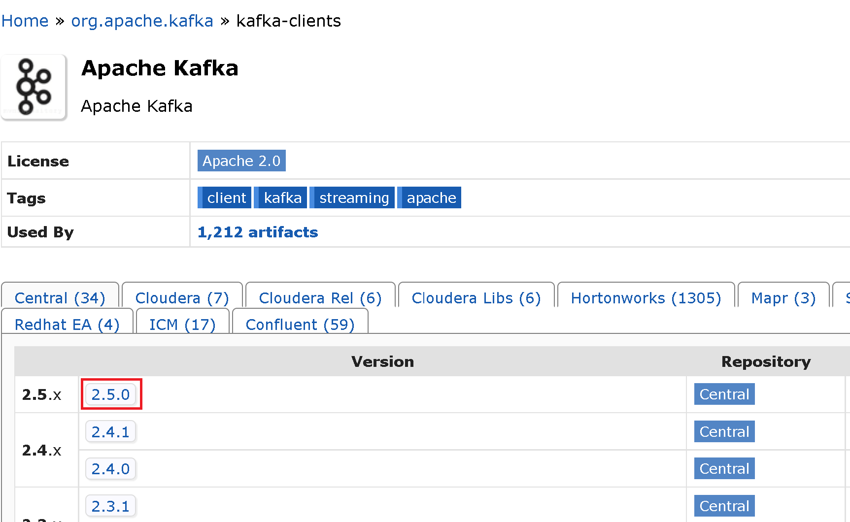

Now, select SBT tab and copy all the lines of code for SBT and paste it in the *build.sbt* file.

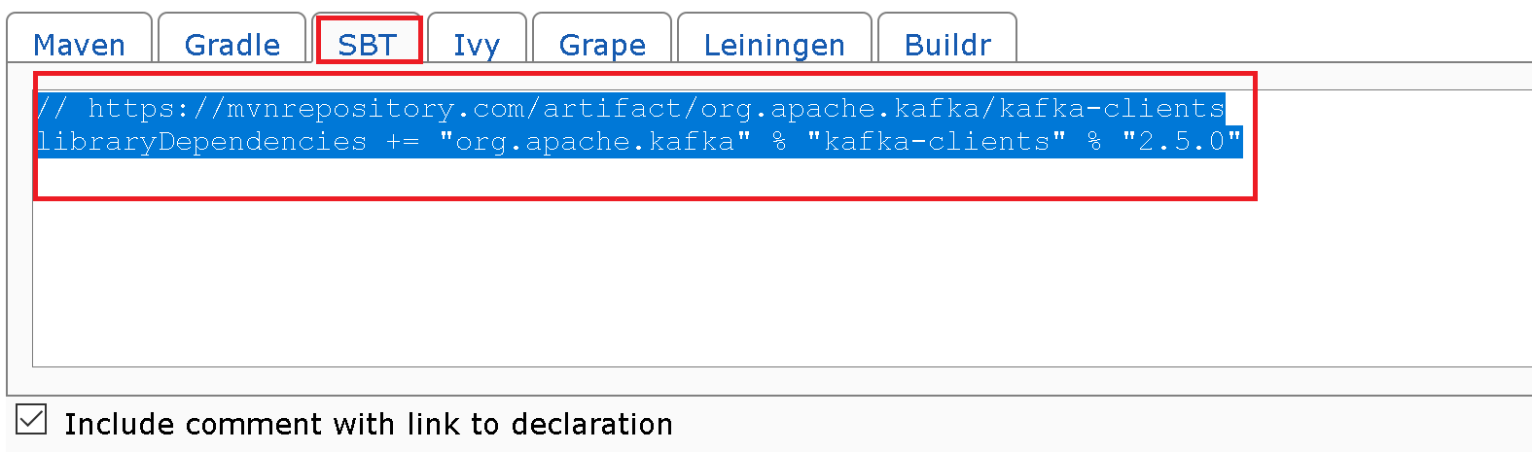

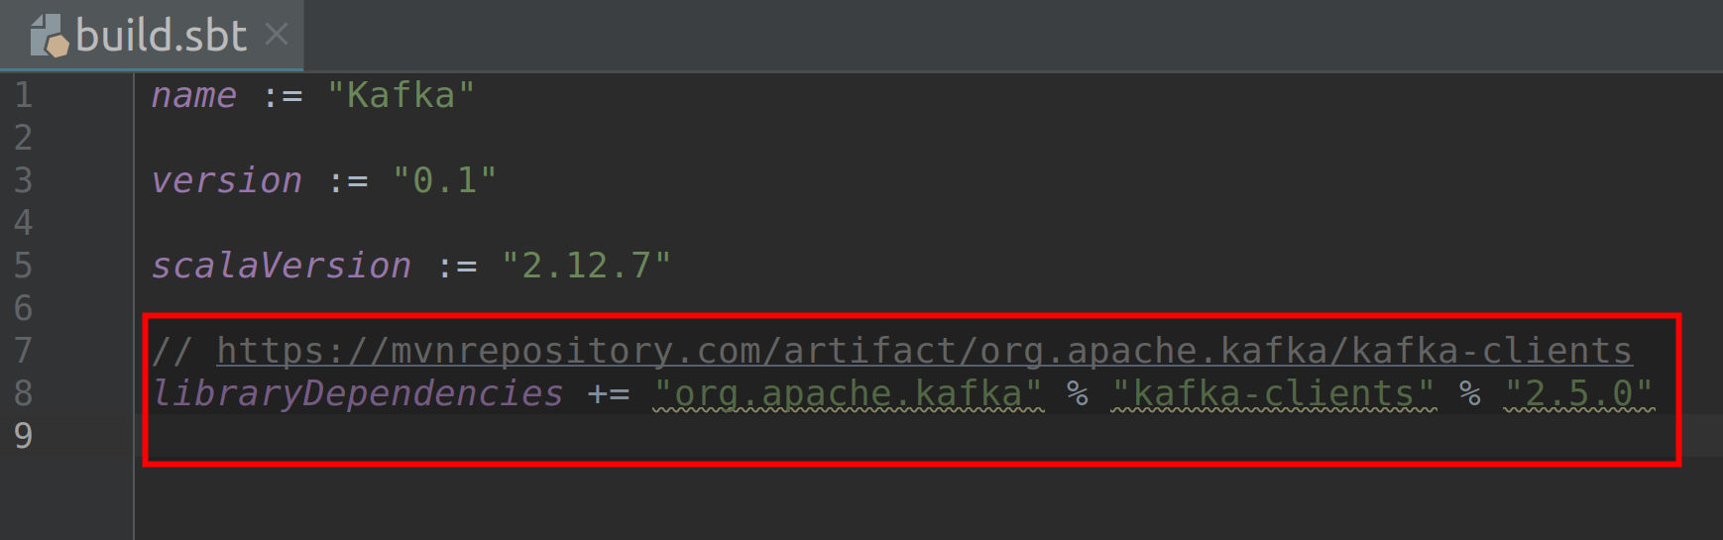

Go back to the Maven Repository page and copy paste the *Kafka* libraries as well in the *build.sbt* file.

Also add the following *slf4j* dependency. You may visit the website below to add the dependency. Make sure you add the latest stable version and not the alpha or beta versions.

// https://mvnrepository.com/artifact/org.slf4j/slf4j-simple

libraryDependencies += "org.slf4j" % "slf4j-simple" % "1.7.30" % Test

Finally, click on the “Import Changes” to finish configuration. The import may take a while depending upon your internet connection.

You can add new libraries if required by following the same procedure. You are now ready to write your first Client program in Kafka!

**Task 3 is complete!**

**Task 4: Specifying Bootstrap Servers**

The Bootstrap servers are specified as a configuration property within the Producer or Consumer code. Let us look at this in the following Producer example.

**Step 1:** The following screenshot is a Producer code.

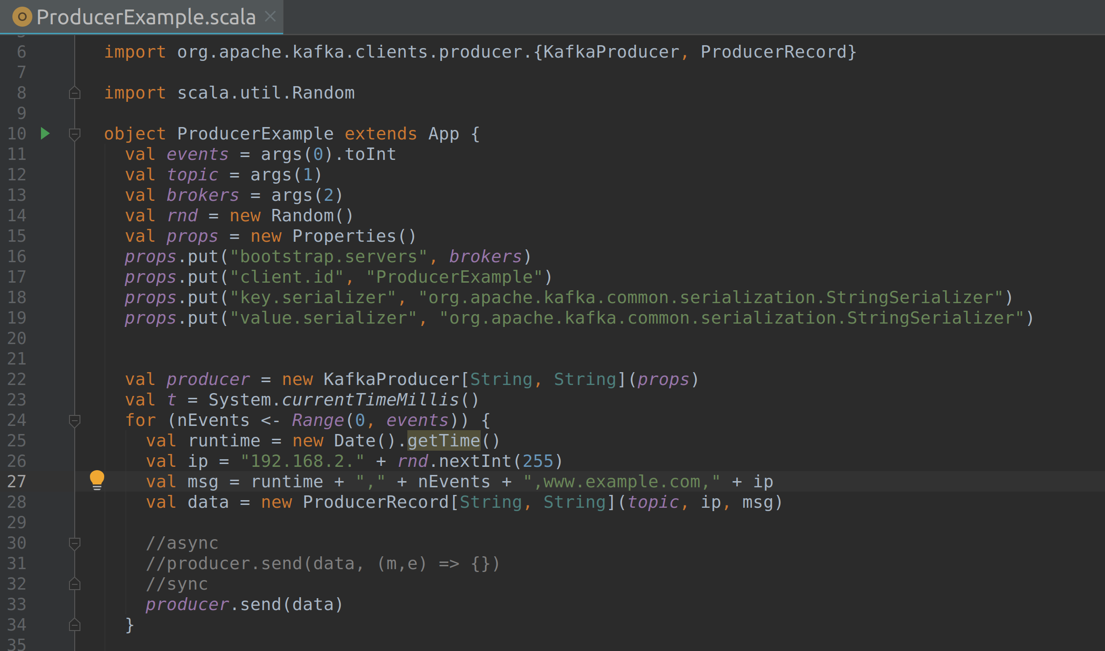

**Step 2:** The Bootstrap servers are set by configuration property called *bootstrap.servers* as shown in the screenshot below.

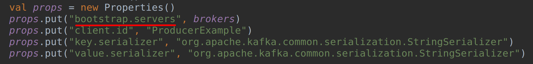

The host:port pairs of Brokers are then mentioned as comma separated values.

For example, the *bootstrap.servers* will look like

props.put(“bootstrap.servers”, “localhost:9092, localhost:9093”)

Please note that the example Producer code above takes the list of Brokers as arguments and hence the variable name is specified in the value field of the property instead of the list of Broker addresses.

We shall be working with Producers in the next chapter and running the Producer code.

**Task 4 is complete!**

**SUMMARY**

In this chapter, we have looked at Replications, Partitions and Bootstrap server configuration property. We have seen how the replication helps in high availability of Kafka cluster, in the event of Broker failure due to hardware or network issues

In the labs, we have downloaded and installed Scala and IntelliJ. We have also configured IntelliJ to run Kafka client code. We have then seen how to specify Bootstrap servers in the Producer example.

**CHAPTER 5: THE PRODUCER**

**Theory**

We have so far completed the basics as well as the in-depth architecture of Kafka. Let us now deep dive and look at the most important component of Kafka called the Producer. The Producer is the Kafka component that generates messages and allows them to write into Kafka using the Kafka Producer APIs.

What are the Producer APIs? As per the Kafka documentation, “*The Producer API allows applications to send streams of data to topics in the Kafka cluster.*” This simply means that the Producer APIs allow users to implement a Producer application that sends data to one or more Topics present in the cluster of Kafka Brokers. For example, consider few web servers generating HTTP logs for all the visits to those servers. The security team might want to analyze the logs generated by those web servers for security issues in real time. In this scenario, they could implement a Producer application using the Producer APIs to get the log data from severs into Kafka and then consume the data using Consumer APIs and do the analysis.

In this chapter, let us first look at all the internal components and workflow of a Producer. We’ll then learn how to implement a Producer application using Producer APIs in Scala. We shall also implement and run a Producer to send messages to Brokers of Kafka cluster in the labs.

**Producer Workflow**

The basic goal behind a Producer is to be able to send the messages to Topics in a Kafka cluster. The goal may look simple at first but a lot of process takes place behind the scenes of a Producer.

The following are the internal components of a Producer.

* ProducerRecord
* Serializer
* Partitioner
* Producer Partition buffers

Let us look at these components in detail and understand the workflow of a Kafka Producer.

The following figure 5(a) shows the workflow of sending messages from a Producer to Brokers in Kafka cluster.

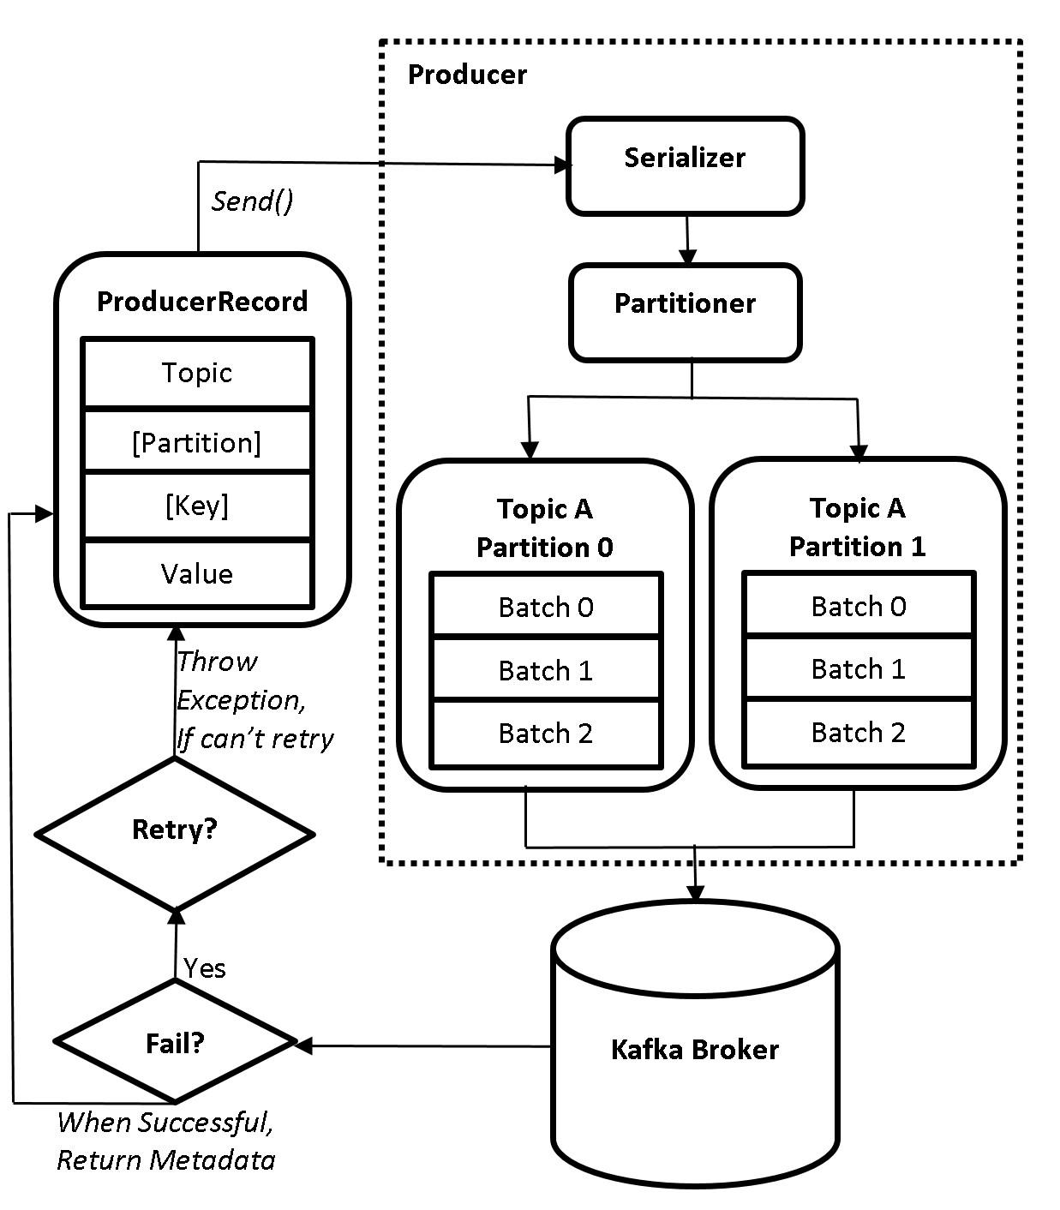

**5(a) Producer Workflow**

**ProducerRecord**

The first step in the workflow is to create a *ProducerRecord* object. This *ProducerRecord* object contains the name of the Topic to which the messages or events are being sent by the Producer. The *ProducerRecord* object also contains a value. The value is the actual message that has to be sent by the Producer to Brokers. We can also optionally specify the key and Partition in the *ProducerRecord* object. Since they are optional, the figure above shows them enclosed inside ‘[]’. An example of *ProducerRecord* object is as shown below.

val record = new ProducerRecord[String, String](topic, value)

The above line of code simply creates a *ProducerRecord* object which takes two parameters of type String i.e., the Topic name and value (actual message). This *ProducerRecord* object has to be programmed by the developer, while the rest of the process is taken care internally by the Producer. This is why the internals of Producer are placed inside a dotted box in the figure above. The *ProducerRecord* is sent to the next step using the *send()* method.

**Serializer**

The *ProducerRecord* is now sent to a *Serializer*. Serialization is the process of transforming structured objects to a Byte stream to send it over the network or save them to a persistent storage. The reverse process, i.e., the transformation of Byte stream to structured objects is known Deserialization. But why do we have to serialize? This is because Kafka only deals with data that is in the form of Bytes. This does not imply that users should only send data in Bytes. The data can be of type String, Int, JSON, class objects and many more. The type will be serialized by the serializer and transmit over the network for storing in the Brokers. The consumers can then deserialize the messages and receive them in the type they were sent by the Producer. We have to specify the type of serializer in the Producer application for the type of message being sent. For example, if the message is of type String, we must specify the String Serializer.

**Partitioner**

After serialization, the data is then sent to *Partitioner*. Let us understand this with an example. Let us consider we have a Topic called *transactions* with three partitions, i.e., *transactions-0, transactions-1* and *transactions-2* stored in 3 Brokers. Now the Producer has started transmitting messages to this Topic. How does the Producer determine which message should go to which Partition? This will be taken care with the help of Partitioner. The Partitioner determines which Partition a record/message will go to. There are a total of 4 types of Partitioners that determine how the messages are delivered to partitions.

* Round-Robbin Partitioner
* Hash Partitioner
* Specify Partition number explicitly
* Custom Partitioner
* The Round-Robbin Partitioner is the default Partitioner in Kafka. When no key or partition number is specified in the *ProducerRecord*, the messages from Producer are sent to partitions in a Round-Robbin fashion. In case of our example, The first message, say M1 will go to *transactions-0*, second message, M2, will go to *transactions-1* and the third message, M3, will go to *transactions-2*. Similarly, M4, M5 and M6 will go to *transactions-0*, *transactions-1* and *transactions-2* respectively and so on. The messages are continuously assigned to the partitions in the Round-Robbin manner.
* The Hash Partitioner is used whenever a key is specified in the *ProducerRecord*. The hash Partitioner will compute the hash of the key and performs modulo of hash result with the number of partitions. The result will be the number of partition, to which the message for that key should go to. The computation is as shown below:

hash(key) % Number of partitions

In case of our example, there are a total of three partitions. So, when the hash of key is performed modulo operation with the number of partitions, the result will always be 1, 2 or 3, based on the key.

* We can also specify the number of partition explicitly in the *ProducerRecord*. This will make all the messages go to the explicitly specified partition number.
* Finally, we can also create a custom partitioner. You can create your own Partitioner and specify how the messages should be delivered to the partitions. Kafka will use the custom partitioner when specified within the *partitioner.class* property in Producer application.

**Producer Partition Buffers**

The Producer sends the messages to partitions in batches. Depending upon the Partitioner used, the Producer maintains a memory buffer for each partition. The messages are flushed to partitions upon reaching a certain threshold. Let us understand this with an example.

* In the figure 5(a) Producer Workflow, there are two partitions for *Topic A*. Since there are two Partitions (Partition 0 and Partition 1), there will be two memory buffers created (RAM allocated) within the Producer. The size of the buffer is allocated using the property called *buffer.memory*.
* Let us consider the Round-Robbin Partitioner is used to determine the partitions for messages to be delivered to.
* Once the Producer has started Producing the messages, it doesn’t immediately send these messages to the partitions. Instead the Producer will store the messages in the buffer. The first message, say M1, will be buffered in buffer for Partition 0. Similarly, the second message, M2, will be buffered in buffer for Partition 1.
* In the same way M3, M5 and M7 will be buffered in Partition 0 and M4, M6 and M8 will be buffered in Partition 1.
* At this point of time, the buffer for Partition 0 contains messages M1, M3, M5 and M7 while buffer for Partition 1 contains messages M2, M4, M6, M8. The messages within the Partition 0 buffer are called Batch 0 while the messages in Partition 1 buffer are also called Batch 0, as seen in figure 5(a).
* Producer always sends the messages to Partition in the form of batches. Once the preset threshold for a batch is crossed, the batches will be flushed to the appropriate Brokers containing the Partitions. For our example, the Batch 0 will be sent to the partitions once the threshold is reached. A new batch, say Batch 1, is allocated for new messages and the same cycle is repeated.
* The threshold at which the batches have to be flushed are controlled using the following configuration properties:

batch.size

linger.ms

* The *batch.size* property is used to specify the size of batch in bytes, while the *linger.ms* property contains the minimum amount of time in milliseconds, to wait for additional messages before sending the batch to partitions. The messages are flushed either when the size of batch crosses the size set in *batch.size* or if the time set in *linger*.ms is reached.
* A batch may contain any number of messages based on the properties discussed above. We shall look how to determine the size for *batch.size* and time for *linger.ms* properties in the upcoming chapters.

Once the Broker starts receiving messages, it will send a response back to the Producer. If the messages were successfully received by the Broker, the Broker will send metadata information i.e., *RecordMetadata*  object. This object contains topic, partition, and the offset of the record within the partition. However, if the Broker fails to receive the message, it will respond with an error. The Producer will then retry to send the messages until the Broker receives them. If the Broker continues to respond with error, the Producer will eventually quit and return an error itself.

**Types of Producers**

There are three different types of approaches which Producers use to send data to the Brokers. The major difference between these approaches is the way the data is being sent to Brokers and how the errors are being handled. Let us look at them in detail.

|  |  |
| --- | --- |
| **Fire and Forget** | The Fire and Forget Producer simply sends a message to a Broker, and doesn’t worry if the message was successfully received by that Broker. Even though Kafka is fault tolerant (Producer automatically resends messages in case of failure), there may be scenarios where the messages sent by the Producer are not received by the Brokers. There is a chance of messages being lost with this type of Producer. This type of Producer should be used when you are dealing with huge volumes of data, and losing few messages is not a problem. A scenario where we could use this type of Producer is while ingesting tweets from Twitter for sentiment analysis. Losing a small percentage of tweets would not really be a problem in this case.  Basically, using this type of approach may result in data loss. Do not use fire and forget approach if it is mandatory to receive all the messages as sent by the Producer. The Fire and Forget Producer has very low latency but may not be fault tolerant to data loss. |
| **Synchronous Producer** | The Synchronous Producer sends a message to a Broker and waits until it receives a response from the Broker. The Broker responds back with *RecordMetadata* object if it successfully received the message. In case of failure, an exception is thrown. There is no data loss when this type of Producer is used. The Producer waits for a response before sending out another message. This type of Producer should be used when it is mandatory to receive every message that is generated. Credit card transaction processing is an example for Synchronous Producer. It is mandatory to receive messages regarding every transaction that has been processed and we cannot afford to lose even one of them.  Synchronous Producer has high latency but is fault tolerant to data loss. It guarantees that every message that is sent to the Producer is either received by the Broker or throw an exception in case of failure. The developer has to then implement a solution on how to deal with the exception. |
| **Asynchronous Producer** | While Fire & Forget and Synchronous Producers are two extreme approaches of sending data, the Asynchronous Producer approach is somewhere in between the above two approaches. The Asynchronous Producer sends a message to a Broker and registers a callback method to handle responses from the Brokers. The Producer keeps on sending messages and will not wait for response. Instead it registers a callback method that gets triggered when there is a response from Brokers.  The callback method returns either the *RecordMetadata* object when the message is successfully received or an exception in case of failure. We do nothing if the message was successfully received, however, we need to implement a solution in case of failure. The difference here when compared to synchronous producer is, in this approach there is no waiting after sending every message for response from the Broker. The callback method fetches the response while still being able to send the messages. There is low latency when compared to synchronous producer but there may be data loss. |

Let us understand these concepts better with an example. Consider a fast food joint that sells burgers. A customer (Broker) places an order for a burger (Messages). The burger can be handed over to the customer by chef (Producer) in three ways.

* The chef makes the burger and places it over the counter. The chef doesn’t care if the customer received the burger. This is similar to the fire and forget approach. The customer might or might not receive the burger. If the customer was not available at the counter while the burger was placed over the counter, the customer might have never received it.
* Let us look at the second approach. The customer after placing the order for a burger is handed over a receipt. The customer always stays near the counter and constantly checks if the burger is available on the counter. Once the chef has prepared the burger, the customer is asked for receipt. The customer hands over the receipt (Return *RecordMetadata* object) and takes the burger. This way the customer always gets the burger and the chef knows that the customer received their burger. The chef then takes the next order. However, if the customer is not available (error exception) at the counter after the burger is ready, the chef might make an announcement with the order number for a few times before cancelling the order. In this type of approach the chef doesn’t take new orders until the current order is handed over to the customer. This kind of approach is similar to Synchronous Producer.
* Let us now look at the final approach. The customer places an order online. The chef receives the order, prepares the burger and places it in the pickup tray. The chef continues to take orders and prepares stuff as ordered and places them in the pickup tray. The delivery boy (callback method) then picks up the orders and delivers the orders to respective customers. The delivery boy then informs the chef that the orders have been successfully delivered (Return *RecordMetadata* object) to customers. However, if the customer is unavailable (error exception) to receive the order, the delivery boy relays this information back to chef. The chef may ask the delivery boy to reattempt deliver in a later time or cancel the order. In this approach, the chef doesn’t stop working on new orders and also makes sure the customers received their orders. However, the customers might not receive their orders if they are not available during the time of delivery. This kind of approach is similar to Asynchronous Producer.

**Producer Configurations**

Let us look at few of the Producer configurations so that we can change them as per our requirement. There are a lot of Producer Configurations available You may check them in the Kafka documentation page using the link available in references section. Most of the configurations are set with default values that need not be changed. We shall now look at configurations that can have major impact on performance when altered.

**acks:** The acks property is a Producer configuration that defines the acknowledgements sent to Producers by the Brokers. This property has the acknowledgement values of *0*, *1* and *all*. It defines the number of replicas that should receive the messages, before the Producer considers the message was successfully received by the Brokers.

***acks = 0*:** When the acks property is set to 0, the Producer will not wait to receive acknowledgement from the Brokers. The Producer just keeps sending data to the Brokers. The Brokers may or may not receive data. There could be data loss if the Broker is unavailable when the Producer sends data. However, there is no latency as the Producer doesn’t wait for acknowledgement and keeps sending data. This is equivalent to the fire and forget approach.

***acks = 1*:** When the acks property is set to 1, the Producer will wait for acknowledgement from the Leader Broker hosting the Partition. The Producer will send the data to Leader Broker and waits for acknowledgement. The Leader Broker after receiving the data sends an acknowledgement to the Producer. The Producer will then start sending other messages. However, the Producer doesn’t care if the Follower Brokers containing the replicas have replicated the data from Leader Broker.

If the Leader is down before followers were able to replicate the data from Leader, there could be data loss. There could be a limited data loss in this case as well as little latency as the Producer has to wait for acknowledgment. This setting guarantees that the Leader has the data but there is no guarantee that the replicas have the data.

***acks = all*:** When the acks property is set to all, the Producer will wait for acknowledgements from both the Leader and Follower Brokers hosting the Partition replicas. The Producer will send the data to Leader Broker and waits for acknowledgement. The Leader Broker will commit the data to its log file. The replicas in Follower Brokers will then request the data from Leader and replicate the data. Once the Follower Brokers have replicated the data, they will send an acknowledgement to the Leader Broker. The Leader will then send the acknowledgement to Producer. The Producer then starts sending other messages.

There is no data loss at all in this case. However, there is high latency as the Producer waits for acknowledgment from all the replicas of a Partition. This setting guarantees that all the replicas of a partition have the data.

**batch.size:** Please check *Producer Partition Buffers* section.

**buffer.memory:** The buffer.memory property specifies the size of memory in Producer to buffer messages before sending them to the Brokers. If records are sent faster than they can be transmitted to the server then this buffer space will be exhausted. When the buffer space is exhausted additional send calls will block. The threshold for time to block is determined by *max.block.ms* after which it throws a TimeoutException.

**compression.type:** The compression.type property is used to specify the compression algorithm to be used while sending data. The messages are sent uncompressed, by default. We can specify snappy, gzip, or lz4 as values for compression type. When a compression is specified, the data will be compressed before sending it over the network. This will enable less network utilization and storage.

**linger.ms:** Please check *Producer Partition Buffers* section.

**max.block.ms:** The max.block.ms property is used to control the duration for which the producer will block while calling KafkaProducer.send() and KafkaProducer.partitionsFor() methods. These methods can be blocked either because the buffer is full or metadata unavailable.

**max.request.size:** The max.request.size property is used to specify the maximum request size a Producer can send. This limits the maximum size of a single message, as well as, number of messages that are sent in a batch that can be sent by the Producer. A Broker also has limit for the maximum request size it can accept using message.max.bytes property. It is recommended to have same value for both the properties, so that the Broker does not reject a message sent by the Producer, which is more than the configured maximum size a Broker can accept.

These are a few of the Producer configurations required to configure the Producer as per the requirement. Please note that the configuration properties mentioned above are only a handful. Please check the link in References section for the complete list of configurations.

That’s all for the theory for this chapter. Let us move to the lab exercise to check all this theory in action.

**AIM**

The aim of the following lab exercises is to implement a Kafka Producer. We shall also run Producer to send data to Brokers.

The labs for this chapter include the following exercises.

* Import Kafka Packages & Declare variables
* Create a Kafka Producer and ProducerRecord Object
* Running the Producer
* Sending messages Synchronously
* Sending messages Asynchronously

We need the following packages to perform the lab exercise:

* Java Development Kit
* Apache ZooKeeper
* Apache Kafka
* Scala
* IntelliJ IDEA

**LAB EXERCISE 4: THE PRODUCER**

1. **Import Kafka Packages & Declare Variables**
2. **Create a Kafka Producer and ProducerRecord Object**
3. **Running the Producer**
4. **Sending messages Synchronously**
5. **Sending messages Asynchronously**

Let us start implementing a very basic Kafka Producer. For simplicity and better understanding, this lab exercise is divided into tasks for the major steps that are involved in implementing a Kafka Producer.

**Task 1: Import Kafka Packages and Declare variables**

**Step 1:** Let us create a new Scala Object. Right click on the *Scala* folder in IDE, hover on *New* and click on *Scala Class*. You should see a prompt to enter the name. Enter *KafkaProducer* in the name field. Click on *kind* dropdown and select *Object*. Click *OK* and you should see the object, as shown in the screenshot below.

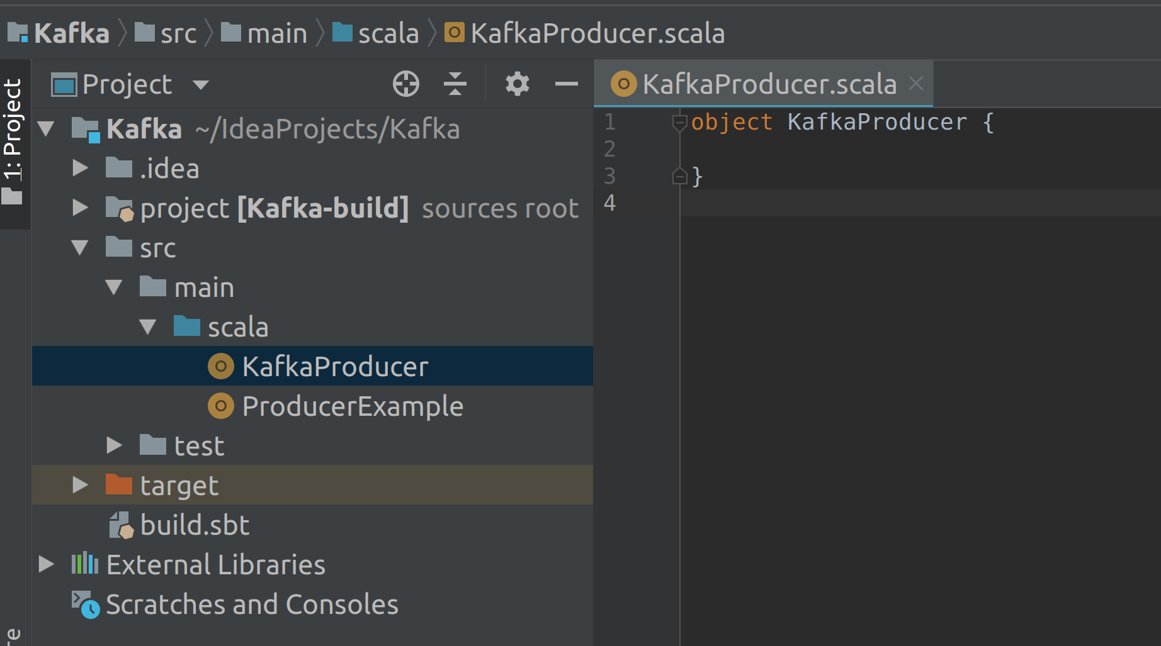

Let’s extend the object to *App* trait to make it an executable program.

object KafkaProducer extends App { }

**Step 2:** Now that we have created an object, let us import the following packages. These imports are required to specify properties and create *Producer* & *ProducerRecord* objects.

import java.util.properties

import org.apache.kafka.client.producer.KafkaProducer

import org.apache.kafka.client.producer.ProducerRecord

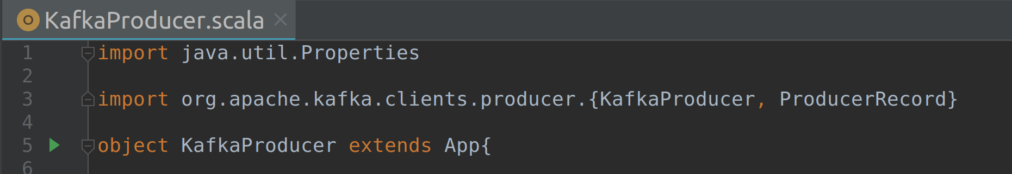

**Step 3:** Let us now specify few variables. We specify the name of the topic and the bootstrap address (brokers) as arguments. Next, we specify the message, i.e., the key and value. This is the message that is being sent to the brokers. The messages are sent in the form of key and value pairs. However, a message can be sent without a key as well.

val topic = args(0)

val brokers = args(1)

val key = “key1”

val value = “value1”

Since we are specifying a key, the hash partitioner is used to determine which message goes to which Partition.

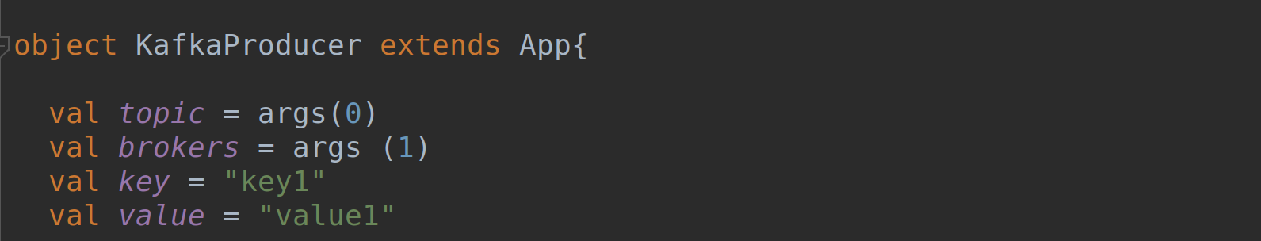

**Step 4:** The next step is to specify the properties. We have already soon the *bootstrap.servers* property in the previous lab exercise.

val props = new Properties()

props.put(“bootstrap.servers”, brokers)

props.put(“client.id”, “Kafka Producer”)

|  |
| --- |
| props.put(“key.serializer”, “org.apache.kafka.common.serialization.StringSerializer”) |
|  |

|  |
| --- |
| props.put(“value.serializer”, “org.apache.kafka.common.serialization.StringSerializer”) |
|  |

* The *put* method is used to specify the configuration properties to the *props* object.
* The *client.id* is an optional property that is used to set a unique identifier to the producer.
* The *key.serializer* is used to specify the serialization for key while the *value.serializer* is used to specify the serialization for value. Since our message is of type String in both key and value, a *StringSerializer* is used for both key and value. However, you can also use an *IntSerializer,* *DoubleSerializer, LongSerializer, JSONSerializer etc,* if the keys or values are of that type.

The serializers in Kafka include *ByteArraySerializer, ByteBufferSerializer, BytesSerializer, DoubleSerializer, ExtendedSerializer.Wrapper, FloatSerializer, IntegerSerializer, LongSerializer, SessionWindowedSerializer, ShortSerializer, StringSerializer, TimeWindowedSerializer, UUIDSerializer*

Please check *Serializer* section under *Producer Workflow* for more information on serialization.

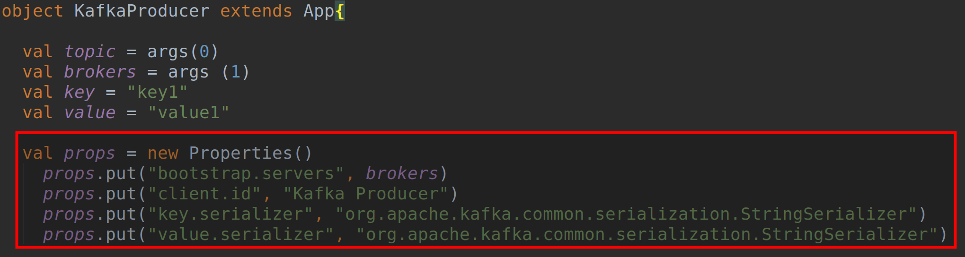

**Task 1 is complete!**

**Task 2: Create a Kafka Producer ProducerRecord Object**

**Step 1:** Now that we have configured the Producer, the next step is to create a Producer object. The Kafka Producer object is instantiated by passing the *props* object as an argument.

val producer = new KafkaProducer[String, String] (props)

The above line of code instantiates a Producer object that is of type String and String. The String type specifies the type for key and value.

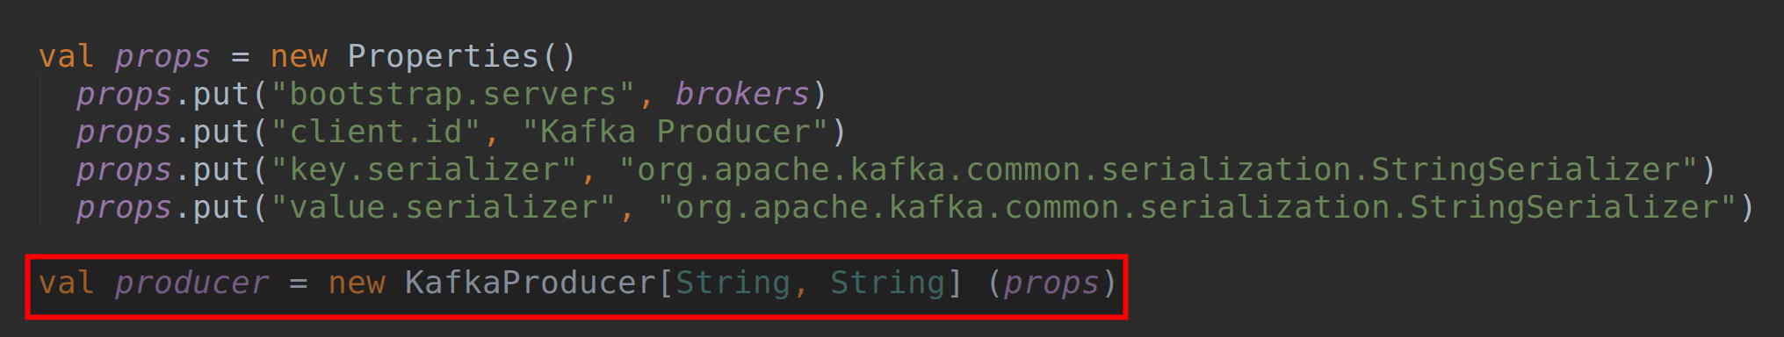

**Step 2:** Now that we have a Producer object created, the next step is to enable this Producer to send messages. To be able to send messages, we must instantiate a *ProducerRecord* object.

val message = new ProducerRecord[String, String] (topic, key, value)

The *ProducerRecord* object constructor is instantiated by passing arguments as name of the topic, key and value. The *ProducerRecord* object contains the actual message that is being sent to Brokers.

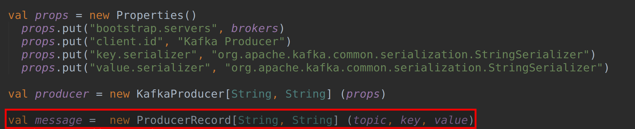

The *ProducerRecord* object has various constructors. While it is mandatory to pass topic and value to *ProducerRecord* constructor, you can also specify the key, the partition number and a timestamp to include within your message.

To know more about the *ProducerRecord* object constructors, you may hold the *ctrl* key and click on the *ProducerRecord* as shown in the screenshot below.

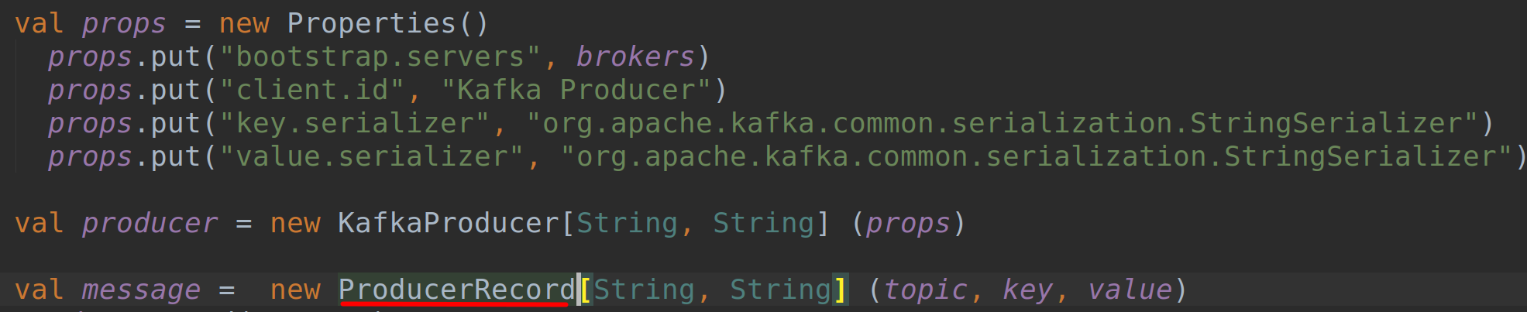

You should then see a new tab *ProducerRecord.java* showing all the constructors as shown in the screenshot below.

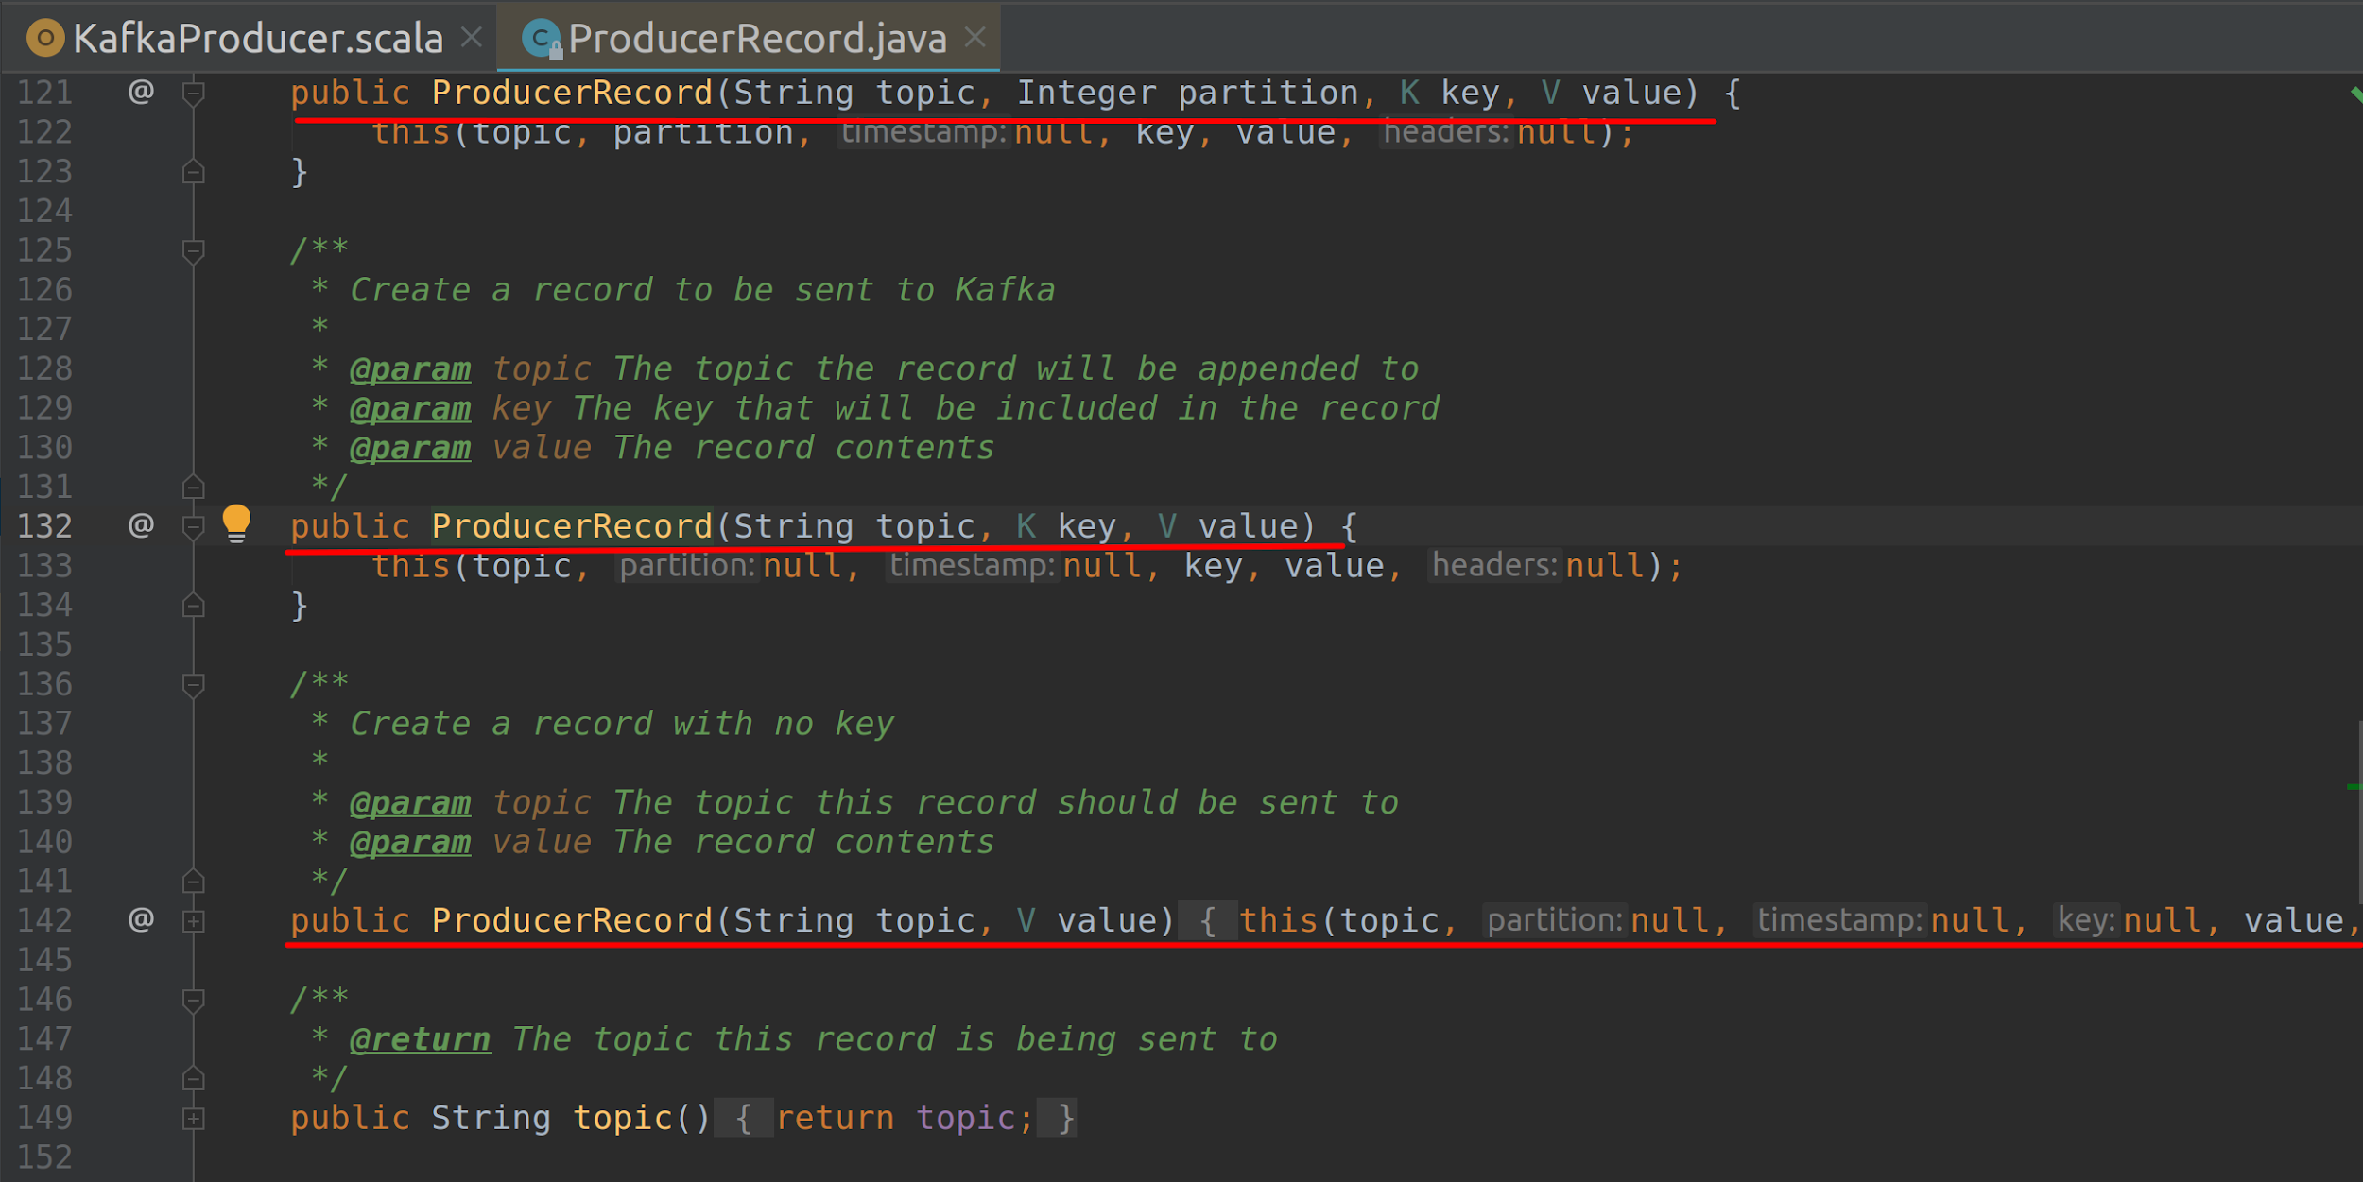

**Step 3:** Finally, we need to trigger the message to be sent. This can be done using the *send* method. We simply call the *send* method on our producer object by passing the *ProducerRecord* as argument. The Producer will then start sending the messages to the Brokers.

producer.send(message)

Finally, after sending the messages, we must close the Producer object using the close message as shown below. Closing the Producer object will free up the resources being used by the Producer.

producer.close()

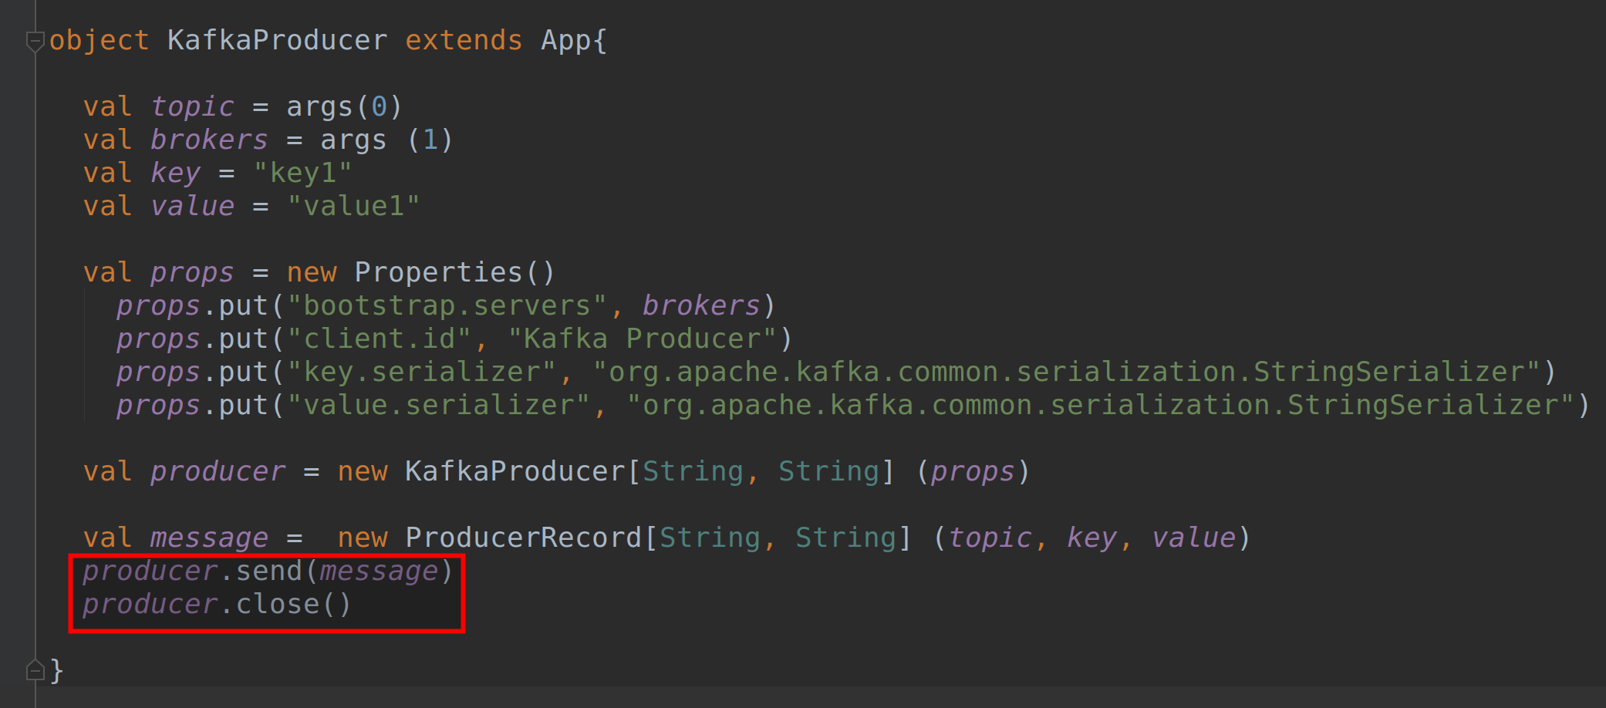

We have completed implementing a very basic Producer. Let us run this and check if the message is successfully sent to the topic.

**Task 2 is complete!**

**Task 3: Running the Producer**

**Step 1:** Now that we have finished implementing the Kafka Producer, let us start ZooKeeper and Kafka server in the terminal.

$ zkServer.sh start

$ kafka-server-start.sh /usr/share/kafka/config/server.properties

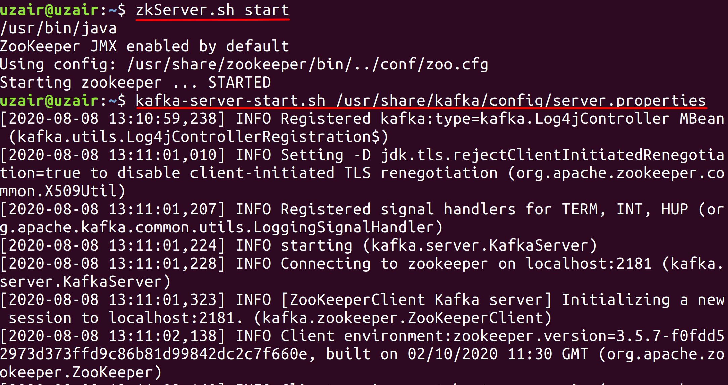

**Step 2:** Let us now create a new topic and name it *logs*. The topic has three partitions and a replication factor of 3. Please open a new terminal to do this.

$ kafka-topics.sh \

--zookeeper localhost:2181 \

--create --topic logs \

--replication-factor 1 \

--partitions 3

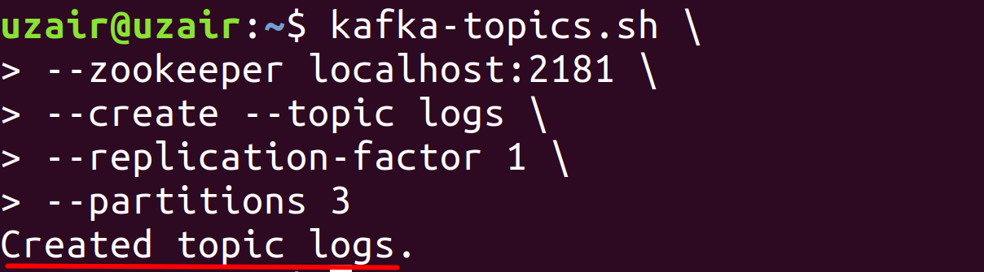

You may also list all the available topics in your Kafka server.

**Step 3:** Now that we have the topic created, let us finally run the Producer code we have implemented in the previous steps. Switch back to the IDE, click on *Run* and select *Edit Configurations…* option. You should see the configurations window as shown in the screenshot below.

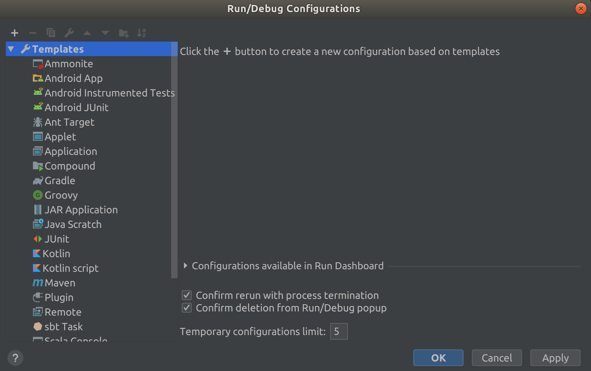

Click on the + icon on the top left of the window and select Application from the drop down list. Enter any name as you like in the name field. We have named it *KafkaProducer*. Click on the … button for *Main Class* field and select the class.

Next, input the program arguments as shown below.

logs localhost:9092

Finally, if *Use classpath of module* is empty,select the value *Kafka* from the drop down. You should see all the values as shown in the screenshot below.

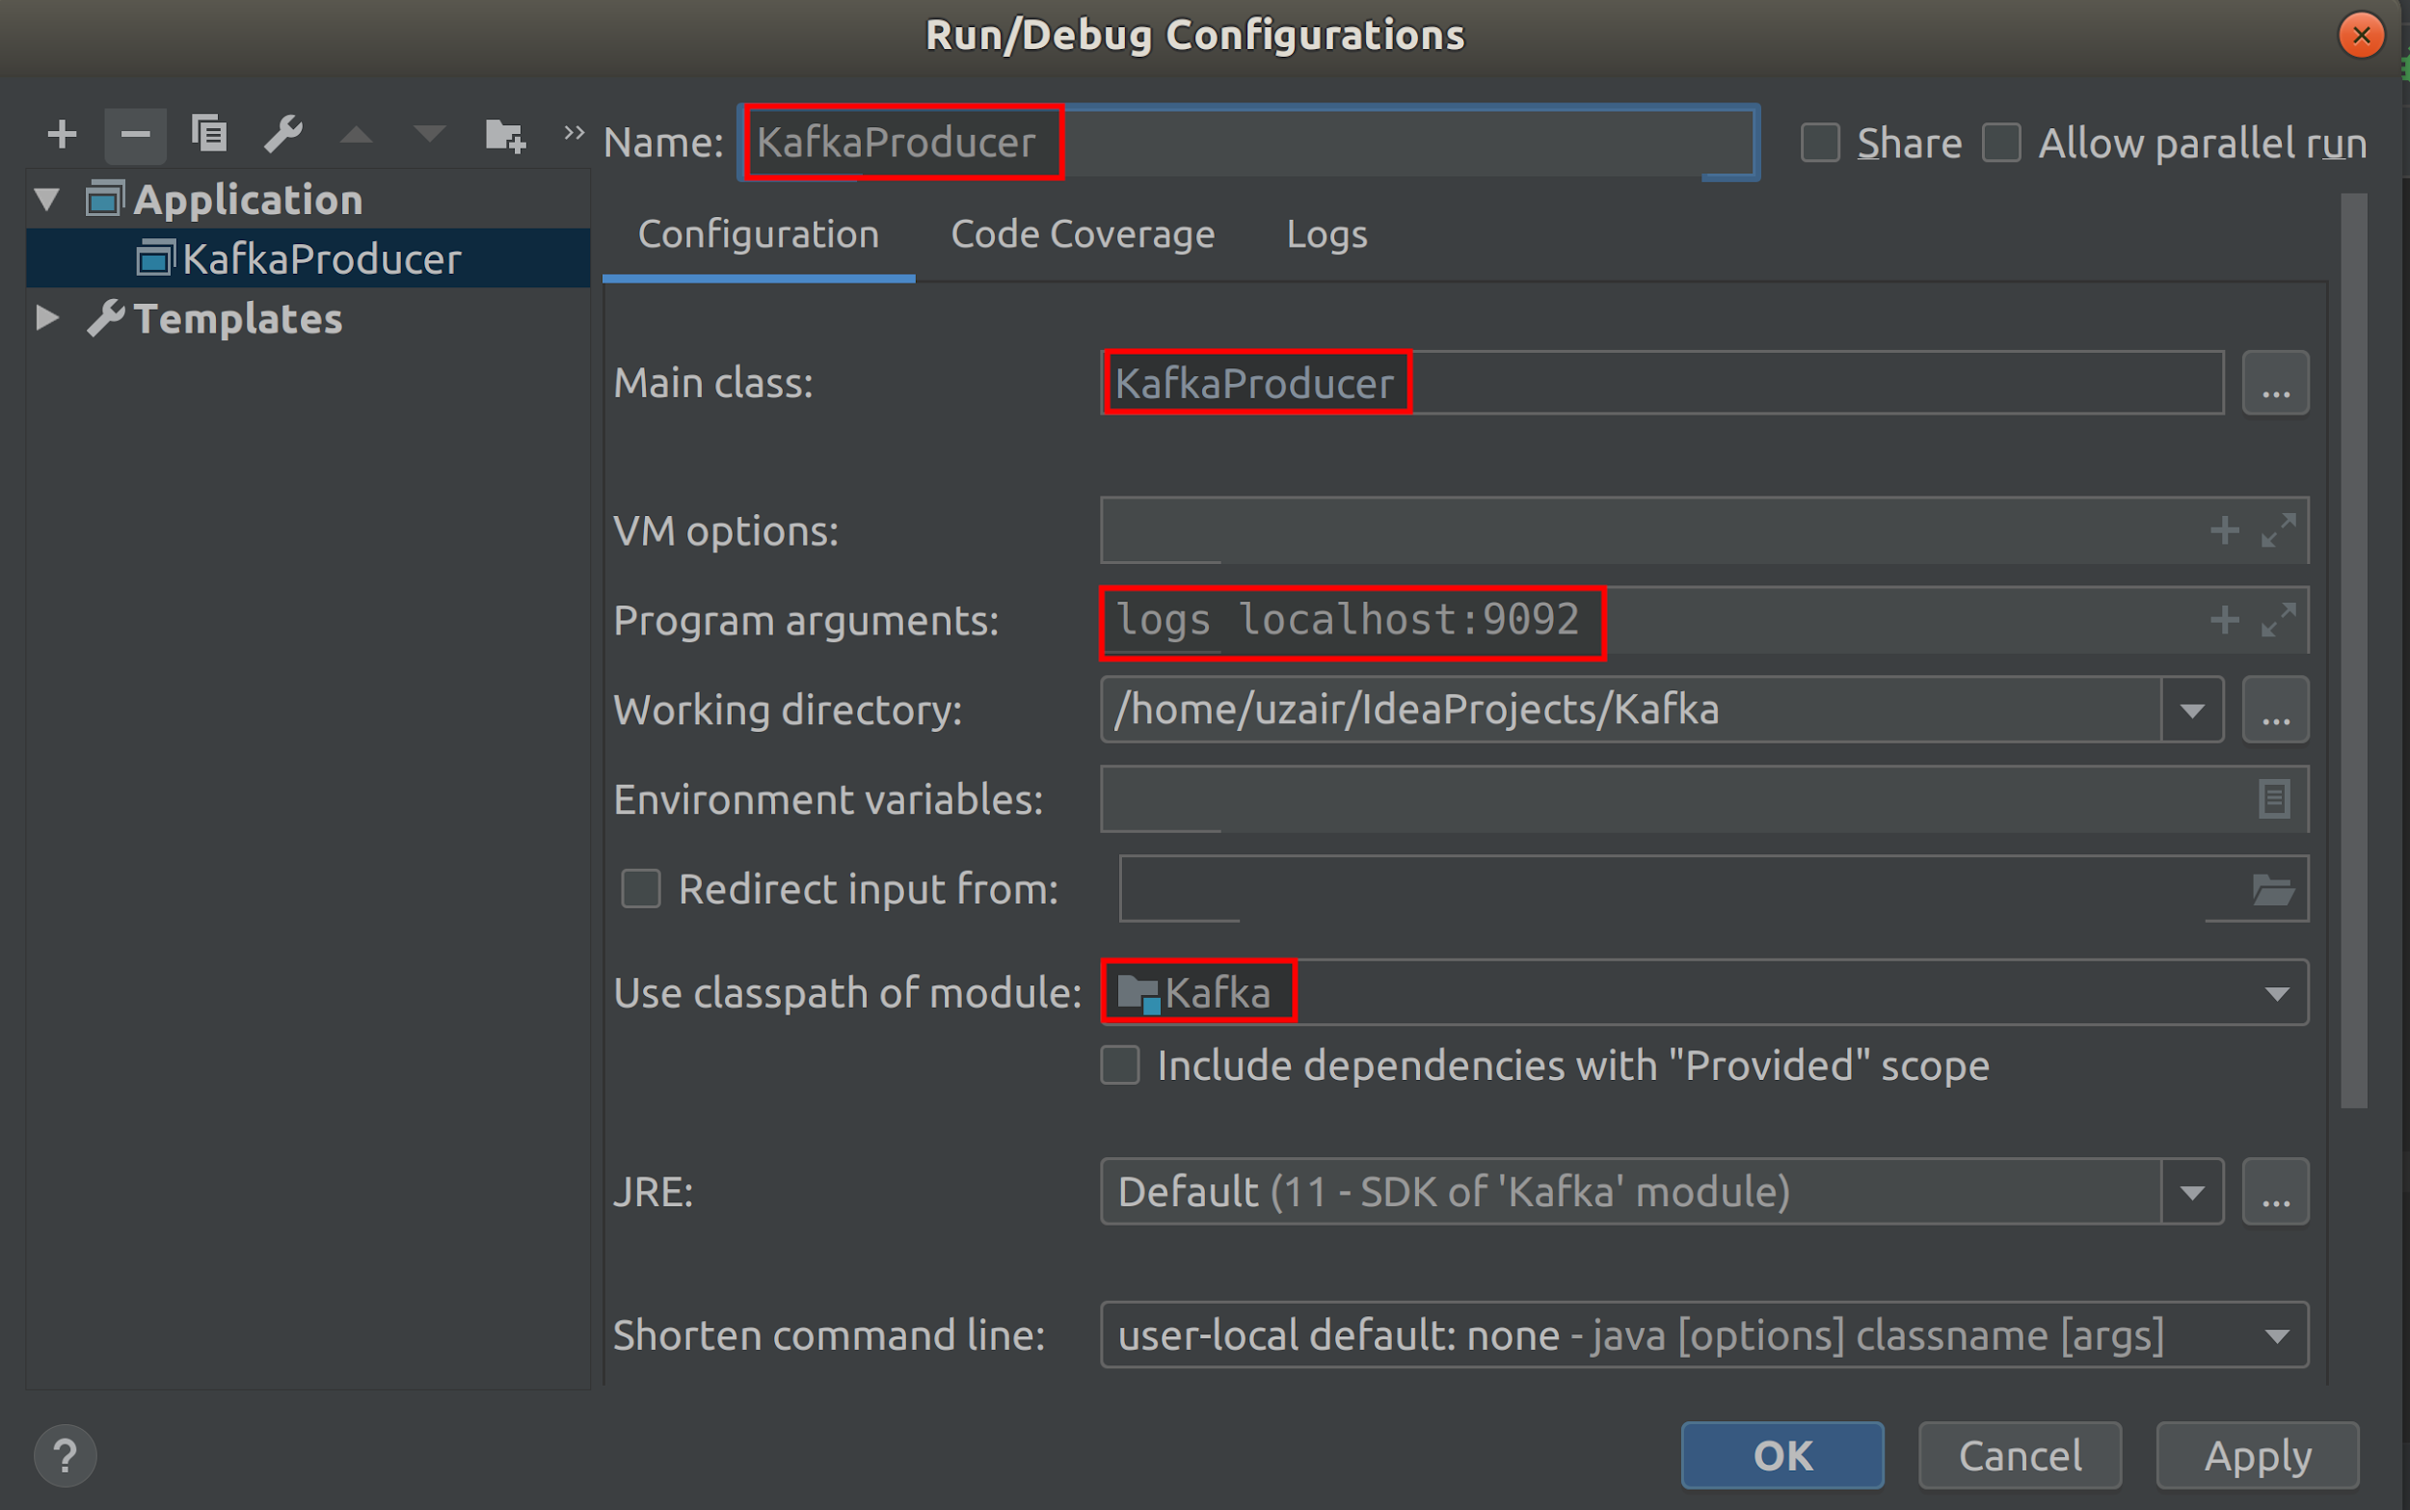

**Step 4:** Once you have ensured that all the values entered are correct, click on *OK* button. You should see the configuration on the top right of IDE as shown in the screenshot below.

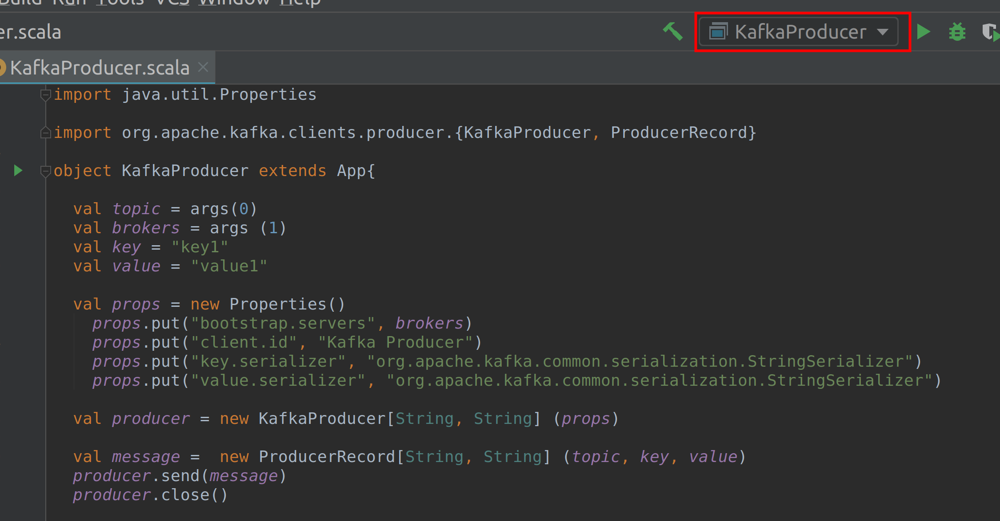

**Step 5:** Let us run the Kafka Producer. Click on the green play icon to the right of the configuration drop down. After a while, you should see that the Producer has run successfully with exit code 0.

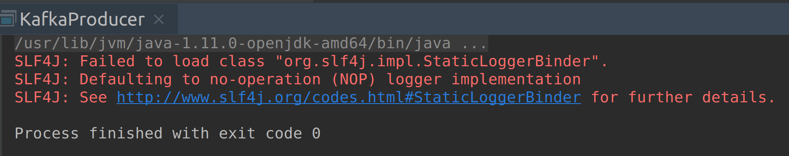

**Step 6:** Now check the *kafka-logs* directory. The default location is */tmp/kafka-logs*. You should see three partitions for *logs* topic. Go through each partition and check the *.log* file for the message that has been received.

This is a very basic implementation of Kafka Producer. In the real world applications, Producers keep sending messages for long time. We have only seen this basic implementation for simplicity and better understanding of Producer.

**Task 3 is complete!**

**Task 4: Sending message Synchronously**

In the previous task, we have sent a message and didn’t really care if the Broker has received that message. Now, let us see how to send a message synchronously to Kafka Broker.

**Step 1:** Create a new Scala object and name it *SyncProducer*. Next, copy the entire code from the *kafkaProducer*. Make sure you change the object name to *SyncProducer.* You should see the same code as shown in the screenshot below.

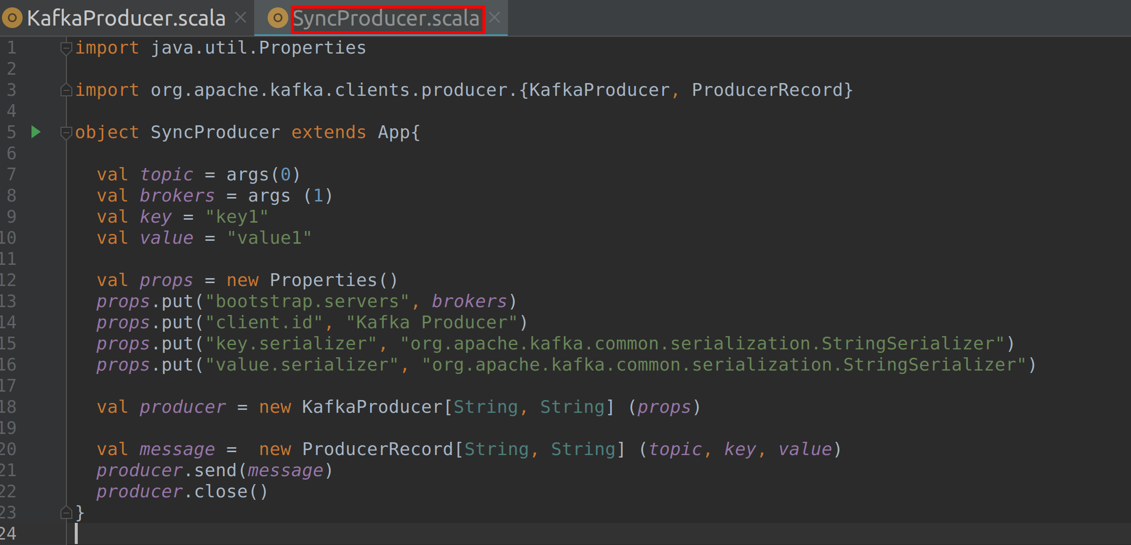

**Step 2:** To send a message synchronously, we use *Future.get()* method and wait for reply from Kafka server. The *get()* method throws an exception if the message is not successfully received by the Broker. However, if the message was successfully delivered, a *RecordMetadata* object will be sent.

The *send()* method we used in the previous task is enclosed within a try-catch block as shown below.

try{

producer.send(message).get()

} catch {

case x => {

x.printStackTrace()

}

}

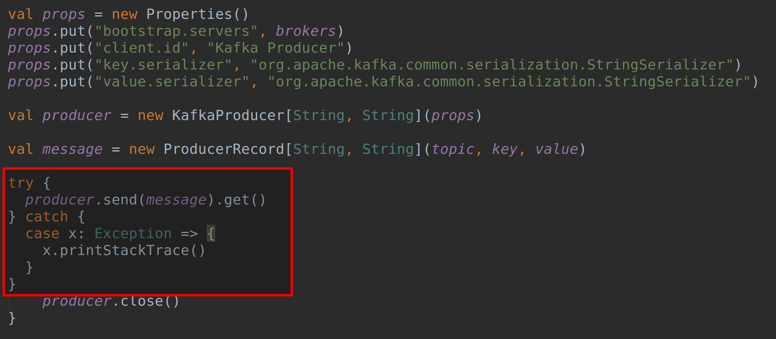

**Step 3:** Before running this Producer, let us create a new topic and name it *sync-log*. After creating the new topic, create new configurations as we did in the previous task and save them. Make sure you enter the new topic name in arguments. Now, run the program. You should see that the program has ran successfully with exit code 0.

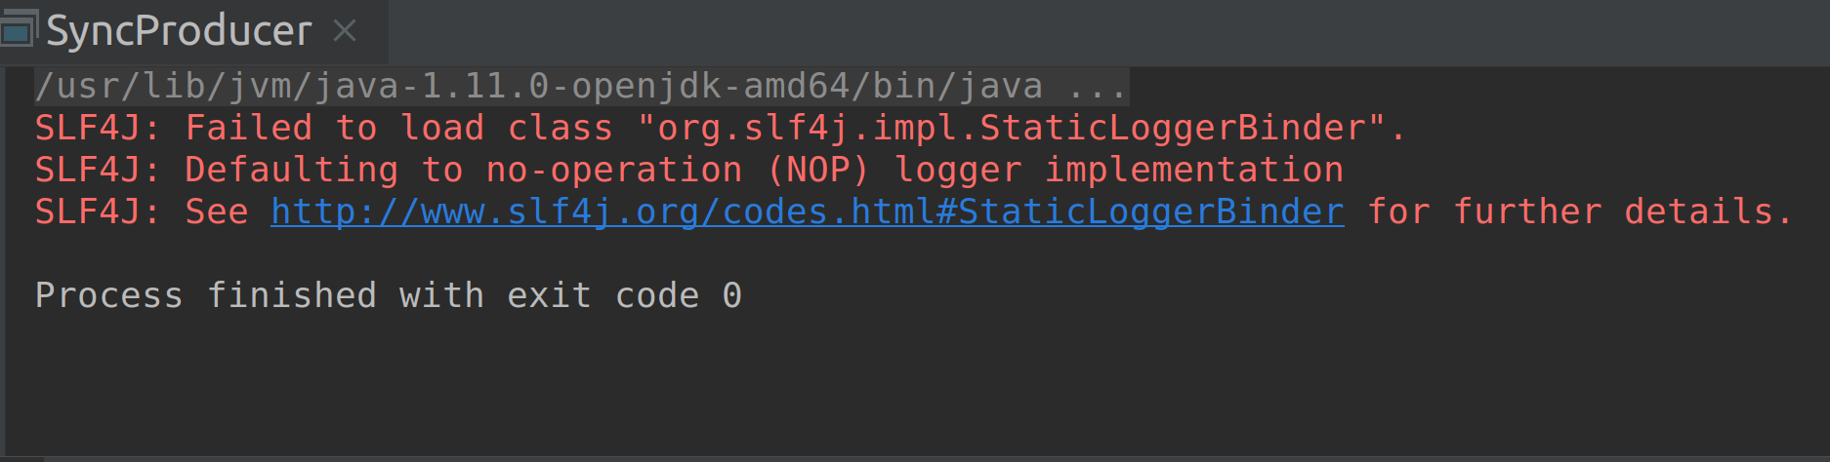

You may check the received message in *kafka-logs* directory under the *sync-logs* topic.

There isn’t much difference here, than what you saw in the previous task. Let us make few changes and create a *RecordMetadata* object to know more about the messages being sent.

**Step 4:** Let us create a *RecordMetadata* object as shown below. Make sure to add the new imports as shown below.

import org.apache.kafka.clients.producer.RecordMetadata

try{

val metadata: RecordMetadata = (producer.send(message).get())

println(“Message sent to Partition No. ” + metadata.partition() + “ and offset ” + metadata.offset())

println(“Message sent successfully.”)

} catch {

case x => {

x.printStackTrace()

println(“Message sending failed with exception.”)

}

}

When the Broker receives the message, it responds back with the *RecordMetadata* object. We can then get the partition and offset from the *RecordMetadata* object and display it on the console.

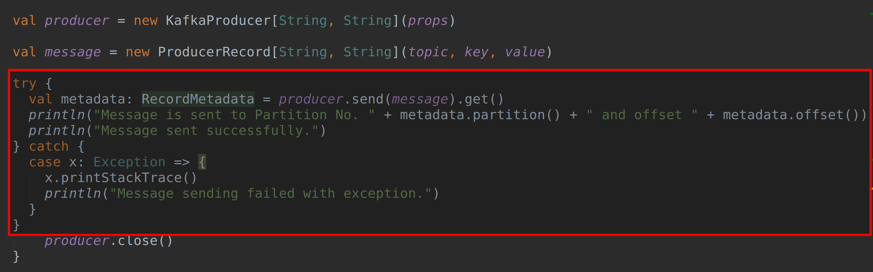

Please note that we haven’t covered offset yet. We will be looking at offsets in the upcoming chapters.

**Step 5:** Let us now run the Producer again. You should see the output as shown in the screenshot below.

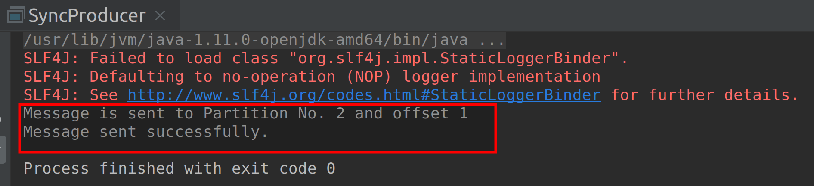

**Step 6:** As a lab challenge, stop Kafka Broker and run the Producer. Observe what happens when the message is not delivered successfully.

**Task 4 is complete!**

**Task 5: Sending message Asynchronously**

Let us finally send messages Asynchronously.

**Step 1:** Create a new Scala object and name it *AsyncProducer*. Next, copy the entire code from the *kafkaProducer*. Make sure you change the object name to *AsyncProducer.* You should see the same code as shown in the screenshot below.

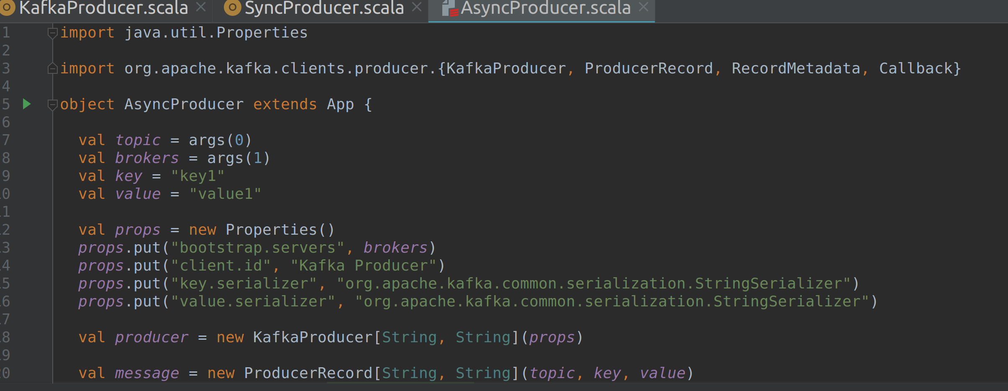

**Step 2:** To send a message synchronously, we use callbacks. Instead of waiting for a response from the Broker, the Producer keeps sending messages but instead registers a callback method to handle responses from the Brokers.

A callback class is passed within the send method along with the *ProducerRecord.* Let us now look at the Asynchronous implementation. Make sure to add the new imports as shown below.

import org.apache.kafka.clients.producer.RecordMetadata

import org.apache.kafka.clients.producer.Callback

producer.send(message, new ProducerCallback)

We must now implement the callback class (*ProducerCallback*) which extends an interface called *callback*. This class has a single function called *onCompletion()*. This *onCompletion()* function should be overridden to specify the error handling technique.

The *onCompletion()* function will take *RecordMetadata* and exception as arguments. If the record was successfully received, the Broker will send a *RecordMetadata* object and the exception will be null. However, if it wasn’t successful, the Broker will send an Exception. So, we check if the exception is not null. If the exception is not null, we handle the error appropriately. Here, we are simply printing the error stack trace to the console. If the exception is null, we do nothing as the message was sent successfully.

This Asynchronous approach eliminates the requirement to wait for a response to send a new message.

class ProducerCallback extends callback {

override def onCompletion(recordMetadata: RecordMetadata, e: Exception): Unit = {

if(e != null) {

e.printStackTrace()

println(“Sending Messages Asynchronously failed.”)

} else

println(“Messages send Asynchronously.”)

}

}

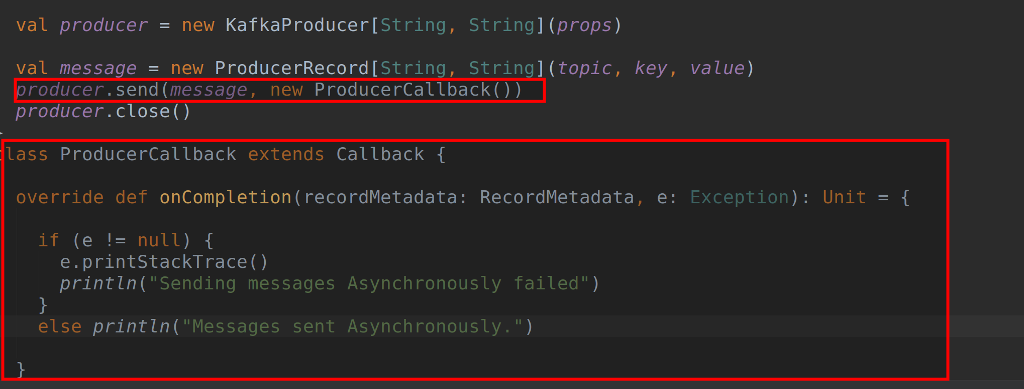

**Step 3:** Before running this Producer, let us create a new topic and name it a*sync-log*. After creating the new topic, create new configurations as we did in the previous task and save them. Make sure you enter the new topic name in arguments. Now, run the program. You should see that the program has ran successfully with exit code 0.

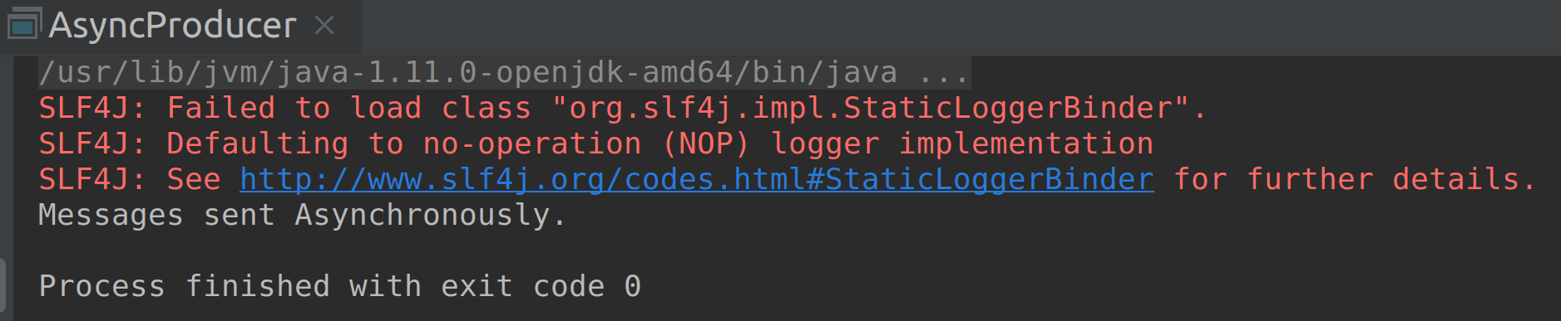

**Step 4:** As a lab challenge, stop Kafka Broker and run the Producer. Observe what happens when the message is not delivered successfully.

**Task 5 is complete!**

**SUMMARY**

The Producer is the Kafka component that generates messages and allows them to write into Kafka using the Kafka Producer APIs.

What are the Producer APIs? As per the Kafka documentation, “*The Producer API allows applications to send streams of data to topics in the Kafka cluster.*” This simply means that the Producer APIs allow users to implement a Producer application that sends data to one or more Topics present in the cluster of Kafka Brokers

In the labs, we have implemented the different Kafka Producer approaches.

**REFERENCES**

* http://kafka.apache.org/
* https://zookeeper.apache.org/
* http://spark.apache.org/
* http://hadoop.apache.org/
* https://www.confluent.io/
* https://kafka.apache.org/downloads
* https://kafka.apache.org/documentation/#configuration